Communicating High Expectations to Students
Online Modules – Technology Overview

The Communicating High Expectations to Students modules is an online resource aligned with the MCPS Framework for Improving Teaching and Learning. The six modules are designed for staff development teachers or administrators to use in small or large group settings with staff. The series was developed using a blended instructional model in which some activities are intended to be delivered face to face and others online. This blended approach provides schools flexibility and opportunities to differentiate the content and learning processes to meet the needs of the participants.

Modules are accessed in the Blackboard learning management system (LMS) using its features, such as pre-assessment/post-assessment tools with feedback and discussion boards. In addition, multimedia and interactive learning activities created with other software are incorporated in the instructional design of the modules to provide a varied and rich learning experience.

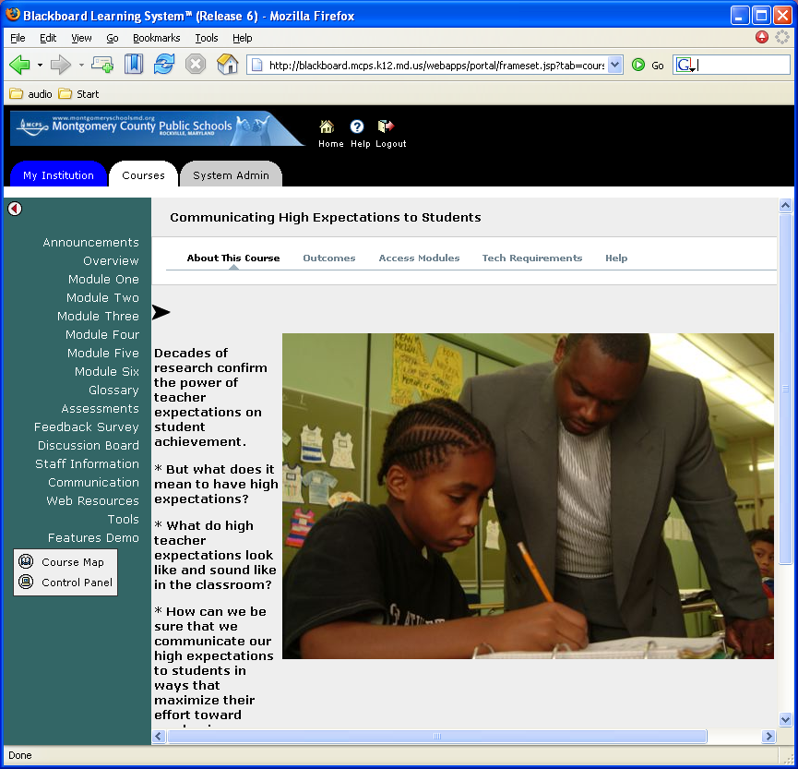

There is a common navigational structure to each module to maximize usability. Each module contains the following elements:
- Getting Ready
  - Video Overview - 1-3 minute video previewing the module
  - Pre-assessment
  - Outcomes
  - Activator
- Content and Learning Activities (specific activities may vary between modules)
  - Articles and activities
  - Interactive websites
  - Student and Teacher Surveys
  - Mini-lectures - video/audio/slides
- Pulling It Together
  - Summarizer
  - Bibliography
  - Video Summary - 1-3 minute video summarizing the module and previewing the next module
  - Post-test
  - Feedback
- Help
  - Navigational support
  - Technical Requirements
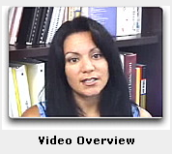
  - Glossary
Each module includes streaming video overviews using Real Video and Quicktime that set the framework for the modules and highlight key learning activities. The video “facilitator” appears in all modules, providing continuity.
Videos illustrating major concepts or demonstrating instructional practices and behaviors are included throughout the modules. Some examples of these are:
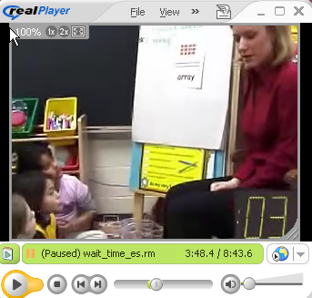
- Effective staff talk meeting
- Demonstration of TESA strategies (Teacher Expectations Student Achievement):
  - Numbered Heads
  - Wait Time
  - Probing and Delving
  - Individual Helping
- Virtual elementary and secondary classroom tours
- Expert interviews
- Principal presentation of school-wide implementation plan.
- ITV produced videos
  - “I Want You to Know Me”
  - “A Mile in His Shoes”


Other technology incorporated throughout the modules for mini-lectures is Impatica. This software allows participants to view presentations that incorporate PowerPoint slides (with animations and visual effects), video, audio, and a searchable transcript. These presentations are highly interactive - participants can quickly navigate to any slide using the menu of slide titles on the left side of the screen. The searchable transcript allows users to find every example of a word spoken in the presentation. Users can then access the portion of the presentation where that word occurs. Each module contains 2-4 of these mini-lectures which provide information and a larger context for research articles and other activities.

Module Two, which focuses on personal cultural history and the importance of understanding the culture of students, allows participants to create PowerPoint presentations about their own cultural background. The presentations can be posted on the discussion board for participants to view and to reflect upon. This was a very powerful and successful activity in the summer training of trainers.

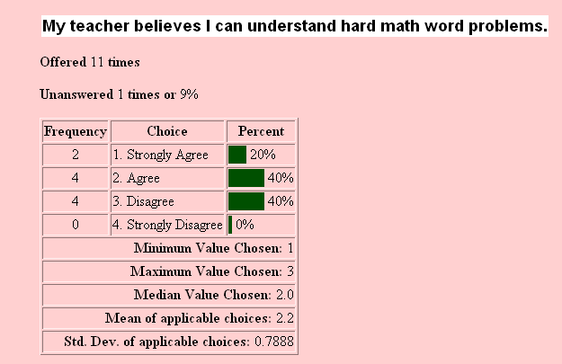
Surveys in Module Two provide a means for students to reveal perceptions and feelings about how teachers communicate expectations. To facilitate data collection and analysis, teachers have the option of using online surveys that provide immediate response data.

Appropriate online activities allow users to activate background knowledge and check content mastery. In this activator, participants use an interactive graphic organizer that gives immediate feedback on their responses.

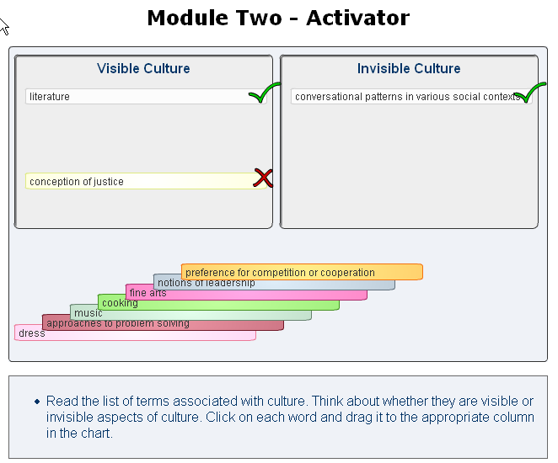

In this Flash activity developed using StudyMate software, participants can check their knowledge.

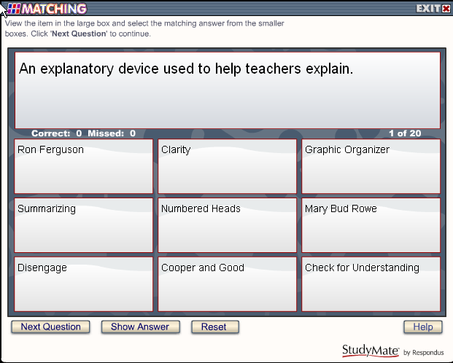

StudyMate is also used to create this searchable glossary:

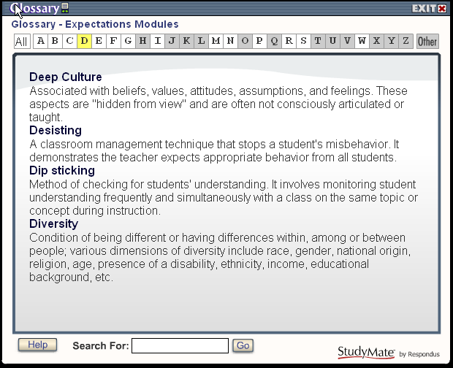

Module Four includes expert video responses to frequently asked questions about feedback. The web interface, allowing users to choose videos, supports a differentiated approach as participants access content based on their needs.

Our intention in the design process for Communicating High Expectations to Students modules was to use interactive learning technologies that were engaging and effective. The examples highlighted in this document illustrate the scope of technology used in the design and delivery of this series. We feel that the use of technology not only allows us to reach a wide audience, but also enhances the effectiveness of the instruction.

