Hydroponic Lighting

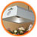
High Pressure sodium Grow light
250 Watts
$180.95

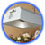
Metal Halide Grow light systems
250 Watts
$189.95

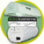
Euro Systems Grow System
250 Watts
$6.99

Hydroponic Air Pumps
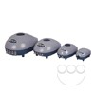Eco Plus Air Pumps
1 outlet $ 6.99
2 outlets $10.09
4 outlets $ 23.95
8 outlets $44.95

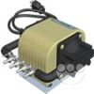Dual Diaphragm Air Pump
$54.95

Hydroponic growing containers

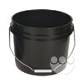3.2 Gallon Bucket
$4.38 each

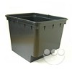Bato bucket with drain fitting
$ 7.89 each

CO2 Emitters and generators

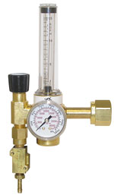CO2 Regulator Valve
$149.95
The C.A.P. CO2 Regulator/Emitter will allow you to maintain ideal CO2 levels for optimum growth.
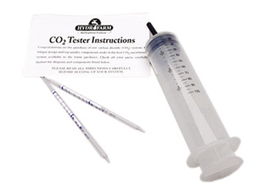

CO2 Test Kit
$14.25
This kit allows you to take samples of the air to check carbon dioxide levels. Measures from 300 - 5000 ppm.

