Grade 4 going into Grade 5 Summer Math Calendar
 | ~ July 2019 ~
Monday | Tuesday | Wednesday | Thursday | Friday | Saturday |  | Sunday
1  Alex says the shape is a rhombus. Carolyn says the shape is a square.  The teacher says they are both correct. Why? | 2  Write a multiplication word problem and teach someone the steps to solve it. | 3  The value of 3 in 934,125 is 10 times the value of 3 in  _ ____________________  369,285 or 253,476 | 4 | 5  Solve:  - 7,801-2,968  - 6,005-499  - 1,000-749 | 6  Four families each brought the same number of chairs to a block party. Three more chairs are needed to seat all 27 of the participants. How many chairs did each family bring? |  | 7  How many ¼ are there in 2 ¾ ?  What about it 4 ½ ?
8  My calculator’s subtraction key is broken.  What else could I put into the calculator to solve this problem?  38 + X = 471 | 9  Sort these fractions: Are they closer to 0, ½ or 1?  Draw a picture or model to prove it.  5/6, 3/4, 7/9, 2/5, 2/3, 1/8 | 10  Solve:  - 34 x 5  - 302 x 8  - 429 x 14 | 12  Order these decimals from least to greatest:  - 34.098  - 33.999  - 34.908  - 34.089 | 13  Draw three different shapes that all have a perimeter of 28.  How are they similar? How are they different? | 14  The area of Mr. Reinke’s rectangular garden is 240 square feet.  - Give at least two different possible measurements for his garden.  - Compare the perimeters of these gardens. |  | 15  Name at least two numbers that come between 1.7 and 1.8.  Create a number line to show these decimals.
15  Write a division word problem and teach someone the steps to solve it. | 16  Two brothers want to make muffins for the 35 kids at their summer camp.  They have $5.00 to spend on muffin mix. The box of muffin mix said it would make 12 muffins. Each box of muffin mix is $1.25.  Will the boys be able to make enough muffins for everyone? | 17  The teachers ate a lot of candy at their meeting! Who ate the most? Least? How can you prove it?  Mrs. A ate 2/6 of her bar  Mr. B ate 2/3 of his bar  Ms. C ate 5/6 of her bar  Mrs. D ate ½ of her bar  Mr. E ate 1/3 of his bar. | 18 Sean has 21 cents in his pocket. Sean told Jesse that he would give Jesse the 21 cents if he could correctly guess what coins they were. He would give Jesse 3 guesses. If Jesse did not guess correctly, Jesse would have to give Sean 21 cents. Should Jesse guess? Explain your math thinking. | 19  In the Land of Oz lives Ozzie, who is confused about time. He is trying to figure out how many times a day the hour hand passes a number that is a multiple of 3.  What is the answer? | 20  The answer is 360, what is the question?  - What other questions could have this same answer?  - Can you come up with a problem that uses multiple operations? |  | 21  3.091  - Is this number closer to 3 or 4?  - Is this number closer to 3 or 3.1?  Be sure to explain how you know.
22  Draw a picture that includes the following (you may add more):  - 2 parallelograms  - 1 right angles  - 1 obtuse angle  - 1 trapezoid | 23 What are the missing #s?  38_4  410_  + _74  8900 | 24  Order these fractions from least to greatest.  1/3, 1/8, 1/5, and 1/10  Draw a model to prove you are correct | 25  The answer to a division problem is 23. What was the problem?  How can you change the problem so that it has a remainder of 3. | 26  The difference between two numbers is 2,106. What could the two numbers be? What other two numbers have the same difference. |  | 27 Draw three different designs that are all 3/4 green. How are the designs similar? Different? | 28  Students from three classes are planning a field trip. On the trip, there will be 24 students from each class, along with 8 teachers  and 12 parents. How many people go on the trip?
29  Ms. Krakaur and Ms. Clary each ate ¾ of their sandwich. Ms. Krakaur ate more than Ms. Clary.  Explain how this is possible. | 30  Sarah rounded a four digit number to 4,700. What could her number be?  What other numbers could be rounded to 4,700? | 31  A student says that 1/3 is bigger than 1/2 because 3 is bigger than 2.  Are they correct? Why or why not? | Welcome to the summer math calendar for students entering Fifth Grade. This calendar is recommended, but not required. Reviewing the learned skills will maintain the foundation for math success at the next grade level. The design of the activities on this calendar is meant to support instruction aligned with the Common Core State Standards in both its content and presentation. Therefore the activities are not to be done as independent problems, but to be worked on with a parent, guardian or older brother or sister. Talking about the problem is an important part of completing each activity.  NAME:

Dear parents,
We are excited to announce that this school year, we’ve been using a software program in the classroom called Freckle. Freckle allows students to practice Math at their own level.This program will help all students to improve their mathematics skills.

I would encourage you to support your child’s continued practice in Freckle over the summer. This will help them maintain the progress they have made over the school year and keep their skills sharp!

You and your child can access Freckle at home in two different ways:
1. Online at www.freckle.com using Google Chrome as your browser, selecting “Student sign in” at the top of the page.
2. On an iPad with the free app: www.freckle.com/app
Your child’s login information is attached to this letter. You do not need to create a new Freckle account; your child will simply log into their existing account and continue practicing where they left off in the classroom.

Once they have logged in, they can choose to practice Math or ELA with a variety of different activities, such as reading articles, practicing math facts, and more. Summer is a great time for students to explore any or all of these activities at their own pace!
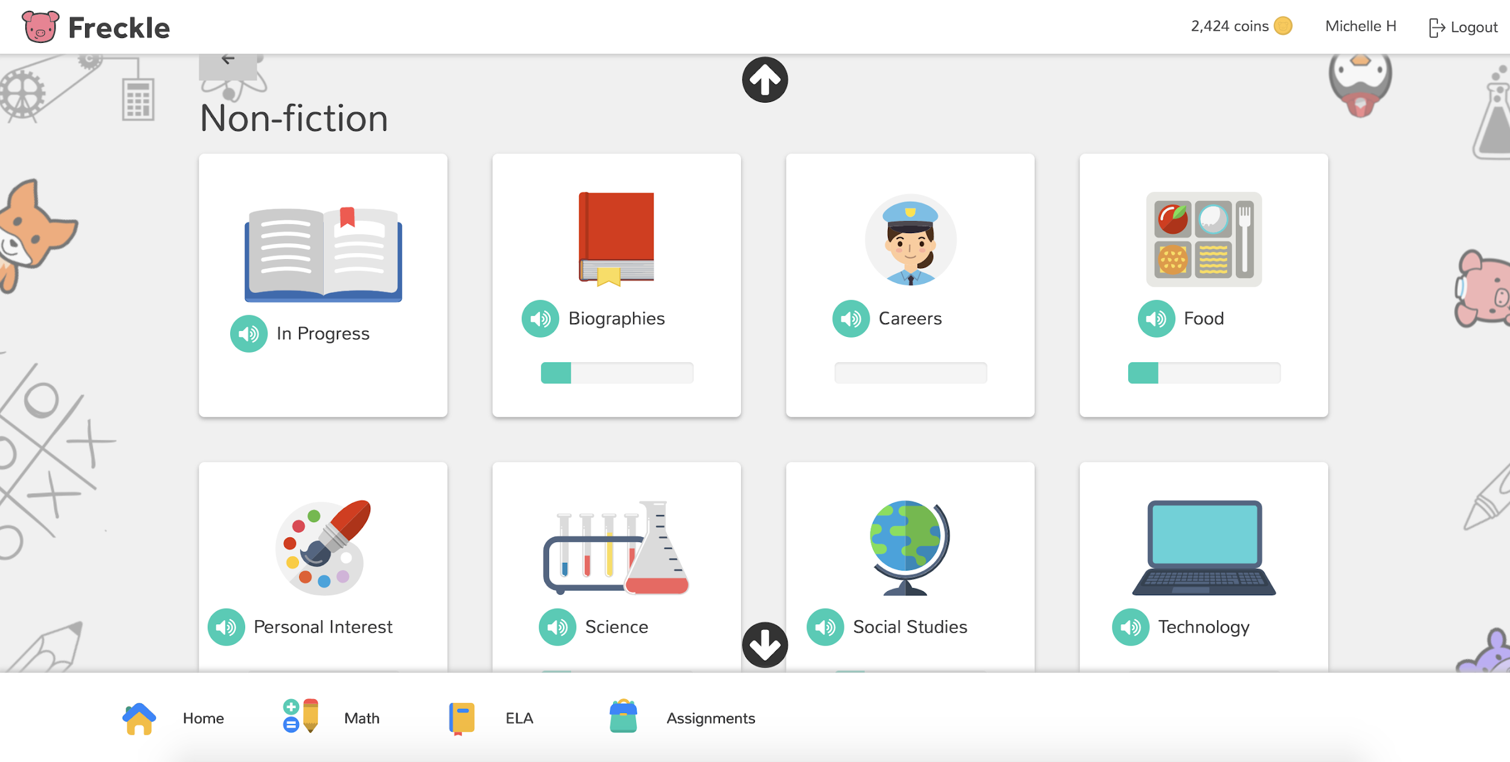
It’s important that your child does this practice independently, without any help. If they are having difficulty with a concept, and the video tutorials on the site do not help, your child may go on to a different section.

Thank you for supporting your child’s summer learning!

Sincerely,
The Westover Math Team

To access Freckle on a computer, go to https://student.freckle.com/#login
They should use their first and last name and the teacher classroom code.
More websites to use to explore Math
http://www.allmath.com/ This site has flash cards and links to other sites for games, math humor, worksheets, math help and more. http://www.aplusmath.com This site has basic facts flash cards and a game room, worksheets, multiplication table practice and more. http://www.mathfactcafe.com This site has a pencil next to pre-made cards so kids can do the facts and have the computer check them. Kids can print them out and also put in their own numbers and make their own worksheets. http://www.funbrain.com This site has easier to harder addition and subtraction computation and problem solving. It also has language and grammar skills activities http://www.dositey.com/ This site is a lot of fun and is good for 2 digit addition with and without regrouping http://www.24game.com This site has math games using basic operations http://www.coolmath4kids.com This site has a wide range of topics and will give you step-by-step instructions. http://www.abc.net.au/countusin/games Each game is designed to help kids understand basic concepts in math. This site has a variety of math games i.e. volume, length, halves, chance, numbers, time, sorting, subtraction, and addition. It is better for students of the primary grades. http://www.learningplanet.com This site has games by grade level but with advertisement and a subscription. There are some free games. https://www.multiplication.com/games/all-games

