Grade 3 going into Grade 4 Summer Math Calendar
 | ~ July 2019~
Monday | Tuesday | Wednesday | Thursday | Friday | Saturday |  | Sunday
1  Complete the fact family for:  7 x 5 = 35  _______  _______  _______  _______ | 2 How can you use 5 x 7 to to solve 7 x 7? | 3  411 when rounded to the nearest hundred is 400. What other numbers round to 400 when rounded to the nearest hundred? Give at least 3 examples. | 4 | 5  Bookstore  Comics $3  Hardcover Books $10  Paperback Books $6  Magazines $2  A customer spends $98 at the Bookstore. What did she buy? | 6  Bookstore  Comics $3  Hardcover Books $10  Paperback Books $6  Magazines $2  John buys 2 Hardcover books and 4 magazines. How much money does John spend? |  | 7  Solve.  ______ = 735 – 660  ______ = 287 + 368  602 + 285 = ______  422 – 109 = ______
8  Write a division word problem for another family member to solve. | 9  Scarves come in packages of 3 for $5. How many scarves could you buy for $25? | 10  What is the perimeter of the rectangle with the length of 36 meters and a width of 42 meters ? | 11 In the first movie, $457 is generated from the sale of tickets. Some more money is generated from the sale of tickets for the second movie. The total income generated from both moves is $958. How much money was generated from the sale of tickets for the second movie? | 12  Round 628 to the nearest ten. Discuss with a family member: How does thinking about place value help you round to the nearest ten? | 13  There are 520 students at Springwood Elementary School. 372 students ride the bus to school. 68 students take a car to school. Some students walk to school How many students walk to school? |  | 14  Which products are even?  8 x 2 =  5 x 4 =  6 x 8 =  3 x 7 =  9 x 6 =  How do you know?
15  Find an analog clock ( a clock with a face) and read the time of day to a family member. | 16  Look at the equations. Write word problems to match each equation.  20 ÷ 4 = ?  7 x 5 = ? | 17  Write a 3-digit number. Round it to the nearest ten.  Ask a family member to write a 3-digit number. Round it to the nearest ten. | 18  What is the area of the rectangle? | 19  Which pair of numbers has a sum of 20 and a quotient of 4? | 20  Write 5 x 7 = 35 as repeated addition. |  | 21  Sweatshirts come in packages of 2 for $9. How many sweatshirts could you buy for $72?
22  Solve for the unknown.  187 = 42 + ? + 79  500 - ? = 318  495 = 131 + ? + 82  ? + 78 = 194 | 23  223 when rounded to the nearest 10 is 220. What other numbers round to 220 when rounded to the nearest ten? Give at least 3 examples. | 24  Which products are odd?  4 x 3=  9 x 2=  3 x 3=  7 x 8=  5 x 7=  How do you know? | 25  Look at the equations. Write word problems to match each equation.  19 + 2 = ?  38 – 15 = ? | 26 Complete the fact family for:  42 ÷ 6 = 7  _______  _______  _______  _______ |  | 27 Which pair of numbers has a difference of 7 and a quotient of 2? | 28  Which products are even?  3 x 5=  2 x10=  7 x 4=  8 x 3=  6 x 5=  How do you know?
29  Write a multiplication word problem for another family member to solve. | 30  Draw a rectangle with a perimeter of 24 inches. Label each side of the rectangle.  Draw a different rectangle with the same perimeter. Label each side of the rectangle. | 31  Complete the fact family for:  9 x 4 = 36  _______  _______  _______  _______ | Welcome to the summer math calendar for students entering Fifth Grade. This calendar is recommended, but not required. Reviewing the learned skills will maintain the foundation for math success at the next grade level. The design of the activities on this calendar is meant to support instruction aligned with the Common Core State Standards in both its content and presentation. Therefore the activities are not to be done as independent problems, but to be worked on with a parent, guardian or older brother or sister. Talking about the problem is an important part of completing each activity. NAME________________________

Dear parents,
We are excited to announce that this school year, we’ve been using a software program in the classroom called Freckle. Freckle allows students to practice Math at their own level.This program will help all students to improve their mathematics skills.

I would encourage you to support your child’s continued practice in Freckle over the summer. This will help them maintain the progress they have made over the school year and keep their skills sharp!

You and your child can access Freckle at home in two different ways:
1. Online at www.freckle.com using Google Chrome as your browser, selecting “Student sign in” at the top of the page.
2. On an iPad with the free app: www.freckle.com/app
Your child’s login information is attached to this letter. You do not need to create a new Freckle account; your child will simply log into their existing account and continue practicing where they left off in the classroom.

Once they have logged in, they can choose to practice Math or ELA with a variety of different activities, such as reading articles, practicing math facts, and more. Summer is a great time for students to explore any or all of these activities at their own pace!
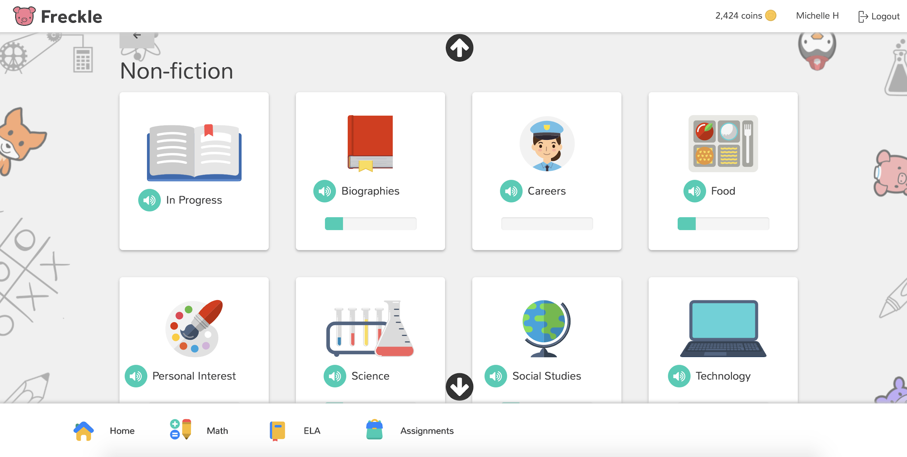
It’s important that your child does this practice independently, without any help. If they are having difficulty with a concept, and the video tutorials on the site do not help, your child may go on to a different section.

Thank you for supporting your child’s summer learning!

Sincerely,
The Westover Math Team

To access Freckle on a computer, go to https://student.freckle.com/#login
They should use their first and last name and the teacher classroom code.
More websites to use to explore Math
http://www.allmath.com/ This site has flash cards and links to other sites for games, math humor, worksheets, math help and more. http://www.aplusmath.com This site has basic facts flash cards and a game room, worksheets, multiplication table practice and more. http://www.mathfactcafe.com This site has a pencil next to pre-made cards so kids can do the facts and have the computer check them. Kids can print them out and also put in their own numbers and make their own worksheets. http://www.funbrain.com This site has easier to harder addition and subtraction computation and problem solving. It also has language and grammar skills activities http://www.dositey.com/ This site is a lot of fun and is good for 2 digit addition with and without regrouping http://www.24game.com This site has math games using basic operations http://www.coolmath4kids.com This site has a wide range of topics and will give you step-by-step instructions. http://www.abc.net.au/countusin/games Each game is designed to help kids understand basic concepts in math. This site has a variety of math games i.e. volume, length, halves, chance, numbers, time, sorting, subtraction, and addition. It is better for students of the primary grades. http://www.learningplanet.com This site has games by grade level but with advertisement and a subscription. There are some free games. https://www.multiplication.com/games/all-games

