Grade 2 going into Grade 3 Summer Math Calendar
 | ~ July 2019 ~
Monday | Tuesday | Wednesday | Thursday | Friday | Saturday |  | Sunday
1  Mrs. Glawe has $10.00 to spend for her lunch. If she buys a salad for $5.25, a drink for $1.25, and an apple for $0.50, then how much money will she have leftover? Will she have enough to purchase a cookie for $0.75? | 2  Write a math word problem for another family member to solve. Try to make it a 2 step word problem. | 3  Complete the fact family for:  8 x 7 = 56  _______  _______  _______ | 4 | 5  Write your numbers by 5’s from 1 - 100. | 6  Use the numbers  2, 3, 1, and 7 to write the largest number and then the smallest number. Explain to a family member how you know you have made the largest number. |  | 7  Find an analog clock (a clock with a face) and read the time of day to a family member.
8  Position the numbers 1-12 so that each row and diagonal has the sum of 26.  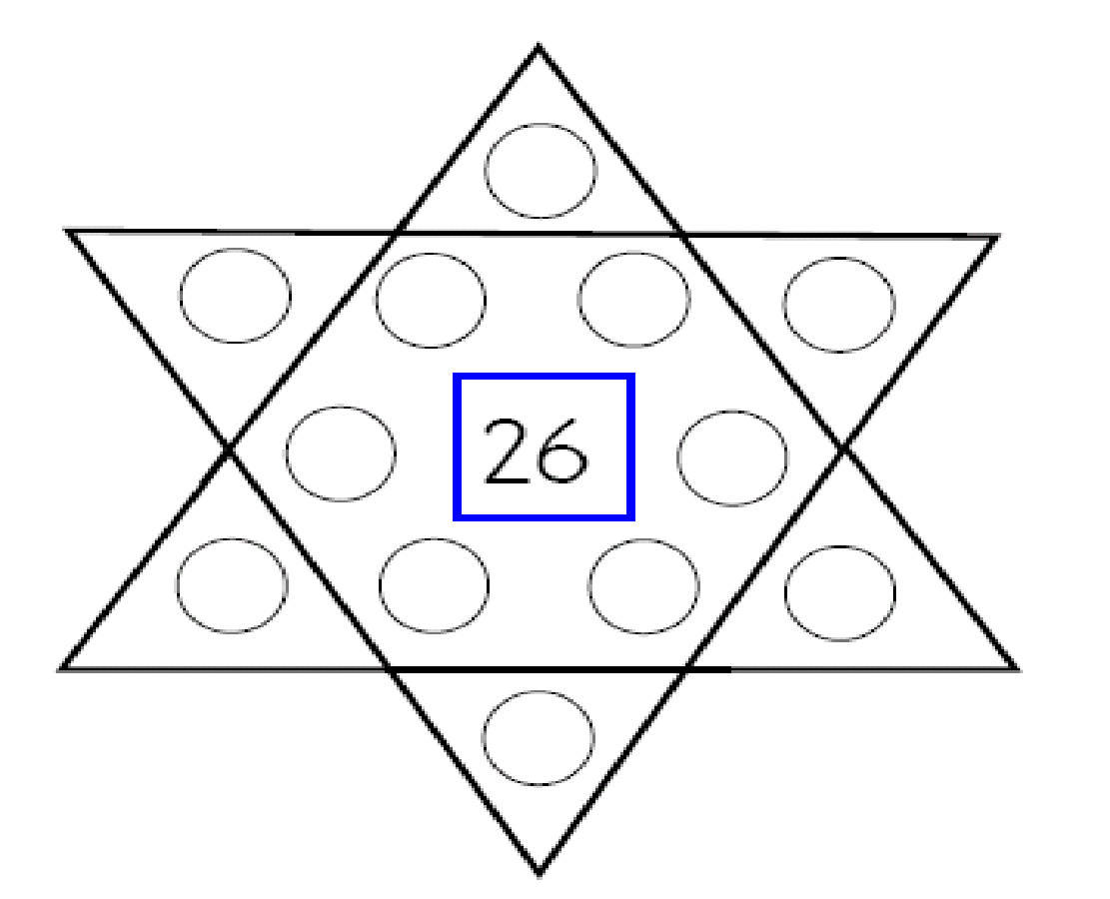 | 9  Look around your house and identify geometric 2 dimensional shapes (polygons, quadrilaterals, pentagons, hexagons, triangles, and octagons). Identify their attributes (sides, faces, corners) | 10  Look around your house and identify solid shapes this time (rectangular prism, sphere, cone, cylinders). | 11  Compare each pair of numbers. Write the correct comparison symbol (> or <) in each circle.  124 O 134  585 O 576  613 O 631 | 12  Make as many different arrays as you can with the number 18. Write a number model for each array.  For example for 12:  xxxx  xxxx  xxxx  4 + 4 + 4 = 12 | 13  Solve 432 + 318 using the strategy Addition Split:  Example: 146 + 235  100 + 40 + 6  +200 + 30 + 5  300 + 70 + 11 = 381 |  | 14  Below is part of a hundreds chart. Fill in the missing numbers.  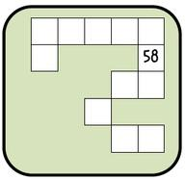
15  Use the numbers  87, 48, 59 and 79 to write the largest number and then the smallest number. Explain to a family member how you know you have made the smallest number. | 16  Solve 85 – 47 using the strategy Subtraction Split:  Example: 96 – 58  80 + 16  -50 + 8  30 + 8 = 38 | 17  Write your numbers by 10’s from 1 - 100. | 18  Play Buzz by picking a number between 1 and 10. Take turns with a family member counting and every time you get that number or its multiple you need to say buzz instead of the number or you are out of the game. | 19  While doing some summer reading, note what page you started reading from and what page you ended on. What is the difference? | 20  Compare each pair of numbers. Write the correct comparison symbol (> or <) in each circle.  915 O 951  188 O 197  411 O 401 |  | 21  Complete the fact family for:  7 x 4 =28  _______  _______  _______
22  Write a multiplication word problem for another family member to solve. | 23  Mrs. Teske needs to buy her daughter some socks for college. She has $10 and the socks cost 6 pairs for $9.95. How much money will she have leftover once she buys the socks? | 24  Make as many different arrays as you can with the number 24. Write a number model for each array (For an example see July 18). | 25  Give your child a handful of change and ask them to count it. Take one more handful, count and compare the two amounts. Which is greater? Less? | 26  Solve 483 – 334 using the strategy Subtraction Split:  Example: 764 – 436  700 + 50 + 14  -400 + 30 + 6  300 + 20 + 8 = 328 |  | 27  Verbally name a specific amount ($0.25). Build sets to show that amount. How many different coin combinations can be made? Which combination uses the fewest number of coins? |  | 28  Solve 53+38 using the strategy Addition Split:  Example: 32 + 18  30 + 2  +10 + 8  40 + 10 = 50
29  Place the numbers 1-6 in each circle once making sure that the sums of each side match the sum of the other sides. | 30  Take a handful of coins. Sort them by name and create a bar graph to show your data. Remember your graph must have a title and labels on each axis. Write 3 facts that you notice about your data. | 31  Complete the fact family for:  4 x 5 = 45  _______  _______  _______ | Welcome to the summer math calendar for students entering Third Grade. This calendar is recommended, but not required. Reviewing learned skills will maintain the foundation for math success at the next grade level. The design of the activities on this calendar is meant to support instruction in the Curriculum 2.0 in both its content and presentation. Therefore, the activities are not to be done as independent problems, but to be worked on with a parent, guardian or older brother or sister. Talking about the problem is an important part of completing each activity. On the back of this calendar are suggested math websites. Choose at least 2 days each week to also play on a website.  NAME:

Dear parents,
We are excited to announce that this school year, we’ve been using a software program in the classroom called Freckle. Freckle allows students to practice Math at their own level.This program will help all students to improve their mathematics skills.

I would encourage you to support your child’s continued practice in Freckle over the summer. This will help them maintain the progress they have made over the school year and keep their skills sharp!

You and your child can access Freckle at home in two different ways:
1. Online at www.freckle.com using Google Chrome as your browser, selecting “Student sign in” at the top of the page.
2. On an iPad with the free app: www.freckle.com/app
Your child’s login information is attached to this letter. You do not need to create a new Freckle account; your child will simply log into their existing account and continue practicing where they left off in the classroom.

Once they have logged in, they can choose to practice Math or ELA with a variety of different activities, such as reading articles, practicing math facts, and more. Summer is a great time for students to explore any or all of these activities at their own pace!
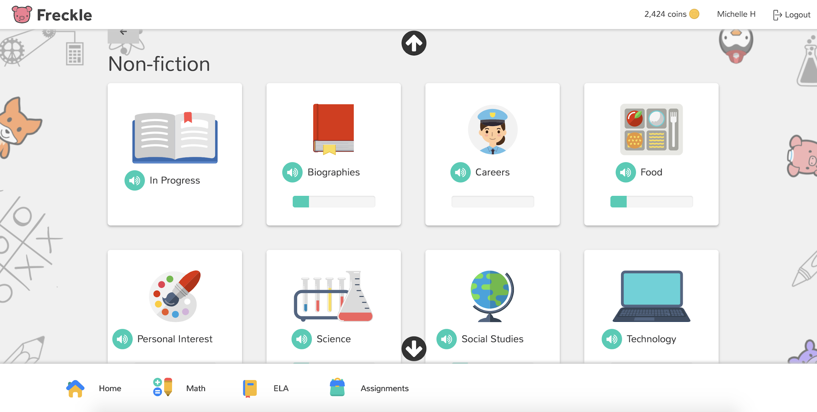
It’s important that your child does this practice independently, without any help. If they are having difficulty with a concept, and the video tutorials on the site do not help, your child may go on to a different section.

Thank you for supporting your child’s summer learning!

Sincerely,
The Westover Math Team

To access Freckle on a computer, go to https://student.freckle.com/#login
They should use their first and last name and the teacher classroom code.
More websites to use to explore Math
http://www.allmath.com/ This site has flash cards and links to other sites for games, math humor, worksheets, math help and more. http://www.aplusmath.com This site has basic facts flash cards and a game room, worksheets, multiplication table practice and more. http://www.mathfactcafe.com This site has a pencil next to pre-made cards so kids can do the facts and have the computer check them. Kids can print them out and also put in their own numbers and make their own worksheets. http://www.funbrain.com This site has easier to harder addition and subtraction computation and problem solving. It also has language and grammar skills activities http://www.dositey.com/ This site is a lot of fun and is good for 2 digit addition with and without regrouping http://www.24game.com This site has math games using basic operations http://www.coolmath4kids.com This site has a wide range of topics and will give you step-by-step instructions. http://www.abc.net.au/countusin/games Each game is designed to help kids understand basic concepts in math. This site has a variety of math games i.e. volume, length, halves, chance, numbers, time, sorting, subtraction, and addition. It is better for students of the primary grades. http://www.learningplanet.com This site has games by grade level but with advertisement and a subscription. There are some free games. https://www.multiplication.com/games/all-games

