Grade 1 going into Grade 2 Summer Math Calendar
 | ~ July 2019 ~
Monday | Tuesday | Wednesday | Thursday | Friday | Saturday |  | Sunday
1  Write the numbers that are 10 more and 10 less.  10 less 10 more  15  36 | 2  Draw a square.  Describe the square. Use the words: sides, angles, equal. | 3  Determine if the equation is true or false.  6 + 8 = 16  True False  Explain your thinking. | 4 | 5  Jane baked 16 cakes. She baked 7 fewer cakes than Serene. How many cakes did Serene bake?  _________ | 6  Write the correct time.  ____________  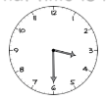 |  | 7  Dave saved three nickels, one quarter and two dimes. How much money did he save altogether?  ___________
8  Circle the shape with two equal shares. Explain your thinking. | 9  A has 2 wheels.  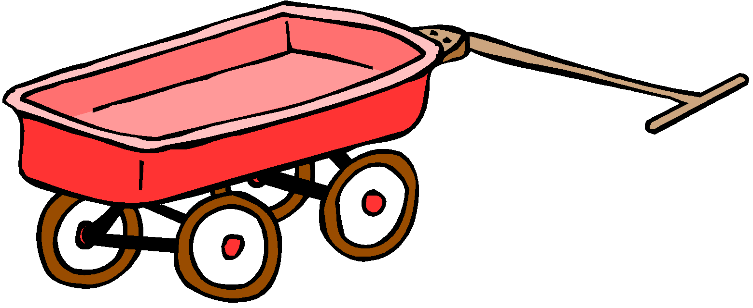  A has 4 wheels.  How many wheels are on 1 bike and 2 wagons?  _________ | 10 Write four related facts using the three numbers  [ 7, 4, 11 ]  ________+ ______ = ______  _______ + ______ = ______  _______ - ______ = _______  _______ - ______= _______ | 11  List the objects from 1 (shortest) to 3 (longest)  ____  ____  ____ | 12  Solve for the unknown.  _____ + 7 = 14  18 - _____ = 8 | 13  Identify two attributes that could be used to describe this shape.  ________________  ________________ |  | 14  Harris has 6 stickers. He buys 3 more stickers every day. How many days does it take him to collect 18 stickers altogether?  ______________
15  Draw a triangle.  Describe the triangle. | 16  Circle the number that is 10 less than 47.  56 37 57 32  Explain your thinking. | 17  Write <, > or = in the blank below.  45 _____ 40 + 5  25 _____ 35 – 7 | 18  Write an addition word problem for another family member to solve. | 19  Circle the shape partitioned into 4 equal parts. Explain. | 20  Complete the equations.  8 + 6 =  13 – 4 =  10 + 4 =  18 – 5 = |  | 21  There are 15 scarves. 6 of them are green and the rest are yellow. How many yellow scarves are there?  ___________  Explain how you know.
22 Solve for the unknown.  _____ + 4 = 12  20 - _____ = 6 | 23  Rope P is 14 units long. Rope Q is 8 units shorter than rope P.  How long is rope Q?  ______________________  What is the total length of rope P and rope Q?  ______________________ | 24  I wake up at ___________.  Is it am or pm. How do you know? | 25  Write <, > or = in the blank below.  15 _____ 32  50 + 3 _____ 60 – 7 | 26  CHALLENGE  Yesterday was Thursday.  What is four days after tomorrow? Explain your thinking. |  | 27  Write a subtraction word problem for another family member to solve. |  | 28  Fill in the missing numbers.  49, ____, ____, 46, ____  ____, 25, ____, 29, 31  Make your own pattern.
29  Drake had 18 crayons. He gave 2 crayons to Nicky. How many crayons does he have now?  _____________ | 30  Identify the number that makes the equation true.  27 + 4 = ____  15 47 31 | 31  Rick had some pencils. A  friend gave him three more  pencils. Rick has eleven  pencils now. How many  pencils did Rick have  before? | Welcome to the summer math calendar for students entering Second Grade. This calendar is recommended, but not required. Reviewing the learned skills will maintain the foundation for math success at the next grade level. The design of the activities on this calendar is meant to support instruction in the Curriculum in both its content and presentation. Therefore the activities are not to be done as independent problems, but to be worked on with a parent, guardian or older brother or sister. Talking about the problem is an important part of completing each activity. On the backside of this calendar are suggested math websites.  NAME:

Math Websites
Use the following websites to practice a variety of first and second grade math topics:
- AAA Math http://www.aaamath.com/
- A+ Math https://www.varsitytutors.com/aplusmath
- Arcademics https://www.arcademics.com/games/
- BBC Bitesize https://www.bbc.com/bitesize/learn
- Fun 4 The Brain https://fun4thebrain.com/
- Gamequarium http://www.gamequarium.org/dir/Gamequarium/Math/
- Math Playground https://www.mathplayground.com/
- National Library of Virtual Manipulatives http://nlvm.usu.edu/en/nav/vlibrary.html
- ICT Games http://www.ictgames.com/resources.html
- ABCya https://www.abcya.com/
- Learning Box http://www.learningbox.com/Base10/BaseTen.html
- http://www.math-play.com/Elementary-Math-Games.html

