We are a united, multi-cultural community of students, families, and educators committed to cultivating a love of learning, developing the character of great people and empowering children with the knowledge and skills to become productive citizens in the 21st century.

Gator Gazette
November 2012

Glenallan Elementary School
“Where Gators Go Above and Beyond”
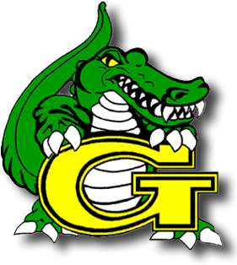

Dear Glenallan Families,

Time continues to move fast and we must capitalize on every minute of the school day. Our first quarter has been outstanding, we are seizing every day of instruction and your children seize every learning opportunity. This is a reflection of the messages and modeling that you do at home that communicate the importance of education. October, of course, ended with our Halloween celebration and parade. The students enjoyed this experience once again, and we are pleased we had the opportunity to provide it. Their happiness and positive attitudes leads to them excelling, not just in the classroom, but as people. A positive attitude breeds success not just for themselves but for the people around them. It is an attitude which separates excellence from mediocrity.

The month of November ends with Thanksgiving. Happy Thanksgiving to you and your families! Thanksgiving marks the occasion of two very different people coming together to sit down at one table and feast together. Glenallan is made up of so many different types of people, and our biggest strength lies in our diversity. Your student not only receives a great education but has the fortunate experience of learning from and growing up together with so many different children. As we consistently tell the Glenallan students learning can take place anywhere. Your student not only receives a great education but has the fortunate experience of learning from and growing up together with so many different children. As we consistently tell the Glenallan students, learning can take place anywhere. We encourage our students to always be listening carefully to the words of people inside and outside of school because everyone you meet knows something that you don't. Be willing to learn from them. If we are not learning, we are not living. On November 22nd, our families will sit down in a similar way that was done almost 500 years ago on the first thanksgiving. This is a great opportunity to reflect on how fortunate we are to share a community purpose, the success and wellbeing of the Glenallan children.

This year, I am extremely thankful to be a part of such a dedicated and hardworking staff. The Glenallan staff is committed to providing an environment where all children and families are valued and where dynamic instruction and diversity in learning opportunities is thriving. I am thankful to be part of a community made up of different cultures that has all embraced the great responsibility of shaping the minds and influencing the character of the children of Glenallan. I am thankful for the opportunity I have to contribute to your children becoming smarter and learning life’s valuable lessons. I thank you for your on-going support and encouragement of our goal of “every gator going above and beyond” as students and people.

Respectfully,
Mr. Moran

A School Where Character Counts
Congratulations to those Students that earned Character Counts for the month of October, when we focused on the character trait RESPECT.
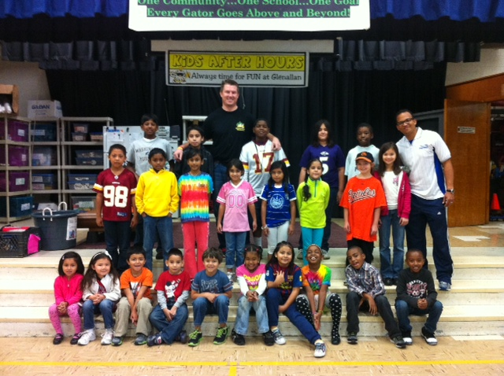
One School, One Community, One Goal……….The Success of Every Glenallan Gator


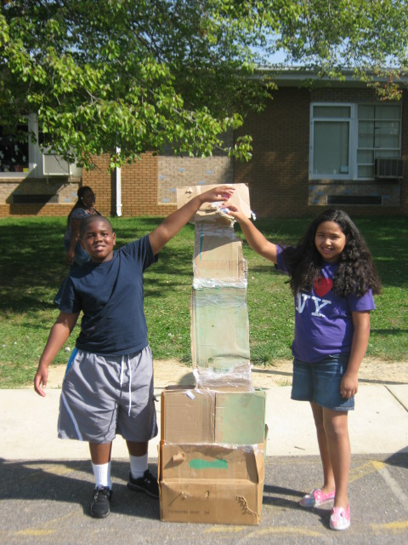
News from Kindergarten-Ms. Yetter, Ms. Ziadi, Mrs. Frank, Mrs. Beckett, and Ms. Ali
The kindergarteners have made incredible progress since the beginning of the school year. We have begun pulling small reading and math groups to really focus on the student’s individual skills and needs. Continue to work at home on the kindergarten word wall words, letters, letter sounds, and numbers 1-30. They have all become masters at patterns, sorting, and graphing. We have begun with the writing process, focusing on using spaces between our words, starting with an upper case letter and the rest of the sentence is lowercase, and using a period at the end of a sentence. We have been exploring the water cycle, types of clouds, and the weather in fall.

We look forward to meeting with you at parent teacher conferences in the beginning of November. If you have not scheduled a conference time please contact your child’s teacher. Thank you for all your dedication and hard work to support your child’s learning and progress.

The Kindergarten Team
PS. READ EVERY NIGHT!!!!

News from First Grade – Mrs. Correa, Mrs. Ralph, Mrs. Lozzi, Ms. Rodriguez and Mr. Cord
The first grade is very excited for the month of November. This month we will begin our focus on customs and cultures in our classrooms and around the world. Having a diverse community is something to be celebrated and be proud of. This focus will bring that pride to the classroom. Also in this month, the first grade will begin Words Their Way. This is a program that focuses on the student as an individual and what they need to strengthen to become a better writer. Words Their Way will be incorporated in the classrooms and at home, so be looking for notices on when that will start in your classroom. Math will go further into depth regarding addition and subtraction in various ways. More emphasis will be put on word problems and place value in the month of November. The day is always busy but it is important to remember, asking questions about any subject is a great tool you can use at home. Math problems can be made up on the spot using anything from food to the envelopes in the mail. Asking your child to read a word from your book, newspaper, or magazine can have them feel pride knowing they are helping you, and give you pride seeing them succeed. Our goals as teachers and guardians will always be the same; help your child grow and succeed as much as possible.
News from Second Grade – Mrs. Navas, Mrs. Johnson, Mrs. Grotewold, and Mrs. Treichler
Second graders have been very busy this month! Here are some highlights from our classrooms: Students have collected data and created graphs to show the data. They have also analyzed graphs to explain the information shown. One of our favorite graphs was about the number of pockets each child had on their clothing. In science, students have learned about landforms around the world, landforms and regions of Maryland, and landforms on the ocean floor. Learning about the ocean floor has been especially interesting. Teachers have incorporated many hands on activities to help students learn and remember these concepts. Second graders have become experts on the food guide pyramid. They can describe each food group and explain why it is important for health. They are currently in the process of creating projects to share their knowledge with others. Parents, please support your child with their homework by providing your child with a quiet space and time to work. Also, please help your child remember to bring their folder and homework journal every day.

One School, One Community, One Goal……….The Success of Every Glenallan Gator

Glenallan Elementary School
“Where Gators Go Above and Beyond”

Gator Gazette
November 9, 2012

News from Fourth Grade- Mrs. Mayer, Ms. DeFrehn, and Mrs. Hubbard
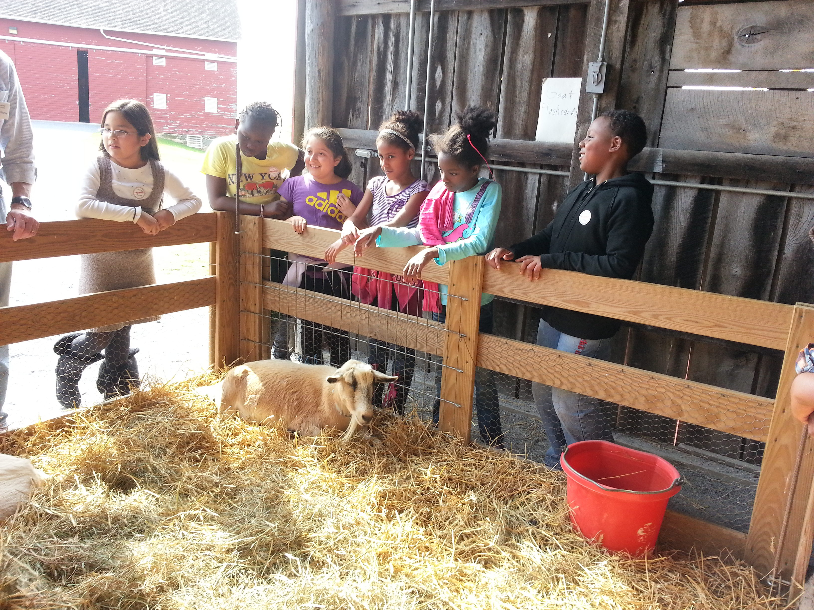
Fourth grade student learned about plants, animals, and nutrition when we visited The Agricultural History Farm Park.
Please be sure to come to your scheduled parent/teacher conference. It is important that you contact your child’s teacher if you are unable to attend.
Counselors Corner 
Mrs. Lyons
School Counselor
For the month of October we focused on the character trait RESPECT. Respect is an important character trait which emphasizes treating others the way you would want to be treated which is the Golden Rule. Being respectful can support success throughout one’s life. When a child displays respect for themselves and others they are demonstrating politeness, courtesy, good manners, showing consideration and valuing the property of other people. As a school we can teach children respect, but parents have the most influence on how respectful children become.
Parent Tip: Children learn from everything we say and do. Make sure that you are modeling respectful behavior. Dr. Robyn Silverman states there are things a parent can do to teach their child respect. 1. Model the behavior if you want your child to be respectful you have to do it to. 2. Expect the behavior when your expectations are high children rise to the occasion 3. Teach the behavior by giving children the tools they need to show respect, 4. Praise the behavior, when you see or hear your child using respectful language of making respectful choices recognize it, 5. Discuss respect with your child when, where and if you see the behavior, 6. Correct it, be strong, firm and direct when teaching respect 7. Reward the respectful behavior with an intangible reward like privileges, extra responsibilities. Teaching respect is a process that takes patience but as long as you’re consistent your child will ultimately receive the benefits.
Character Counts October Respect
Beckett- Miguel Paz Garcia Cord- Cecilia Jean Rodriquez- Ines Evehe
Frank- Nataly Reyes Yetter- Christopher Acuna Johnson- Reena Smith
Edhegard-Druva Tharmalingam Langrock-Maddie Gottshall Treichler- Yuliza Saravia Escobar
Navas- Jackson Mackinnon Ziadi- Adriana Amaya Ali- Alex Vanegas
Ralph- Stefano Gasasira Correa- Thelma Enriquez Lozzi- Christopher Regis
Grotewold-Pratiksha Das Davies- Asini Gulanawatthalage Gottshall-Coralani Yuen
Mayer- Eric Staley Defrehn-Velvet Peace Hubbard-Soriya Morn
Jameson-Maysarah Sungkar Billings-Eduardo Ramos Leitzel- Shaun Allahrakha
One School, One Community, One Goal……….The Success of Every Glenallan Gator

We are a united, multi-cultural community of students, families, and educators committed to cultivating a love of learning, developing the character of great people and empowering children with the knowledge and skills to become productive citizens in the 21st century.

Gator Gazette
November 2012

Glenallan Elementary School
“Where Gators Go Above and Beyond”

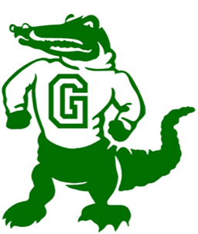

Reading Strategies and Tips from the Reading Team
Mrs. Raiford and Ms. Smith
When you and your child are reading together, what strategies do you notice he or she is using? Are they stretching out their words, skipping words and going back, and asking themselves if what they read makes sense? Below is a list of strategies your child uses in school. Please encourage your child to use these strategies when reading with them!
Message from Math Content Coach – Mrs. Stewart
We are preparing our children to become strategic and creative problem solvers in all academic areas. All staff members challenge students through questioning that requires students to explain their reasoning and go deeper into the content. In math, teachers facilitate student discussion to uncover and explore many strategies student will apply throughout the year. At home, continue this discussion by asking your child to explain and “teach you” about what they are learning in math. Listen to their thought processes and strategies – you will be amazed and you might even learn something new!
News from Grade 3 – Ms. Davies, Ms. Edhegard, Ms. Langrock, and Ms. Gottshall
The students in third grade are making great progress! Here are some ways that you can help your child at home. Please continue to:
- Check your child’s homework folder each day and encourage your child to do his/her best work.
- Complete and return important forms promptly.
- Take interest in what your child is reading. Ask questions about the reading and provide your child with positive feedback about their reading.
Daily Homework consists of: a math sheet, spelling activities, and reading for 20 minutes.
Reminder: Parent/Teacher conferences are being on held on Monday, November 12th and Tuesday, November 13th (or another date if previously arranged with the teacher). Please be sure to confirm your conference with your child’s teacher as soon as possible.
Field Trips: Please mark your calendar for our two upcoming field trips. On Monday, November 19th, we will visit the College Park Aviation Museum and on Monday, December 10th, we will travel to Toby’s Dinner Theater to see “Alexander”.

Fun learning experiences: Some education activities you can share with your child this November are to read family recipes together and when you are grocery shopping, your child can estimate costs of Thanksgiving dinner items.
As always, please let us know if you have any questions or concerns!
One School, One Community, One Goal……….The Success of Every Glenallan Gator

Glenallan Elementary School
“Where Gators Go Above and Beyond”

Gator Gazette
November 9, 2012

MUSIC – Mr. Tilkens 
Music Notes: November
In all my classes we have been learning songs by Carl Orff. I tell students that we learn about Carl Orff because he was a man who really understood children and made music class more fun! Orff believed that children learn best when they are doing what they love to do: play games! Orff composed multiple books of music just for elementary school children and we have been playing some of the spookier selections for October.
My Kindergarteners see me in the hallway and cannot stop singing “The grizzly bear song”. We’ve also been learning different songs about pumpkins and leaves for Fall.
First grade is getting a good dose of Patriotic songs in music and in their homeroom classes, due to our new curriculum. We have also been very excited to practice our un-pitched rhythm instruments: Wood block, triangle, maracas, tambourine, hand drum and claves.
Ask your Second Graders to name all four of the families of the Orchestra, I bet they can! We have been busy preparing for our trip to the Strathmore coming up in November and they will be sent home with their own “Guide to the Orchestra” packet soon.
Third grade continues to impress me! We are working on our “Do-re-mi” hand signs and we have been singing “Egy Uveg Alma”, a counting song in Hungarian.
Fourth Grade learned that “Ostinato”, which literally means “stubborn”, is sometimes a good thing in music. We have been practicing our Ostinati on Xylophone and Metallaphones. Ask them to tell you what “Pinch, wrap, ride” means.
My Fifth Graders have been doing a good job of handling some of Orff’s “trickier” selections on the xylophone and metallaphones and are in the middle of learning about the piece, “Danse Macabre” by the French composer, Camille Saint-Saens.
MEDIA CENTER – Mrs. Bean and Mrs. Marley-Emery 
The upper grades will be beginning inquiry projects in November. 4th graders will be researching Native Americans and 5th graders will be learning about countries around the world. They will use our online resources and books to gather information. Some databases available to them are World Book, Culturegrams, and Britannica Online. Look for a pamphlet coming home with your students that has usernames and passwords to access these services at home.
Third graders are creating Power Point presentations to share their community projects. They chose a community or health topic to investigate and take notes on. Their presentations will include a pledge statement, factual information, and images.
The primary grades are learning the difference between fiction and nonfiction books. The little ones love choosing their own and learning about where to find their favorite topics (dinosaurs and princesses are just a few of their favorites). They continue to amaze me with their excitement and love of books.
ART – Mrs. Vanegas
We have been very busy in art continuing to learn about the art elements and principles of design. Kindergarten is learning how to draw trees; first graders are using geometric shapes to make animals. Second graders are inspired by the artist Carl Warner and are creating landscapes using pictures of food. Third grades are about to experience the magic of shrink art. Fourth graders are making digital art by learning how to manipulate pictures
in word and pixie. Lastly 5th grade just finished their clay tiles and are working on designing a bracelet or cuff "wearable art".

One School, One Community, One Goal……….The Success of Every Glenallan Gator

One School, One Community, One Goal……….The Success of Every Glenallan Gator

Glenallan Elementary School
“Where Gators Go Above and Beyond”

Gator Gazette
November 9, 2012

Glenallan Elementary School
“Where Gators Go Above and Beyond”

George B. Thomas Saturday School


November 8 5th Grade to Georgetown University
November 12 Half Day for Students: Dismissal 1:15
November 13 Half Day for Students: Dismissal 1:15
November 14 McDonald’s Night 5:00 – 8:00
November 17 Mobile Dentist Lab
November 20 2nd Grade Pot Luck Dinner 6:00 – 7:30
November 21 Half Day: Thanksgiving Holiday
November 28 2nd Grade to Strathmore
Character Counts:
The character trait for the month of November is Gratitude. Staff will be looking for students demonstrating respect at school, in the community, and focusing on it through instruction.

Hats and Gloves
If you are in need of hats or gloves, come to the office and see Mrs. Hirst or Mrs. Brashers

The core program of the George B. Thomas, Sr. Learning Academy, Saturday School offers tutoring and mentoring in reading/language arts, mathematics, and test-taking skills for students in grades 1-12. It takes place Saturday mornings from 8:30 to 11 a.m. at Kennedy High School. Currently, Glenallan ranks in the top 5 elementary schools to participate in this program.
Important Dates for the Gators in November
PTA Updates
Thank you for all the support from many families this year. We’ve had several successful events and they could not happen without everyone’s participation. Please remember to try and volunteer at least two hours per marking period per family.
Membership - Currently we have 40 enrolled in the PTA. As a reminder PTA membership helps us provide this to the children such as assemblies, additional items needed in the classroom and funds for those who cannot pay the full amount for field trips. Please send your $10 with the form into school. The forms can be found on the PTA website http://www.montgomeryschoolsmd.org/schools/glenallanes/pta/
Brick sales – engraved bricks that will be placed at the new school will be on sale till December 1st

A Conversation about the MCPS Budget
The Board of Education would like to hear from you concerning the values that should guide the school system. Parents, students, staff and community members are invited to participate in a Community Conversation with the Board of Education.
The information gathered during this event is an important part of the Board’s strategic planning and budget processes.
Wednesday, November 14, 2012, 7 – 9 p.m.
Richard Montgomery High School, Cafeteria
250 Richard Montgomery Drive
Rockville, MD 20852

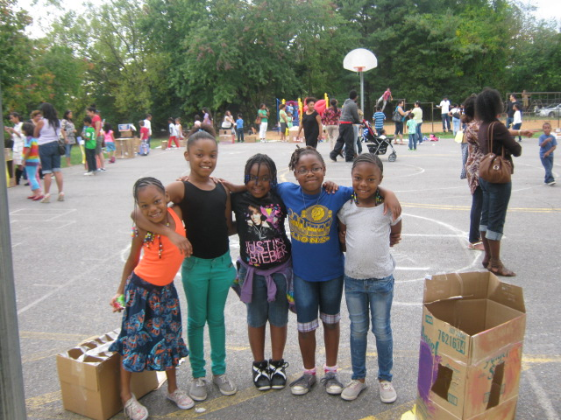

As we express our gratitude, we must never forget that the highest appreciation is not to utter words, but to live by them.
John F. Kennedy

