Vision: We are a united, multi-cultural community of students, families, and educators committed to cultivating a love of learning, developing the character of great people and empowering children with the knowledge and skills to become productive citizens in the 21st century.

Gator Gazette
February 2013

Glenallan Elementary School
“Where Every Gator Go Above and Beyond”


Dear Glenallan Families,
The month of February marks many things in which our community can take pride. Recently, I had the opportunity to speak with our Board of Education members, the Superintendent, and our PTA and community leaders. Often our opportunities to engage in conversations with those that make decisions about the funding, resources, and policies that impact us are limited. I took great pride in describing the things that make our community extraordinary: the persistence and motivation of our students that result in their academic excellence, our diversity, our efforts to develop a school that reflects a collective and community voice, and our parents and teachers who believe that each day is an opportunity to prepare our students for successful and happy lives. Three things that I specifically presented were increased student engagement in the classroom as we promote and share creativity through high energy planning sessions, increase in students talking and leading discussions, and continuing to make learning relevant to today's learners and reflect their interests through increasing the use of non-fiction/informational texts. I feel fortunate to be able to represent our community in these settings, and not only advocate for what will help build our success but promote the extraordinary things our students are doing each day and the overwhelming support we receive from our parents.

Academic/Character Success to Celebrate
The month of January was filled with evidence of success. In Kindergarten, the teachers have instilled confidence in their students’ ability to read. I continually hear them celebrating their own success saying, “Look what I learned!” or “Watch what I can do.” In Grade 1, I have seen students gain knowledge about our world, about other cultures, land features, and even knowing the names and locations of the continents! Having a global understanding will be important to their success in our society. In Grades 3, 4, and 5, 103 students were recognized for the growth they demonstrated on the MAP-r assessment which assesses their level of reading comprehension. 103 students increased five points or more! Please congratulate them, help them set goals for the remainder of the year, and remind them that each day is a chance for them to become smarter and learn something new! As a school and community, please join me in celebrating our School Performance Index (SPI) which is Maryland’s new system for measuring our success. It is made up of three criteria: student achievement, student growth, and decreasing the gaps in achievement between demographics. Our score was the highest in the Kennedy Cluster and 3rd out of all elementary schools located in Blair, Einstein, Northwood, and Kennedy Clusters! To further this progress, we are submitting our proposal for the most cutting edge technology to support student learning in the new building. I will update you on the specifics in March.

At our mid-year awards ceremony, we gave 125 tee shirts to the students who have been recognized for character in their classes and around the school. I look forward to passing out 125 more at the end of the school year! The importance of character and developing the whole student is a significant focus for us. Please continue to speak to your students about their character and that being a good person is their most important job! Someone recently said to me, that special things are happening at Glenallan. I said you’re right; those special things are the Gators. Have a great February and feel free to visit us!

We are Glenallan!
Mr. Moran
This is what ood Character Looks Like – Congratulations Character Count Winners for January
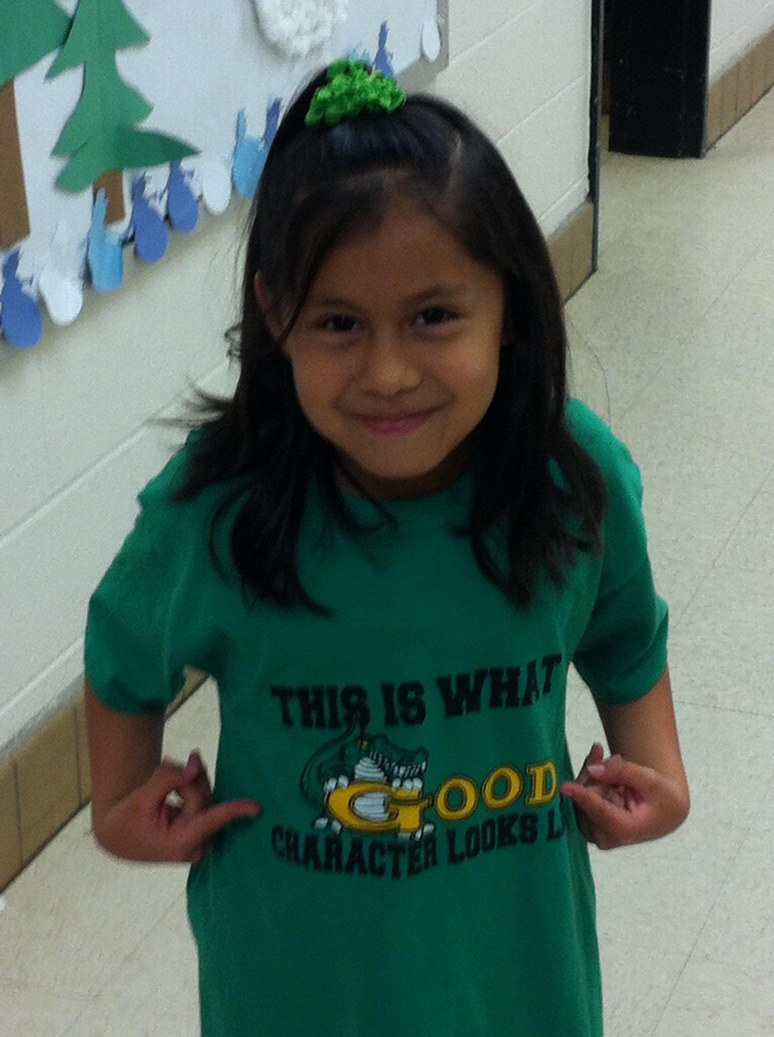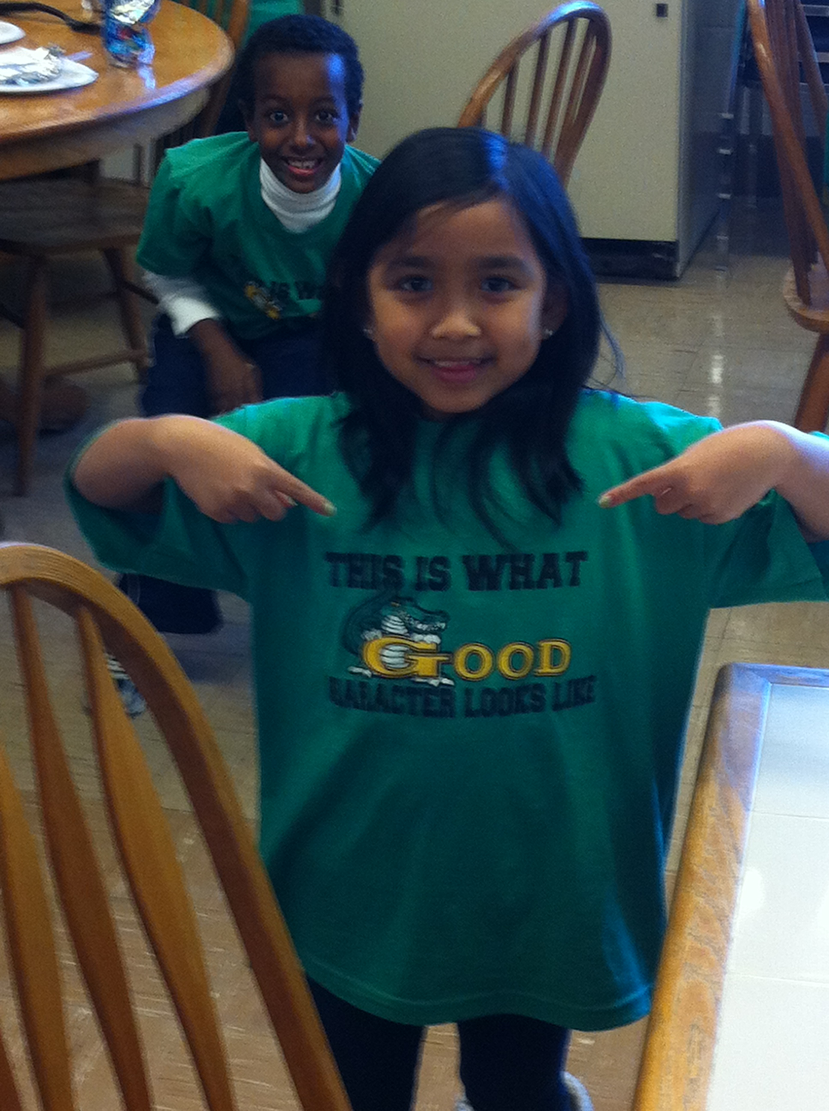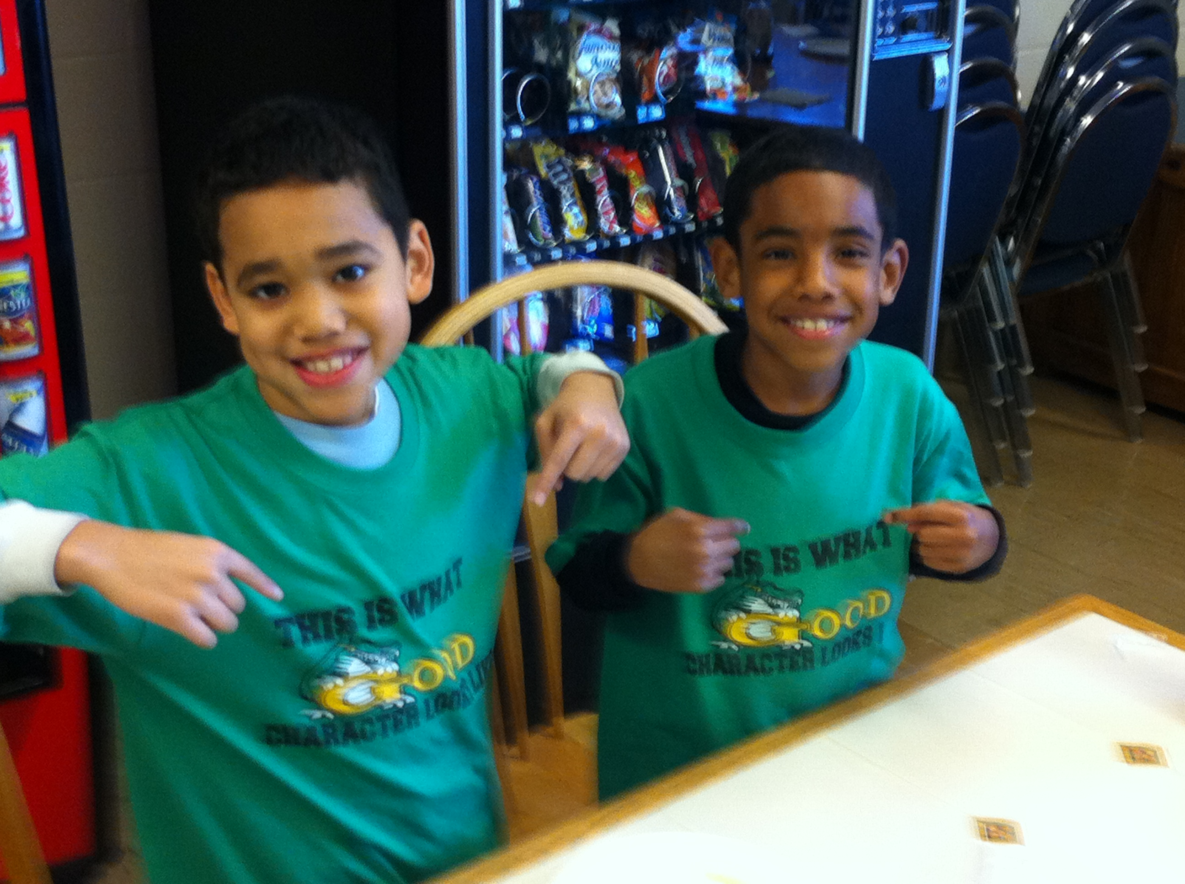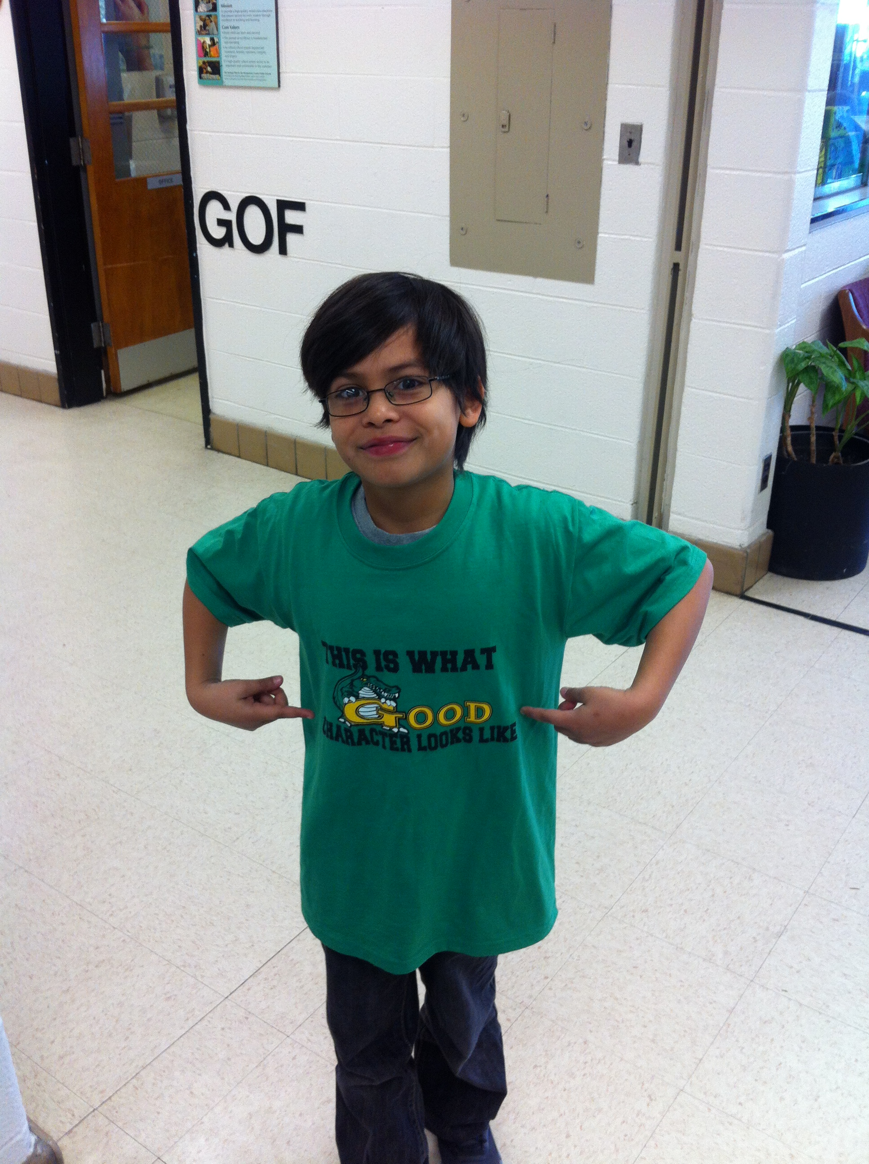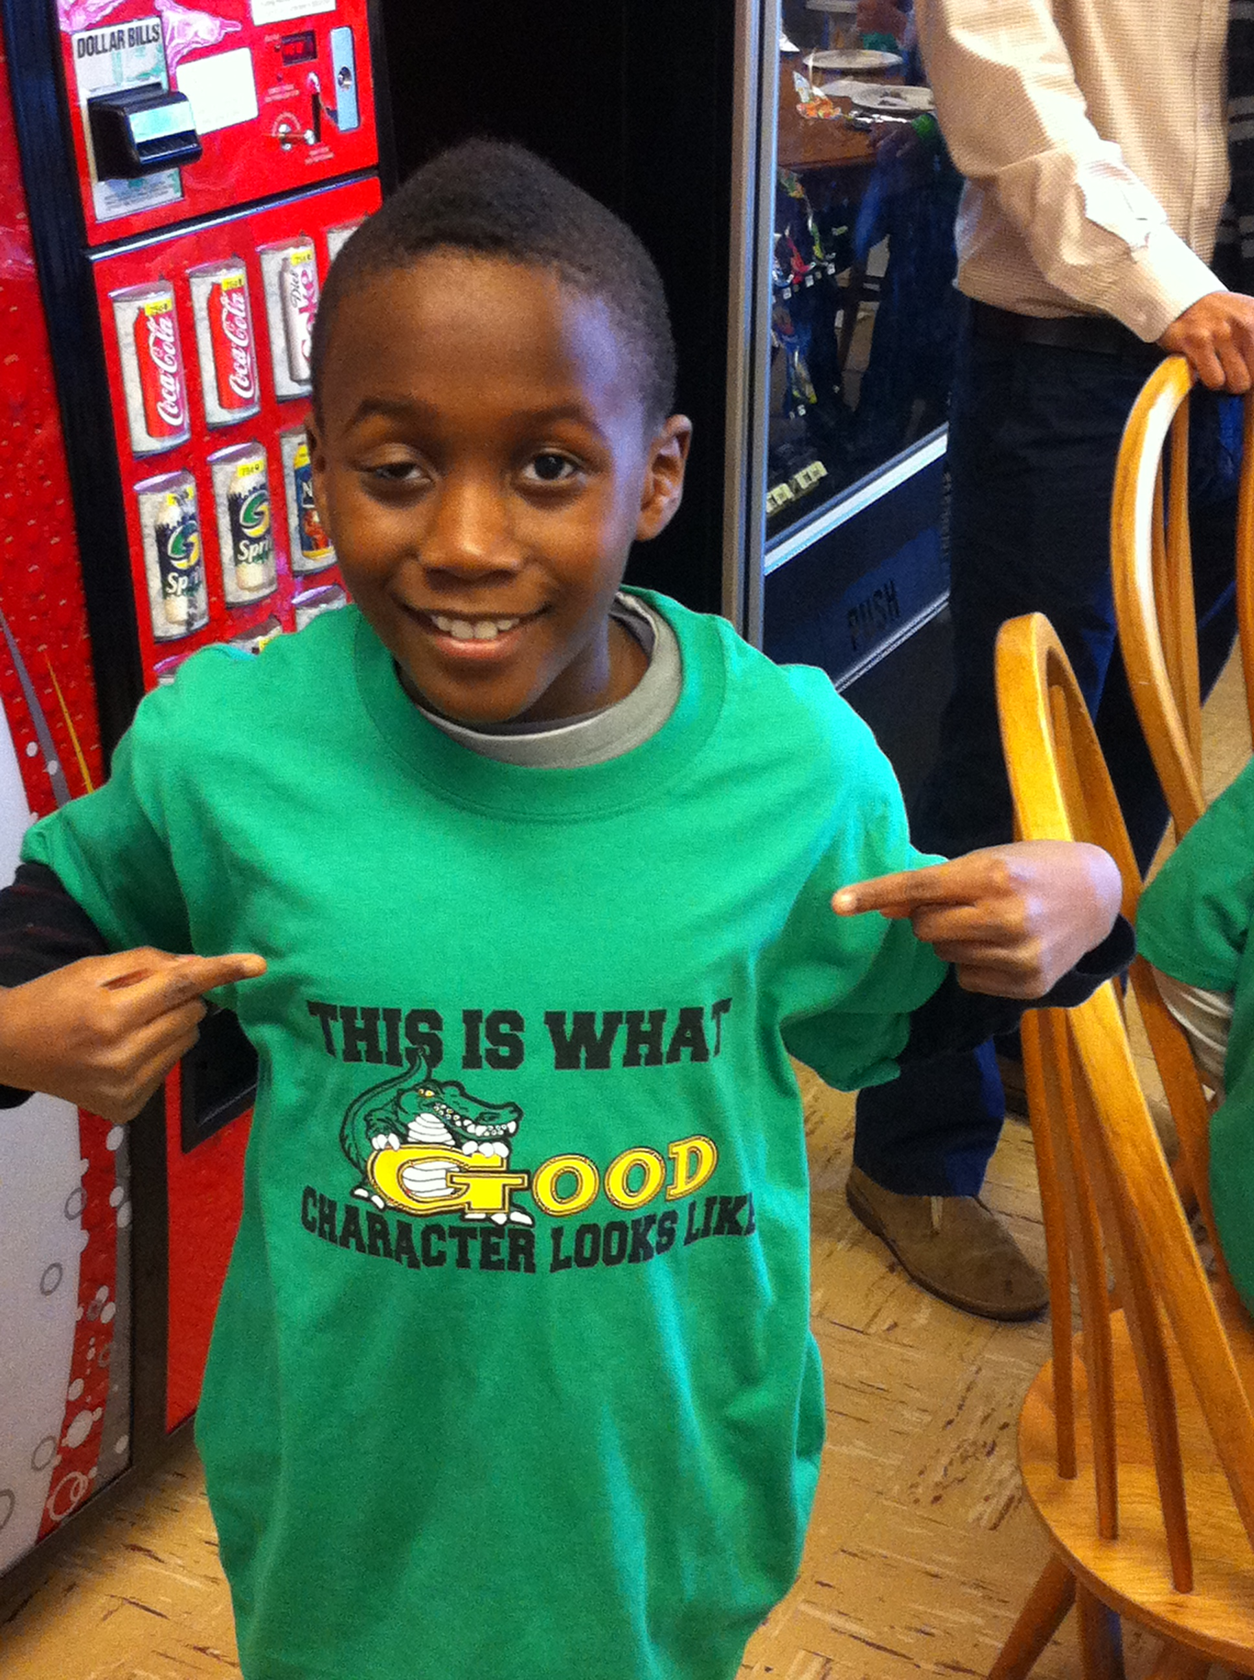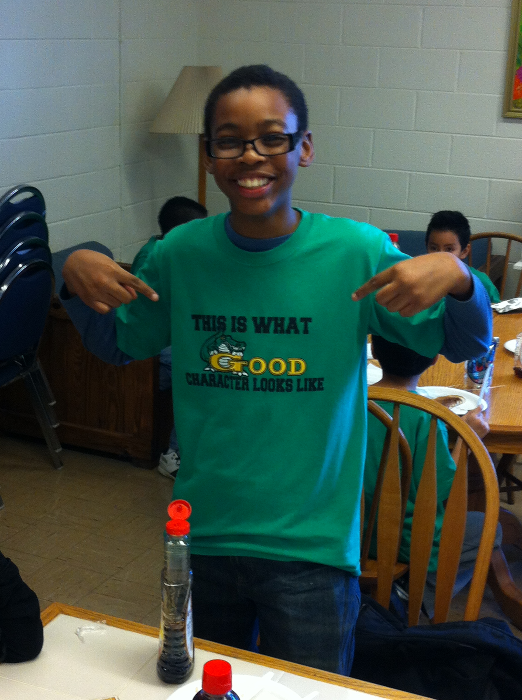
One School, One Community, One Goal……….The Success of Every Glenallan Gator

News from Kindergarten – Ms. Yetter, Mrs. Frank, Ms. Ziadi, Mrs. Beckett, and Ms. Ali
We have been busy bees since the New Year has begun! We have seen so many improvements since the beginning of the school year. Your children are making huge leaps. We are looking forward to the field trip to Lisner Auditorium on February 12th. If you have not turned in your permission slip or money please do so as soon as possible. Please look out for information about the Valentine’s Day party, coming up on February the 14^{th,} donations and volunteers are needed. In reading we are focusing on word families, which are words that all have the same middle and ending sound. For example the –at family has words like cat, bat, splat, and fat. We are also focusing on characters actions and settings in a text. Continue to read with your child every day, discuss the book, look for word wall words, and practice writing the words as well. Our 100th day of school was on February 7th. Ask your child to show you how they can count from 1 to 100, by one’s and tens. Continue to identify numbers, write numbers, and show number combinations. We are half way through the school year and are looking forward to even more growth throughout the rest of the year. Thank you for all your continued support at home and at school!
News from First Grade – Mrs. Correa, Mrs. Ralph, Mrs. Lozzi, Ms. Rodriguez and Mr. Cord
1st grade is excited to start the third quarter! We have seen great progress in our students from the beginning of the year until now. First grade teachers are proud of the accomplishments students have made and we expect more great things as the school year continues. Please utilize addition and subtraction flashcards at home to increase fluency of basic math facts. Students are using appropriate reading strategies learned thus their ability to read independently has grown tremendously. It is imperative that your child knows his/her sight words in order to continue this growth. We are asking for volunteers to assist first graders as they participate in a bread making activity here at Glenallan Elementary School. The date for this activity is February 21, 2013 at 9:45am. We would greatly appreciate donations of hand sanitizer and tissues.
News from the ESOL Department – Mrs. Chavis, Mrs. Alvarado, Mrs. Wagner and Mrs. Bobo
The ESOL department has been busy administering the WIDA ACCESS, which is the English Language Proficiency Assessment (ELPA) used in the state of Maryland, to our ESOL students. The testing window opened on January 14th and we began testing grades 1-5. The English language is assessed in four different domains; listening, reading, writing and speaking. Our students have been concentrating and are very attentively during these different testing sessions. We are quite proud of how diligently our ESOL students are working to do their best. As February begins we will continue this assessment by
administering the test to our Kindergarten ESOL students, which is given individually. We anticipate the
completion of all ELPA testing by February 15, 2013.

Did you know that vocabulary development is one of the best ways to develop language skills as well as
to give an overall academic boost? Studies show that writing and reading comprehension really benefit
from a strong vocabulary. Here are two activities to try at home:
1) Post words with their definition on the refrigerator.
2) Choose a word of the week and use that word as much as possible.

Here are some words to try:
Doubt (not sure) I doubt that it will snow.
Excessive (too much) That is an excessive amount of ice cream.
Mention (to say something) Did I mention that I love pizza?
Discard (to throw away) May I please discard my banana peel?
Absorb (to soak up) Today, I absorbed all this cool information on dinosaurs.
Make learning new words intentional and fun. Then watch your child acquire the English language as their vocabulary grows!
One School, One Community, One Goal……….The Success of Every Glenallan Gator



Glenallan Elementary School
“Where Gators Go Above and Beyond”

Gator Gazette
February 2013

News from Second Grade – Mrs. Navas, Mrs. Johnson, Mrs. Grotewold, and Mrs. Treichler
The overall theme for marking period 3 is "Change." Students will apply their understanding of how change occurs to affect the way that people live, work, and play. One project students will participate in is observing the moon at night. Each night a different student from each class will bring home the class moon observation journal. That student must observe the moon and record in the journal what was seen. We really appreciate your support with this task. Please allow your child to see the moon on their assigned night. Sometimes the moon cannot be seen at night due to cloud coverage. Students are given a website that shows what the moon looks like for a given date. It is okay to use this website if needed.
Students have been working hard on their winter reading test (MClass) over the last few weeks. The second grade teachers are very proud to note that many students show great improvement in their reading skills. Keep reading at home! Your child should read every day and you should read to your child every day as well!
News from the 3rd Grade Team – Ms. Davies, Ms. Gottshall, Ms. Langrock, and Ms. Edhegard
Donations: We would like to thank all who have donated pencils and tissues to our classrooms. Thank you so much!!
Text Support: As your child reads each night, ask questions that require your child to re-visit the text. The ability to use text support in reading and writing is a very important and valuable skill.
Fractions: As your child continues to learn about fractions and practices strategies for homework, please ask your child to explain their thinking as they solve each problem.
Thank you for all of your continued support! As always, please let us know if you have any questions or concerns!
News from Fourth Grade- Mrs. Mayer, Ms. DeFrehn, and Mrs. Hubbard
In math, we are working with decimals using manipulatives. Many of these concepts are new to fourth graders and they should review them each night. In class students are given the opportunity to demonstrate mastery of multiplication through a weekly timed test. Please continue to have your child practice his/her basic multiplication and division facts at home daily. Knowing their facts and reviewing learned concepts will prepare students for the upcoming MSA math test in March. In reading, we will study the poetry of Eloise Greenfield. We will use her poems to learn about the characteristics of poetry. Read this poem with your child and discuss:

I Look Pretty
Mama’s shiny purple coat
Giant-sized shoulder bag to tote
Tall, tall shoes and pantyhose
Big straw hat with shiny bows
I look pretty
I float
I smile
I pose
In writing, our mini lessons will focus on writing to persuade. Students will examine various examples of persuasive writing and will create their own pieces. Valentine’s Day Parties will be held in your child’s classroom on Thursday, February 14 at 2:15-3:30. Please be sure to return party forms so room parents can plan accordingly.
One School, One Community, One Goal……….The Success of Every Glenallan Gator

Gator Gazette
February 2013

Glenallan Elementary School
“Where Gators Go Above and Beyond”

Gator Gazette
February 2013
Reading Strategies and Tips from the Reading Team
Mrs. Raiford and Ms. Smith
Bring a Book! Take 2 Books! Fairland’s Reading Night Book Swap
Thursday, February 12th, 2013 6:45 – 8:00 P.M. in Fairland Cafeteria
Donate a favorite “old” book that is still in good condition and pick 2 new to you, gently used books to take home at Fairland’s Book Swap. Extra book donations will gladly be accepted ahead of time to be used during the swap.
All children must be accompanied by an adult. We will also be having a special guest author, as well as other fun activities to do! We hope to see you there!
Counselors Corner - Mrs. Lyons
In January we focused on the character trait HONESTY. Honesty encompasses actions like cheating, stealing and lying. Honesty does not always come naturally for all children. Hence, parents can play a key role in teaching this important character trait. Psychology Today featured an article entitled Teaching Your Kids to Be Honest. In the article it highlighted three important tips parents can use to help children learn honesty:
- First, parents need to begin talking to their child early about how much honesty is valued in the family. Making the connection to how honesty and trust are interconnected.
- Second, parents should model honesty to their children in words, actions and in the overall family lifestyle. Avoid lying to children even about difficult subjects. It is better to just admit that something’s are hard to talk about than to try to cover them up.
- Lastly, emphasizing to your child that you value honesty over punishment for dishonest behavior. Most children lie because they don’t want to get in trouble. Most punishment comes out of anger and if children know that you will be angry they may feel defensive or even afraid of telling the truth. Compassion and understanding can in turn promote honest behavior.
Creating a close, trusting and nurturing relationship with your child will help support them in developing the character trait honesty.
Music Notes– Mr. Tilkens
Kindergarten is working on learning all the names of the classroom instruments and identifying them by sound.
During February, 1st grade has been learning “hand games” and also identifying so-mi intervals in songs. Second grade is working on learning songs and dances from around the world including Pata,Pata, a traditional Zulu song from Africa and a song from Norway. Third grade is busy learning the fundamentals of playing the recorder. Fourth grade has been exploring “spirituals” and will start learning about improvisation soon. Fifth grade has been learning about “Spirituals”, Street performers, and instruments from around the world. Save the date! Selected 4th and 5th grade students have been working hard to remember their lines and memorize songs. Phantom of the Music Room will open on Friday, February 15th at 7:00pm in the Glenallan APR. We hope to see you there!
Physical Education News – Mr. Kogok
In Physical Education we will be breaking out the gymnastics and tumbling equipment. Students will be focusing on weight transfer, static and dynamic balance, upper body strength and tumbling sequences. We will also be launching our Jump Rope for Heart Fundraiser. Each physical education lesson will begin with a jump rope cardio workout! We are looking forward to a great month of February!
One School, One Community, One Goal……….The Success of Every Glenallan Gator

Glenallan Elementary School
“Where Gators Go Above and Beyond”

Glenallan Elementary School
“Where Gators Go Above and Beyond”


February 14 Valentines Day Parties@2:15
February 18 No School: President’s Day
February 20 Mock MSA Test 10:00 – 12:00
February 22 Half Day Dismissal 1:15
March 1 Gator Pep Rally
March 3 – 4 MSA Reading Grade 3 and Grade 4
March 5 – 6 MSA Reading Grade 5
March 7 MSA Math Grade 3 and Grade 4
March 9 MSA Math Grade 3 and Grade 4
March 10 – 11 MSA Math Grade 5
Character Counts:
The character trait for the month of February is Citizenship. Staff will be looking for students demonstrating respect at school, in the community, and focusing on it through instruction.
“We all have an obligation as citizens of this earth to leave the world a healthier, cleaner, and better place for our children and future generations.”
Brick Drive:

If you are interested in purchasing a brick, please contact Mrs. DePasquale directly at jennifer.depasquale@gmail.com Be part of continuing the tradition of Glenallan and building our new traditions!
Flu Prevention
The 2013 flu season has arrived and Maryland, like many states, is experiencing a widespread outbreak of the virus. We are asking students and staff to take some simple steps to keep themselves healthy, and help prevent the spread of the flu.
The Centers for Disease Control recommends that everyone 6 months and older gets a flu vaccine.
- Wash your hands often with soap and water, especially after you cough or sneeze, or use alcohol-based hand sanitizer. When coughing or sneezing, cover your nose and mouth with your sleeve or a tissue and throw the tissue in the trash.
- Avoid touching your eyes, nose, or mouth to minimize the chance for infection.
- Stay home from work or school if symptoms develop such as fever, coughing, sneezing, runny nose, headache, and body aches.
PTA Dates to remember:
- International Night April 26th (Volunteers needed to help)
- Teacher Appreciation Week May 6 – 10th (Volunteers needed to help plan)
Updated Mathematics Website
The MCPS mathematics website was recently updated and provides important information on changes to mathematics instruction, why the changes are needed, and how MCPS is improving math instruction to meet the needs of all students and ensure their success.

Important Dates for the Gators in February/March 2013

This information can be accessed at montgomeryschoolsmd.org/curriculum/math/



