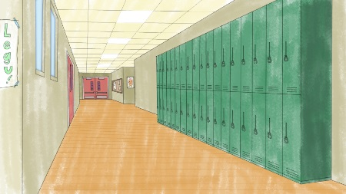
Hallways/Stairwells
Are you a PALS student?
- Walk quietly and on the right side

- Keep your hands to yourself

- Go directly to your destination
- Be respectful of learning in the classrooms

