Assembly
Are you a PALS student?
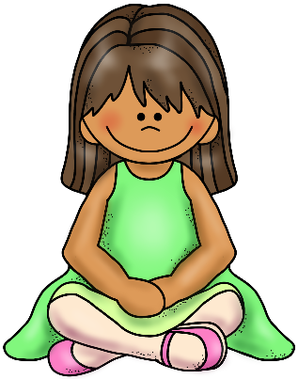
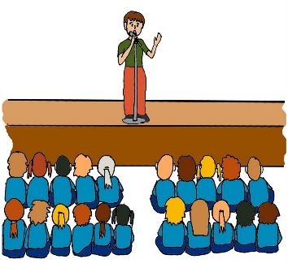
- Be respectful of the speaker
- Sit on your bottom
- Keep your hands to yourself
- Participate appropriately

