Ashburton Elementary School

6314 Lone Oak Drive, Bethesda, MD 20817 * 240-740-1300

September 4, 2018

Peanut and Tree Nut Allergy Information

Dear Parents and/or Guardians:

Food allergies have become common among students nationally and within our school system. Currently, there are students at every grade-level who have a severe food allergy to peanuts and/or tree nuts that could result in a life-threatening reaction called anaphylaxis. In order to minimize the risks to these students and to strengthen healthy habits, we encourage students to wash their hands before and after eating, and we are reminding them not to share food with their classmates. We ask for your support in reinforcing these habits at home.

In addition, for snacks that will be consumed in the classroom during the regular day or during classroom celebrations, we urge you to send snacks that do not contain any peanuts or tree nuts such as walnuts, cashews, pecans, pine nuts, almonds, hazelnuts, pistachios, and Brazil nuts. Some online resources and nut-safe food lists include: http://www.foodallergy.org/home , http://www.peanutfreelife.com/safe-food-list/ and http://snacksafely.com/snacklist.pdf .

Food that is provided for classroom celebrations should be store-bought, labeled, and contained in a sealed package. Food products with labels indicating that the product contains any peanut or tree nut ingredients or stating that the food product was manufactured in a facility that also processes peanuts or tree nuts are not permitted for classroom parties.

Students who are in need of a separate space to eat in the cafeteria due to a peanut or tree nut allergy may sit at the “Nut Free Zone” table. They may have friends join them so long as their friends’ lunch does not contain any peanuts or tree nuts. If you would like your child to sit at this table on a regular basis, please contact the health room to let them know. Also, if your child has a known allergy to peanuts, tree nuts, or another allergen, please make sure that our health room staff has been notified if you have not done so yet. Please call them at (240) 740-1302.

Thank you for your understanding and assistance in making this a healthy and safe school year for all of our students. If you have any questions, please contact the office at (240) 740-1300.

Sincerely,
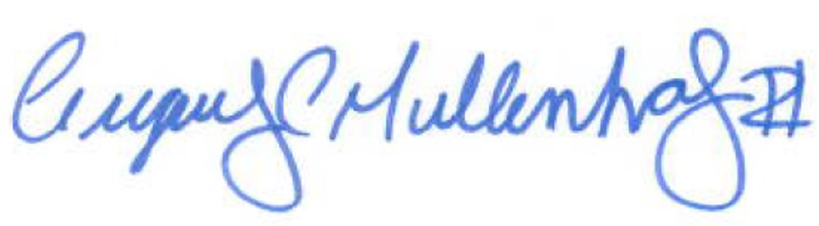

Greg Mullenholz

GCM:mej

