WebBlender 2 Quickstart Guide

The WebBlender interface:

Toolbar
Workspace
Editing Panel
Tool Palette
Storyboard

The Toolbar: contains buttons for the most common functions
The Tool Palette: contains tools for editing and previewing your pages
The Workspace: shows the page you are working on
The Editing Panel:
Options: Displays options for selected objects (such as font styles for
a text box)
Library: Contains folders of buttons, clip art and photos
The Storyboard: Displays thumbnails for each page of your project

The Tool Palette:
- Change to Editing Mode
  - This tool is used for moving text, images, and objects while in Editing Mode
- Change to Preview Mode
  - This tool is used for testing hyperlinks while in Preview Mode

- Add a text object to the page
  - Double click in the text box to add text
  - Use formatting options in the Options panel to change font, size, style, color, alignment, background
  - For large amounts of text, check the box for Show Scrollbar in the Options panel
  - Use the handles to resize the textbox; click in the middle of a selected textbox to move around the page

- Add an image or movie from a file
  - Browse to find an image or file to add to a web page

- Add a Podcast object to the page

- Add a shape to the page
  - Click on this icon to reveal the different shape choices
  - After selecting one, use the crosshair to draw the shape
  - Use the options in the Option panel to add a hyperlink; change the appearance, fill, and width; and rotate and/or flip

- Add a tables to the page
  - Click on this icon and select the number of cells for the table (up to 10 x 10)
  - Use the handles to resize the table; click and drag the row and column lines to change the size of cells
  - Use the Option panel to change the fill and the borders of the table
The Storyboard Panel

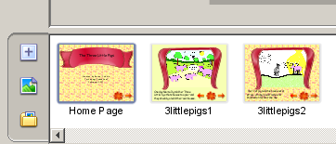

- To create additional pages, choose one of the following options from the Storyboard panel at the bottom of the screen:
  - add a new blank page
  - add a page from a file so it appears as the background of the page
  - add a page from each supported file in a folder
- To change the order of pages, click, hold, and drag the page thumbnail to the new location
- To view a page, double click on the page thumbnail

The Options Panel

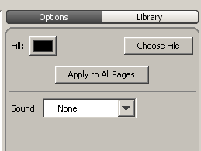

- Changes depending the tool selected on the Tool Palette (see individual tools for Option panel options)
- To add backgrounds, make sure the Edit mode tool is selected
  - Click on the rectangle next to the word Fill to choose a solid color
  - Click on Choose File to pick an image and browse through document files
  - To apply the same background to all pages, select Apply to All Pages
  - To add sound, click on the drop-down menu next to Sound and choose Sound. Then navigate to add a sound from a document file or record an original sound.

The Library Panel:
On the Editing Panel, click the Library tab. Then select the category and possibly a subcategory (Example: Animals is the category, Pets would be the subcategory). Then click, hold, and drag the appropriate picture onto your page.

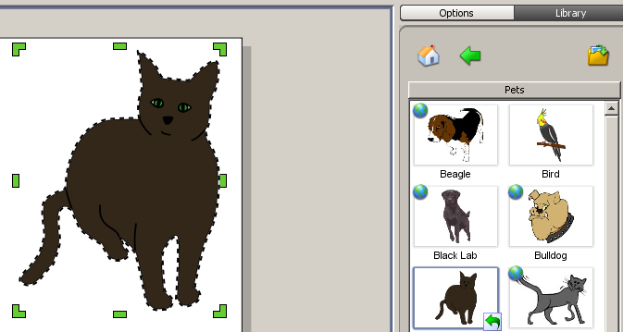

Adding Buttons to Pages: You can add navigation buttons to your pages. To add navigation buttons, select the Library tab from the Editing Panel. Then select Buttons.

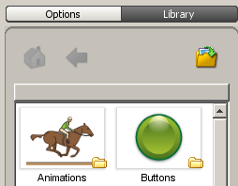

You will then see several categories of buttons. Open one of the categories, click on the desired button and drag it onto the page.

To make a button active, double click on it to get the green handles. You will now see the tab at the top has switched from Library to Options. Click on the Hyperlink button and choose the page, web page, file or email destination for the link . If you want this button on each page at the same location, select the Add to All Pages button.

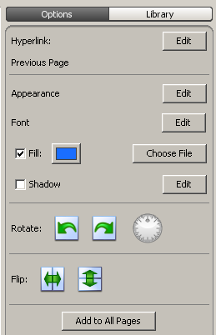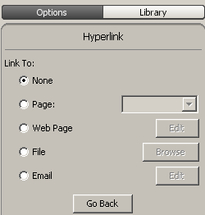
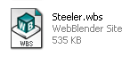
Saving your Work: To save your work, go to File>Save As. Give your file a name. It will save as a WebBlender file. It will have a .wbs extension at the end. As a .wbs file, you can open and edit the file in WebBlender as often as you like.

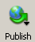
Publishing your Work: You can publish your work as web pages. This process will save your files in html format. To do so, click the Publish button on your Toolbar. You will now be given several publishing options. Choose To Local to save the files to your computer. In the Save dialog box name and save the site.

Note: Once you have saved your site, a folder will be created with the name that you used to save your site. Your files will be located in this file. To launch your new html pages, double click the index.html page from within the folder.

