Clicker 5 Tutorial

Clicker 5 multimedia software program has two components:

1) Clicker Writer - a talking word processing program
2) Clicker Grids - composed of rectangular shapes, or cells, that contain letters, words, phrases, and/or pictures that can be combined to assist with word processing

Each component can be used together or separately. There are numerous example files with ready-made grids for use with many curricular areas. In addition, you can quickly create your own grids with the help of templates. Available files include sound and video clips, as well as graphics. In addition, many more free clicker grids can be found and downloaded for use within Clicker from the following website: http://www.learninggrids.com/

To start Clicker 5, click on the Clicker icon on your Applications menu. You will get a Home screen that looks like this:
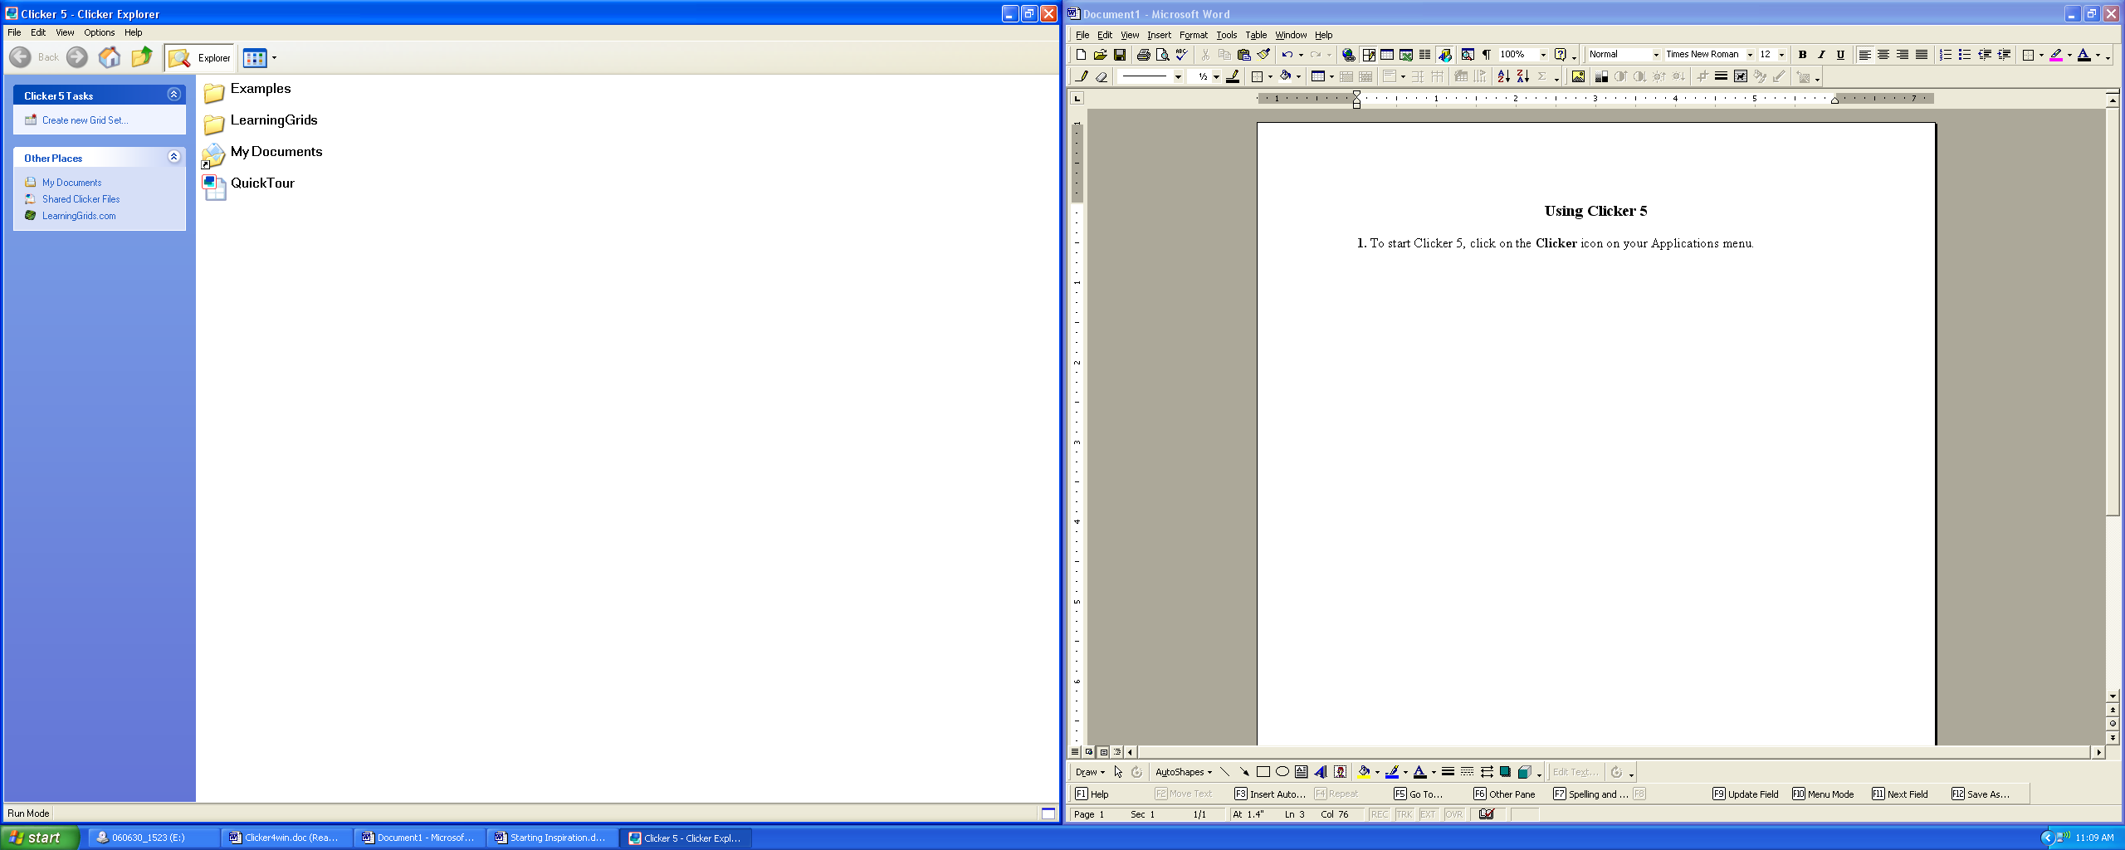

Creating a Clicker Grid Using a Template

- Click on the Create New Grid Set link located in the left navigational area of the Home screen.
- A dialog box will appear listing folders that contain different types of template grid layouts. For example, double click on the Sentence Building folder.
- Within each folder there usually are several layout designs to choose from. For example, double click on the Model Sentence Building.
- Click on the 3X1 grid.
- Click on Create button.
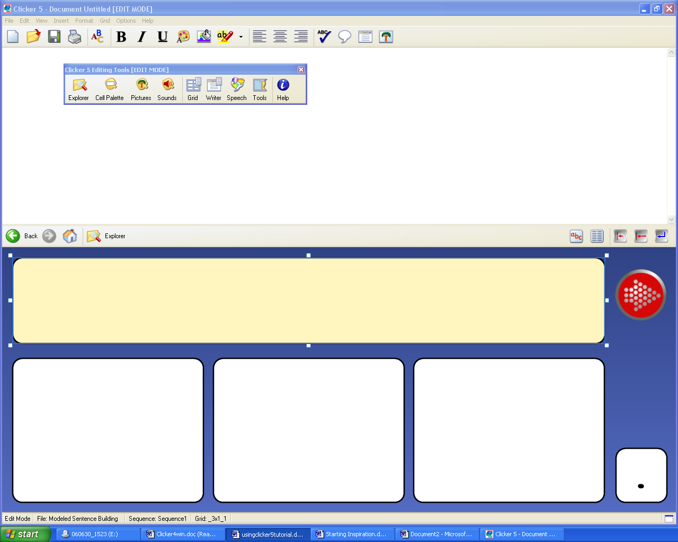
- To begin creating the grid, switch to the Edit Mode by going to the tool bar and clicking the Edit menu and then click on the Edit mode. Your screen should look like this:

Now you are ready to start creating your sentence building activity.

Changing Background Color and Cell Color

Background color:
Using the Editing Tools toolbar, click on the Grid icon. The Grid Properties dialog box appears with color choices. Choose a color by using the drop menu arrow. Here you can also change the pattern and add additional color patterns. Another option is to simply Right Click somewhere on the grid itself. One of the menu options that appears is the Grid Properties dialog box; click on that to begin making background color changes.
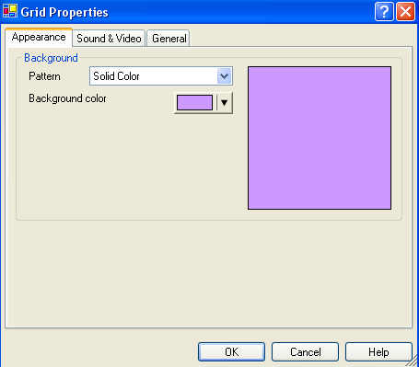

Cell Color Within a Grid Set:
To change the color of one cell, Shift Right Click on 1 cell and the Cell Properties dialog box will appear. Change the color by clicking on the drop arrow next to the Background Color field.

If you would like to change the color of all the cells, press and hold the Control Key and click on each cell that you want to change. This selects all the cells at once before the Cell Properties dialog box appears, enabling you to select a desired cell background color for all the selected cells.

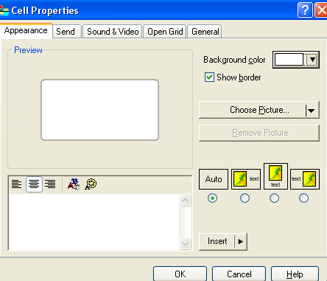

Adding Text to Cells
To add text to a cell in the grid set, Shift Left Click on the desired cell. A blinking cursor will appear enabling you to type text. To move on to the next cell to enter in text, simply click on the Tab key.

Adding Pictures From the Clicker Library to Cells
To add a picture to your cell, use the Editing Tool toolbar and click the Picture icon. A Picture Palette dialog box with folders will appear. Click on one of the Library folders displayed and search for the picture you wish to add. Once you have found the picture you wish to add, simply click on the picture and drag and drop it into the desired cell.
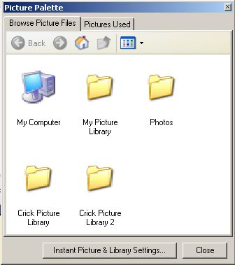

Adding Additional Cells to a Grid
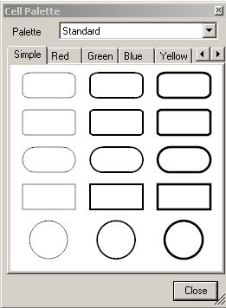
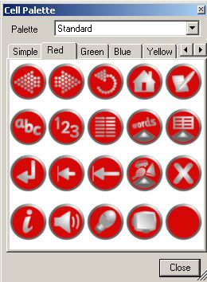
To add additional cells to your grid, use the Editing Tool toolbar and click the Cell Palette icon. A dialog box will appear showing different tabs to click on that show a variety of cells and colors of cells that can be added to a grid. To add another cell to a grid, simply click on the desired cell from the dialog box and drag and drop it on the grid in the desired location.

Adding Another Grid to the Current Grid Set
To add another grid to the current grid you’re working in, click on the Grid menu in the top toolbar and then click on the option to Add Grid. A pop-up window will appear. Click on Templates at the top of the screen and then double click on the folder containing the desired template layout design desired.

Adding a Text Box to a Clicker Grid
To add a text box to the grid you’re currently working in, click on the Grid menu in the top toolbar and then click on the option to Insert from the drop down menu. Afterwards another menu will appear to the right of Insert and you will choose the option Text Box.

Adding Buttons to a Clicker Grid
1. Click on the Cell Palette icon on the Editing Tools toolbar.
2. A dialog box will appear displaying different tabs to move between to find a button of desired color and that visually communicates the desired action of the button as well (speaker to play sound to read text aloud, TV to play a video, arrows to move on to the next or previous grid).
3. Once you have found the desired button, click and drag the button from the Cell Palette dialog box onto the grid set. Use the handle bars surrounding the button to resize it.

Applying Action to a Speaker Button
1. Shift Right Click on the speaker button cell, or another button cell desired. The Cell Properties dialog box will appear.
2. Click on the Sound & Video tab.
3. Click next to the radio button option of Speak or play this…
4. Click on arrow next to the Insert button shown and from the menu that appears to the right, click on either Text Boxes or Cells, depending upon if what you want read aloud is contained within a cell or text box.
5. Afterwards, select the cell or text box that contains the text that you want that speaker button to read aloud when clicked on.
6. Another menu of options will appear; click text, to have the text entered in the cell or text box read aloud.
7. Click the OK button in the Cell Properties dialog box.
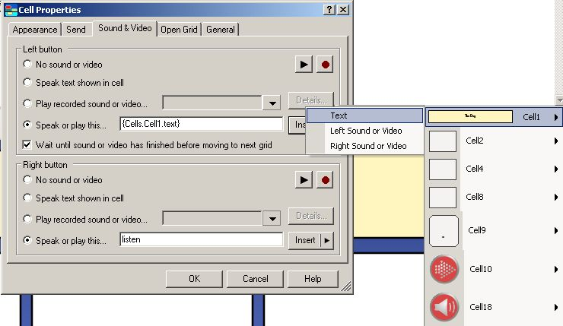

Applying Action to a Video Button
1. Shift Right Click on the TV button cell, or another button cell desired. The Cell Properties dialog box will appear.
2. Click on the Sound & Video tab.
3. Click next to the radio button option of Speak or play this…
4. Click on the arrow next to the Insert button shown and from the menu that appears to the right, click on either Text Boxes or Cells, depending upon if the video you want to play is contained within a cell or text box.
5. Afterwards, select the cell or text box that contains the video that you want to play when clicked on.
6. Another menu of options will appear; click Left Sound or Video to have the video contained in that cell or text box play when left clicked upon.
7. Click the OK button in the Cell Properties dialog box.

Embedding a Picture or Video From a File Into a Cell
1. Shift Right Click on the cell desired to contain either a picture or video from a personal file. The Cell Properties dialog box will appear.
2. On the Appearance tab of the Cell Properties dialog box, you will see a Background Color field. Click on the arrow next to this field and select Transparent.
3. Now click on the arrow on the Choose Picture button on the Appearance tab and then click on the Browse button that appears. A dialog box will appear enabling you to navigate to the location of where the desired picture is saved.
4. Next click on the Sound & Video tab and click next to the radio button option Play recorded sound or video…
5. Click on the arrow across from this radio button option and click on the Browse button that appears to bring up a dialog box that will enable you to navigate to the location of where the desired video is saved.
6. Click on the Details button. A Video Details dialog box will appear. Across from the “Play the video” field, click on the arrow to display a menu and select the option that says “in the cell”.
7. Click the OK button in the Video Details dialog box.
8. Click the OK button in the Cell Properties dialog box.
