Movie Maker Quick Guide

IMPORTING DIGITAL MEDIA (VIDEO, AUDIO, IMAGES)

To import existing digital media files:

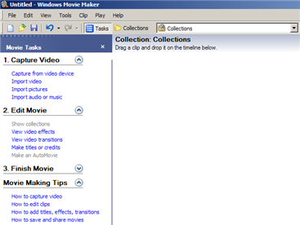
- On the File menu, click Import into Collections.
–or-
Do one of the following, depending on what type of digital media file you want to import:
  - In the Movie Tasks pane, under Capture Video, click Import video.
  - In the Movie Tasks pane, under Capture Video, click Import pictures.
  - In the Movie Tasks pane, under Capture Video, click Import audio or music.
- Navigate and select the desired file.
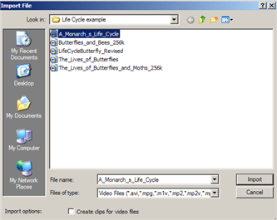
Note: You can import several files at one time. For consecutive files, click the first file in the list, press and hold down the SHIFT key, and then click the last file in the list. For files that are not consecutive, press and hold down the CTRL key, and then click each file that you want to import.
- If you want selected video files to be separated into smaller clips, select the Create clips for video files check box.
- When ready, click Import.

To capture the entire video from a tape in a DV camera:
- Make sure your DV device is connected properly to an IEEE 1394 port, and then set the camera mode to play recorded video (often labeled VTR or VCR on a DV camera).
- On the File menu, click Capture Video.
–or-
In the Movie Tasks pane, under Capture Video, click Capture from video device.
- On the Video Capture Device page, in Available devices, click the DV camera.
- In the Enter a file name for your captured video box, enter a file name for your captured video file. Then, in the Choose a place to save your captured video box, select the location where you want your video to be saved or click Browse to select a location.
- On the Video Setting page, choose the video setting you want to use for capturing video and audio.
- On the Capture Method page, click Capture the entire tape automatically. The tape in the DV camera rewinds. Capturing begins automatically and ends when the video tape ends.
- Select any of the following commands:
  - To separate the video into smaller clips, select the Create clips when wizard finishes check box.
  - To stop capturing before the end of the video tape, click Stop Capture, and then click Yes in the resulting dialog box to save the video that has been captured.
- To close the Video Capture Wizard, click Finish. The captured content is imported into a new collection with the same name as the specified video file.

ADDING DIGITAL MEDIA TO YOUR PROJECT

To add the video (or still image) from your collections to your Storyboard:
- In the Movie Tasks pane, under Edit Movie, click Show collections.
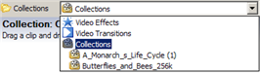
- If you have more than one Collection, you may need to select the desired Collection from the Collections drop-down list.
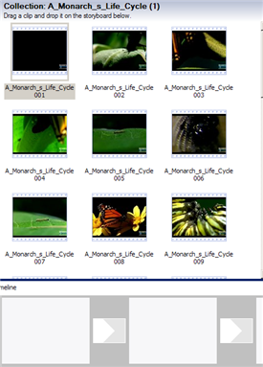
- Click and drag a media clip to the storyboard to begin making a movie.
Note: You can drag several files into your movie at one time. For consecutive files, click the first file in the list, press and hold down the SHIFT key, and then click the last file in the list. For files that are not consecutive, press and hold down the CTRL key, and then click each file that you want to import. Once the desired files are selected drag them to the storyboard or timeline.

To view the audio that was imported with the video:
- Make sure you are in the Timeline view not the Storyboard view. If you are in Storyboard view, click Show Timeline. The Timeline view is displayed.
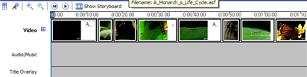
- Click the + sign to expand the Video. The audio that is attached to the video is displayed.
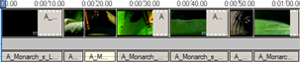

To add an audio clip (not attached to the video):
- Make sure you are in the Timeline view not the Storyboard view. If you are in Storyboard view, click Show Timeline. The Timeline view is displayed.
- Click and drag the audio clip from your Collection and drop it on the Audio/Music lane.
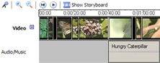

SPLITTING and TRIMMING CLIPS

To split a video and audio clip:
- If you are not already in Timeline view, click Show Timeline.
- On the storyboard/timeline, click the clip you want to split.
- Click Play, and then click Pause to pause the video at the point you want to split the clip. Or drag the Playback Indicator (Timeline view only) to the point you want to split the clip.
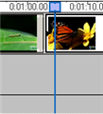
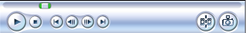
- On the monitor, click the Split button. The selected video and audio (if there is any) will be split into two clips.

To trim a clip:
- If you are not already in Timeline view, click Show Timeline.
- On the timeline, select the clip you want to trim.
- On the timeline, click the playback indicator and drag it to the point where you want to trim the clip.
-or-
Use the playback controls on the monitor to go to the point where you want to trim the clip.
- Do the following:
  - When the playback indicator is at the point where you want the selected video or audio clip to start playing back, on the Clip menu, click Set Start Trim Point.
  - When the playback indicator is at the point where you want the selected video or audio clip to stop playing back, on the Clip menu, click Set End Trim Point.
Note: You can also drag the trim handles to set the start and end trim points. The trim handles appear when the clip is selected on the timeline.

TRANSITIONS AND EFFECTS

To add a video transition:
- This is easiest to do in Storyboard view. Therefore, if you are not in Storyboard view, click Show Storyboard.
- In the Movie Tasks pane, under Edit Movie, click View video transitions.
- Click and drag the desired video transition to the storyboard (in between the two video clips).
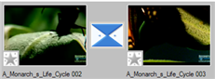
Note: If you hover your mouse over the transition, the name of the transition is displayed.

To add a video effect:
- This is easiest to do in Storyboard view. Therefore, if you are not in Storyboard view, click Show Storyboard.
- In the Movie Tasks pane, under Edit Movie, click View video effects.
- Click and drag the desired video effect to the Star icon on the clip. The Star icon will turn blur to show that an effect has been added.
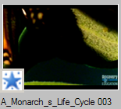
Note: If you hover your mouse over the blue Star icon, the type of effect is displayed.

TITLES AND CREDITS

To add a title or credit:
- In the Movie Tasks pane, under Edit Movie, click Make titles or credits.
- On the Where do you want to add a title? page, click one of the links depending on where you want to add the title.
- In the Enter Text for Title page, type the text you want to appear as the title.
- Click Change the title animation, and then on the Choose the Title Animation page, select a title animation from the list.
- Click Change the text font and color, and then on the Select Title Font and Color page, choose the font, font color, formatting, background color, transparency, font size, and position of the title.
- Click Done, add title to movie to add the title to your movie.

NARRATION

To add narration:
- If you are not already in Timeline view, click Show Timeline.
- Click the Microphone icon.
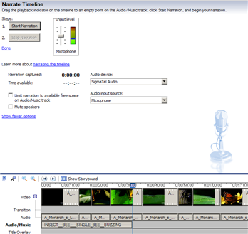
- Drag the playback indicator on the timeline to an empty point on the Audio/Music track.
- If you are going to be talking over audio that is attached to the video, check the Mute Speakers checkbox.
- Click Start Narration, and begin your narration. The movie will play in the monitor to the right so you can time your narration with what is being shown on the screen.
- When finished, click Stop Narration. A new window will open prompting you to save the narration that was just recorded.
- Enter a file name for the narration and click Save. The recorded narration is displayed in the Audio/Music track in the timeline.
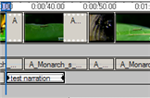
- Record additional narrations as needed. When finished, click the Done link to return to your Collections.

AUDIO EFFECTS and LEVELS

To add an audio effect:
- On the Audio or Audio/Music track of the timeline, select the audio clip.
- Do one of the following:
  - To fade in the audio, on the Clip menu, point to Audio, and then click Fade In.
  - To fade out the audio, on the Clip menu, point to Audio, and then click Fade Out

To mute the audio or adjust the audio level of a clip:
- In Timeline view, click the audio clip that you wish to mute or adjust.
- On the Clip menu, point to Audio, and then click Mute or Volume…
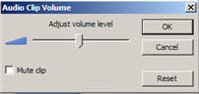
- If you selected Volume, drag the slider to the left or the right. Then, click OK.

To set the audio levels for the entire movie:
- In Timeline view, click the Set Audio Levels icon.
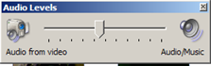
- To hear more of the audio from the video, drag the slider to the left.
- To hear more of the audio from the Audio/Music track, drag the slider to the right.
Note: This adjustment of the audio from the video and the audio/music is for the entire movie; not individual clips.

SAVING YOUR PROJECT AND MOVIE

To save a Movie Maker project:
Note: This only saves your movie project as a Windows Movie Maker file. It does not create a published movie. To continue to work on your project open up the file in Movie Maker from the same computer.

- On the File menu, click Save Project or click the Save icon on your toolbar.
- Navigate to the folder where you would like to save your project.
- In the File Name field, type an appropriate name for your project.
- Click the Save button.

To publish your project as a movie:
Note: This is a published movie and can be played in Window Media Player. It is read-only and cannot be edited. You can burn it to a CD or save on a jump drive and watch it from any computer. To edit your movie, you need to open up the Windows Movie Maker Project file (see previous steps) in Movie Maker (not the actual published movie).
- On the File menu, click Save Movie File, and then click My computer.
–or-
In the Movie Tasks pane, under Finish Movie, click Save to my computer.
- In the Enter a file name for your saved movie box, type a name for your movie.
- In the Choose a place to save your movie box, do one of the following:
  - Choose the path and folder name from the list of available places in the drop-down list.
  - Click Browse to choose a new place that is not already listed in the drop-down box.
  - To create a new folder, click Make New Folder in the Browse For File dialog box, and then type a name for the new folder.
- Click the Next button.
- On the Movie Setting page, do one of the following:
  - To use the default movie setting, click Best quality for playback on my computer (recommended). The specific setting details, such as the file type, bit rate, display size, aspect ratio, and frames per second displayed in the video, are shown in the Setting details area.
  - To use a different movie setting, click Show more choices, and then choose another movie setting from the list.
- Click the Next button. Depending on the length of your movie, it may take several minutes to publish.
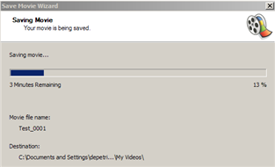
- Optionally, check the Play movie when I finish checkbox.
- After the movie is saved, click Finish.

