Inspiration 9.0 Cheat Sheet

How to make a web using Inspiration:

- Click on the Inspiration icon, found within your Applications folder, to begin.

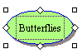
- In the symbol that says “main idea”, type your main idea for your web.


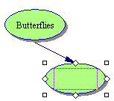
- To create subtopics that branch from the main topic, be certain that the main topic is selected (white handles will surround it). Then, click on the Create button on the Main Toolbar on the oval that points in the direction in which you would like to add a related idea. This will create a new symbol where you can fill in your subtopic.
- Click within the new symbol to type in the subtopic for your web.
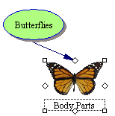
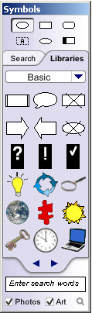
- To replace the default oval symbol with a picture or another shape, select the symbol (white handles will surround it). Next, select a new picture or shape from the Symbol Palette (to turn on/off the Symbol Palette, go to View > Symbol Palette or use Ctrl + 8). Click on the Search tab to use the search feature at the bottom, or click on Libraries to scroll through the library topics.

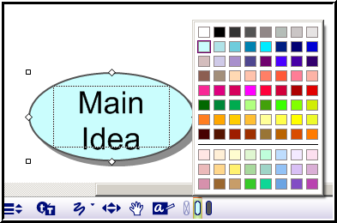
- You can continue to add ideas to your web, in the form of pictures or words, or both, by first selecting the starting point, and then clicking on the Create button, as described in step #3 above.

- Tools along the bottom of the Inspiration window can be used to change the color of your symbols. Your symbol must be selected first in order to change colors. Then click on the colored ovals at the bottom of the window to change the fill and outline color of your symbol.


- Text within the selected symbol can also be changed by using the font tools at the bottom of the window.

- All shapes can be moved around the screen by dragging them.
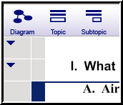

- You can view your web as an outline, by selecting the Outline button on the Main Toolbar. Once you are in Outline Mode, you can go back to your diagram view, by using the Diagram button, found at the top on the Main Toolbar.

Additional Features in Inspiration:

- RAPID FIRE: This tool is useful to generate several subtopics from a main idea.
- Begin by selecting your main idea. Then click the RapidFire tool found at the top on the Main Toolbar.. You will see a lightening icon appear in your main idea symbol.

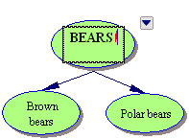
  - As you type subtopics and press the ENTER key, your subtopics will be added in new symbols.


- LINKS: If you have symbols or pictures that are not connected to your web, you can connect them using the Link tool.
  - Click on the symbol you want to connect FROM to select it.
  - Click the Link tool.
  - Next click the symbol that you want to link TO and a link will be added.
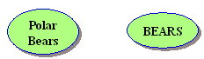



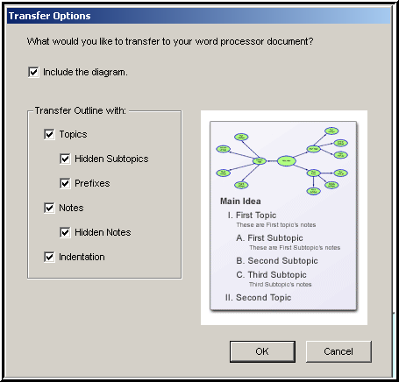
- TRANSFER: The Transfer button allows you to transfer your graphic organizer and outline easily to a word processor (Microsoft Word) when you are ready to finalize your work for publication.

  - Before transferring, save your Inspiration document.
  - The new Word document retains the look and structure of your Inspiration graphic organizer and outline when you transfer from the Diagram View. You can choose to include the graphic organizer or to exclude it.

