Remove an Autocorrect

- Open a new Word document.

- Click on Tools> Autocorrect Options.
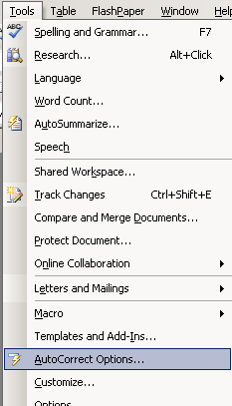

3. Type HSA in the “Replace Box.”
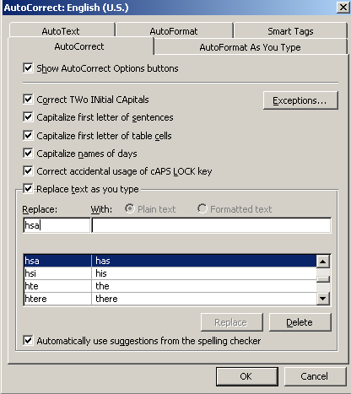

4. If this is an autocorrect on your computer, you will see HSA and HAS in the options list. Click on it so that it is highlighted. Press delete. This will remove this auto correct from your computer.

