Inserting a Time Stamp

Step One: Set your Time Stamp Default
(The insert timestamp feature is taking advantage of an “insert” feature in Word. The first thing you need to do is set the type of insert you wish to enter. You only need to reset this option once. )
1. Click on Insert and then Date and Time.
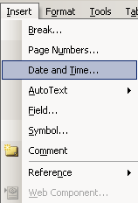

2. Select a the time formatted with hours, minutes and seconds by clicking on it. Next, click default.

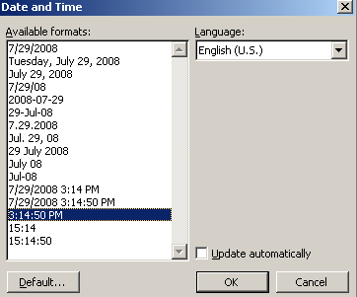
Note: make sure “Update automatically” is unclicked.

3. Press “OK”
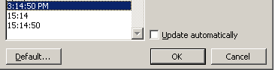
Step Two: Insert the Timestamp

(Once you have set the default timestamp, you can enter timestamps into documents with several simple clicks. This is the pattern of clicks.)

- Hold down the Alt Key.

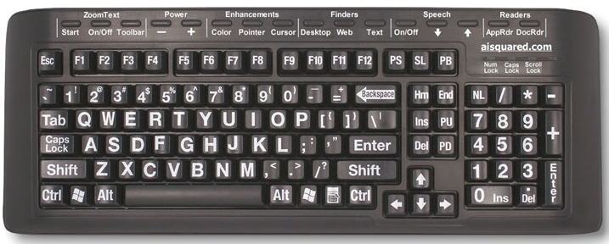

- While holding down the Alt Key, click I and then T
3. Let go of all the keys and press enter
4. You will now have entered a timestamp.

