How to Back-up Your Autocorrects

1. Open Word and click on File Open.
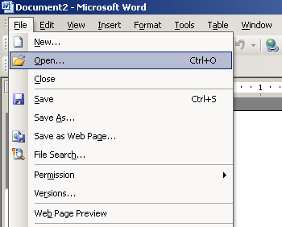

2. Navigate to Macros folder: C:\Program Files\Microsoft Office\Office11\Macros
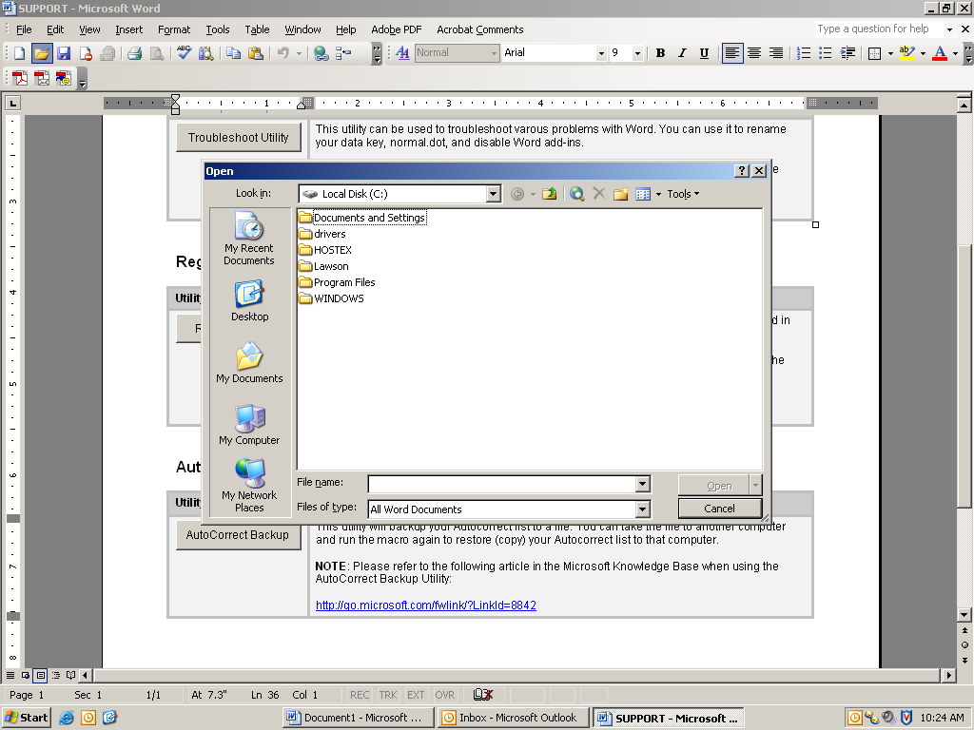
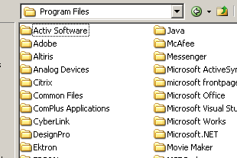
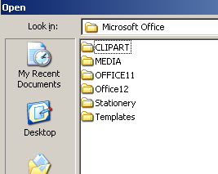
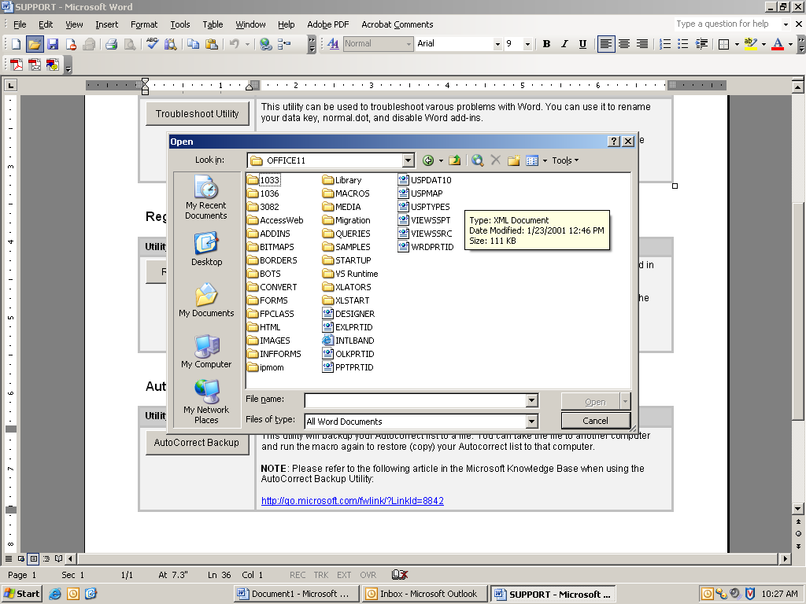

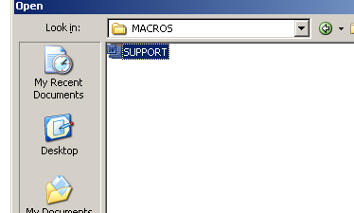

3.If this alert box opens, click the “Always trust macros from this publisher” check box and then select, enable macros.
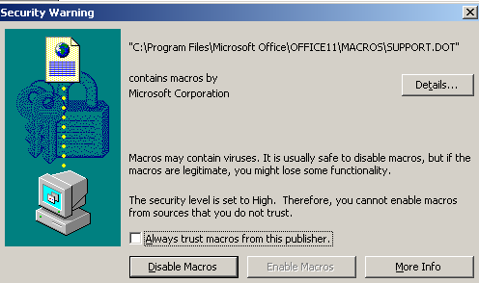

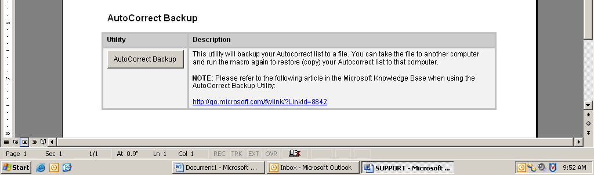
4. A new document will open. Scroll down and click on AutoCorrect backup.

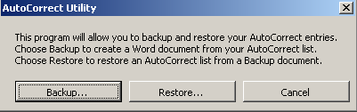
5. Select Backup… This will prompt you to create a new document. This new document will contain your personal Autocorrects.

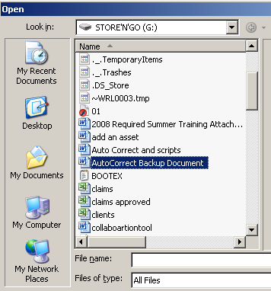
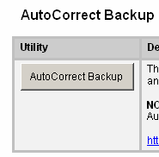
6. To restore autocorrects or import your autocorrects to a new computer. Open this newly created document. Scroll down and click on “AutoCorrect Backup.” Next, select Restore

