Autotext Feature in Word

- Open a new Word document.
- Select Tools>Autocorrect

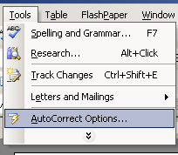

3. Click on AutoText:
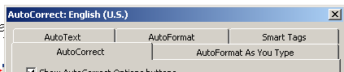

4. Type the text you would like to finish in the “Enter AutoText entries here:” and then click Add.

