Setting the Autocorrect Feature in Word: Formatted Text

- Open a new Word document.

- Type a string of text you type frequently. Our example is “Students will be able to:”

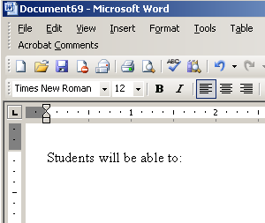

3. Format the text by changing the font type, size and color.
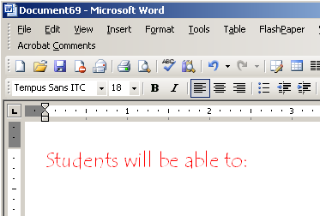

4. Highlight the text.

]

5. Click on tools and then AutoCorrect Options.
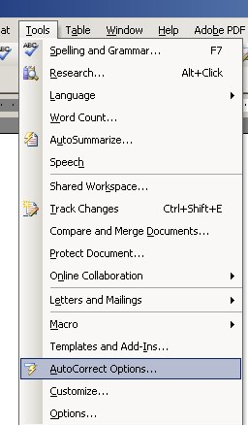
- Make sure the “formatted text” radio button is clicked. 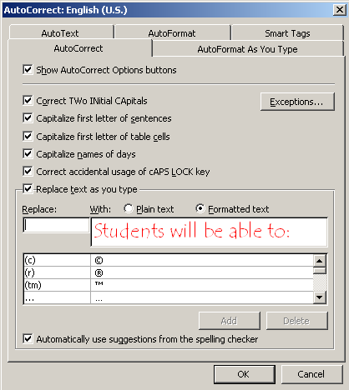

- In the Replace box, type the text you wish to be changed (in our example this is “SWBAT”) and click add. When finished click OK.
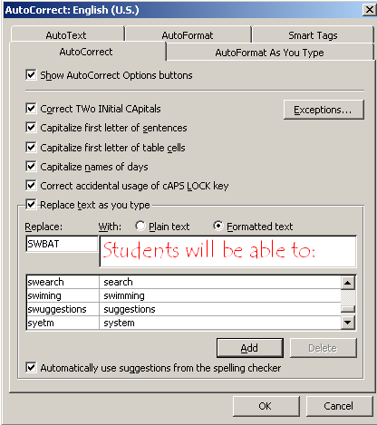

- Congratulations, you have now set your first Autocorrect. Now, whenever you type SWBAT, the words “Students will be able to” will appear- you’re your selected formatting.

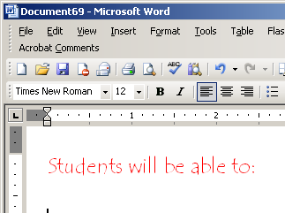
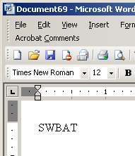

Working with Vista and Word 2007?
See these directions: http://wordprocessing.about.com/od/microsoftword2007/qt/autocorrect07.htm

