Setting the Autocorrect Feature in Word

- Open a new Word document.

- Type a string of text you type frequently. Our example is “[Wait Time]”
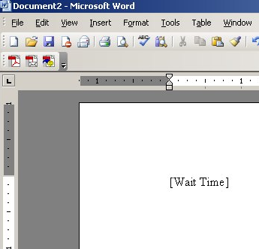

3. Highlight the text.
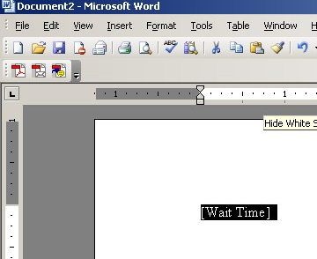

4. Click on tools and then AutoCorrect Options.

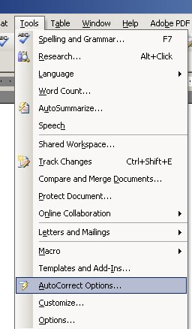

- Click on plain text. You may need to delete a miscellaneous asterisk which will appear.
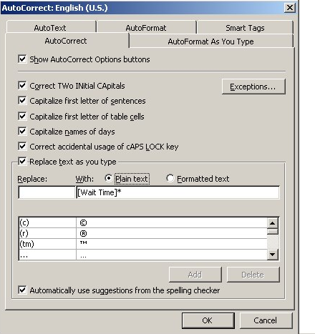

- In the Replace box, type the text you wish to be changed (in our example this is “WT”) and click add. When finished click OK.
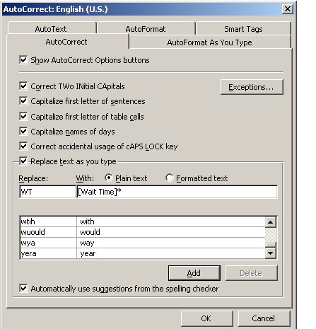

6. Congratulations, you have now set your first Autocorrect. Now, whenever you type WT, [Wait Time] will appear.
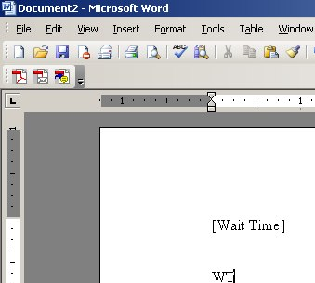
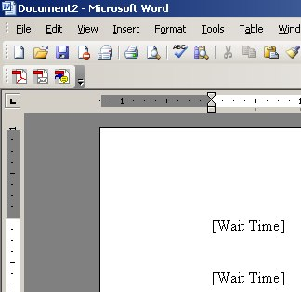

Working with Vista and Word 2007?
See these directions: http://wordprocessing.about.com/od/microsoftword2007/qt/autocorrect07.htm

