- Where do I go to review my transactions?
- Login to JP Morgan
- Click on the Transactions Tab > Manage

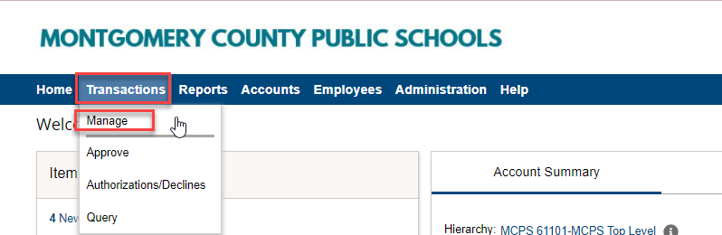

- How do I review my transactions?
- Open your transaction by clicking on blue dollar amount

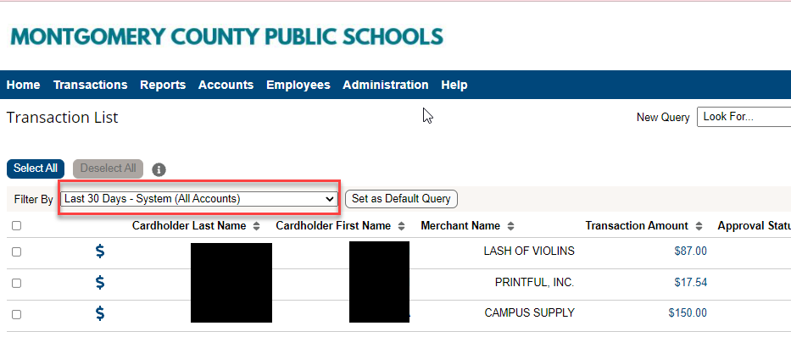

- Compare merchant name & total amount charged with your receipt.
- Make sure you were not charged tax.
- Write a brief note in the transaction note field.
- If all looks good go back to the top and select the check box next to the “Review” field.
- Make sure there is an approver name listed.
- Click the save button.
- If you have more transactions, click the arrow at the top of the general information page.

