Department of Transportation Shady Grove South Depot
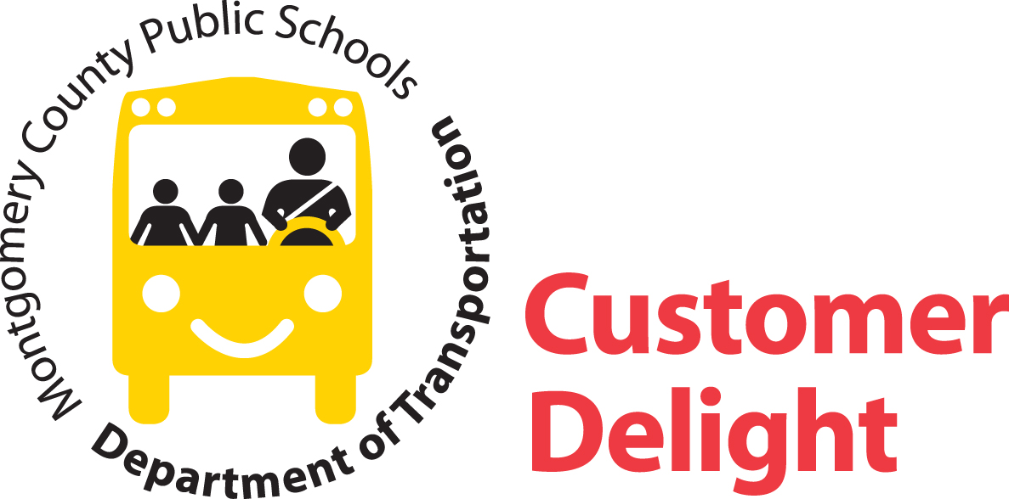
16651 Crabbs Branch Way
Rockville, Maryland 20855
240-740-6211 Fax: 301-840-8132

July 1, 2022

Dear High School Parent:

Enclosed are route schedules for buses serving your child’s school. Please note the appropriate time, location, and route number for your child. Students should be ready and waiting to board the bus five minutes prior to its scheduled arrival time. Route numbers are displayed on the side window of the bus. Students who live within 2 miles of the school are not eligible for transportation services if age-appropriate walking routes are available. Questions should be referred to the transportation cluster supervisor who is responsible for your school. Your school or the Montgomery County Public Schools (MCPS) website can provide you with contact information for your transportation cluster manager.

Bus stops previously scheduled may have been eliminated or relocated to provide economies in operation. Every effort is made to minimize inconvenience to students and parents, and provide a reasonable level of service. Saving support budget dollars provides more resources for classrooms.

When bus stops are scheduled at intersections, students should stand safely away from traffic, within 150 feet of the stop. Parents are responsible for maintaining discipline and safety at bus stops. Students waiting for buses may choose to stand in carports and garages for protection from the elements. This is acceptable only if: (1) it does not alter the route; (2) it does not increase the number of stops; (3) it is acceptable to all parties involved; and (4) it is reasonably close to the regular stop (so that a substitute bus operator, not familiar with special arrangements, may easily locate the students). Please note: bus operators are only authorized to stop at designated stops; do not request unauthorized stops. MCPS realizes substantial fuel and other operational savings by limiting the number of bus stops.

Inclement weather creates many hardships for all. It is not possible to provide additional transportation during winter months or on rainy days, and for this reason, students should dress accordingly. In case buses are not able to reach designated stops due to snow and ice accumulation, parents are encouraged to make advance arrangements with bus operators so that students who live in these areas can board at alternate locations when necessary.

Appropriate student behavior is important to the safety and comfort of everyone. Parents are encouraged to discuss behavior with their children regularly to reinforce this message. It is important that all students follow the rules stated in “Ride by the Rules.” campaign. For more information on this, please visit: https://www.montgomeryschoolsmd.org/departments/transportation/rules/.

Student transportation can only operate effectively if we all do our part to make things work. Parental assistance and cooperation are needed to provide a safe transportation system for student riders.

Sincerely

Robin Wolff

Robin Wolff
Depot Manager

RW;dm

Enclosures

