Centrally Purchased Online Subscription Services- Whetstone Elementary Schools

None of these require a username or password in MCPS schools. We have included access information for home use.

Please email Kelly_L_McConnell@mcpsmd. org to obtain home use logins and passwords.

Resource and website URL | Description
http://school.eb.com | Britannica School is an encyclopedia where you can search for articles on a variety of topics.
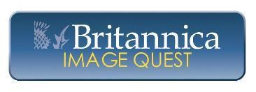http://quest.eb.com | Image Quest has a collection of images that you can download and use in your school projects.
http://www.america.eb.com | Annals of American History has speeches, historical accounts, memoirs, poems, images and multimedia all about American History.
http://escolar.eb.com/ | Escolar Online is the Britannica School encyclopedia in Spanish. Find articles on a variety of topics written in Spanish.
http://moderna.eb.com/ | Enciclopedia Moderna is a Spanish language encyclopedia that has many articles plus timelines, an atlas, and a dictionary.
http://global.eb.com/ | Global Reference Center is a database where you can find information from around the globe written in Japanese, Korean, Chinese, French and Spanish.
http://world.eb.com/ | World Data Analyst is a database in which you can compare data on different countries.
http://online.culturegrams.com | Culturegrams has information on 182 countries and cultures, including history, land and climate, religion, personal appearance, gestures, language, government, and family life.
http://noodletools.com | Use Noodletools to create citations, notecards, outlines and papers for your research projects.
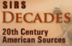  http://sks.sirs.com | SIRS Decades is a database of primary and secondary source documents organized around the decades of the 20th century.
http://discoverer.sirs.com | SIRS Discoverer is a database of articles and images from newspapers, magazines, government documents, and websites.
Rourke Ebooks  www.rourkeebooks.com | Books to support 4th and 5th grade curriculum in an electronic format.
www.MackinVIA.com  select Whetstone ES from the drop-down menu | E-content packages for ES consisting of approximately 33-38 titles. These titles are from a variety of publishers and public-domain sources and are both non-fiction and fiction. The non-fiction titles are simultaneous use, the fiction titles are a one check –out at a time.
http://teachingbooks.net/home/ | Teaching books has author interviews, book summaries and other information about books and authors.

Resource and Website URL | Description
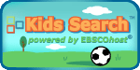http://search.ebscohost.com | Kids Search includes a dictionary, encyclopedia and images and videos. It also has teacher resources.
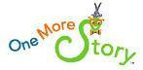  http://www.onemorestory.com/ | One More Story is the online library of children’s books set to music and read aloud to you. Follow Benjamin D. Bookworm, Bendy, through your favorite books, or try the I Can Read It mode to read them yourself.
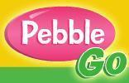http://www.pebblego.com | PebbleGo has “Animals”, “Biographies”, “Social Studies” and “Science” articles to help you with your research projects.
http://search.ebscohost.com | Searchasaurus is an encyclopedia and dictionary site which includes images, articles and definitions. It also has a teacher resource section.
http://www.tumblebooks.com/library/auto_login.asp?U=mcpsmd&P=books | TumbleBook Library has animated “talking” books. You can read a book on your own or have it read to you. There are

