Innovative School NewsleTter
Arcola Elementary School •Roscoe R. Nix Elementary School
March/April 2019
Volume 1, Issue 1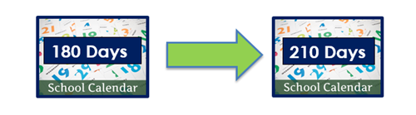

Important Dates

First Day of School
Monday, July 8, 2019

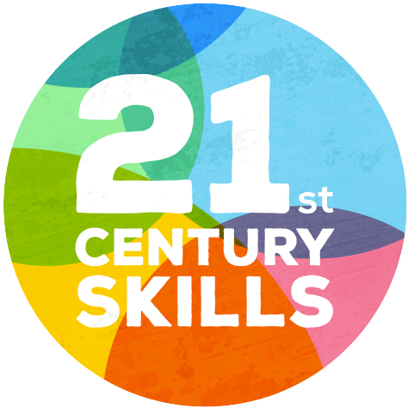
- Critical Thinking
- Communication
- Collaboration
- Creativity

What is Mindfulness?
- Mindfulness is paying attention to what is happening in the present moment.
-Mindful Schools
- Mindfulness is the self-regulation of attention with an attitude of curiosity, openness, and acceptance.
-J. Kabat-Zinn, M.D.

Extended School Year
Dear Arcola & Roscoe Nix Families,
Our school year will begin on July 8, 2019 for All Students. We are excited to provide access to 30 additional days of learning to ALL of our students. Our students will engage in innovative programing in the following areas:
- Social Emotional Learning
- Mindfulness
- Project based learning
We look forward to providing deep and enriching learning experiences that will help all of our students to thrive in the 2019-2020 school year.

INNOVATIVE PROGRAMMING
Social Emotional Learning & Mindfulness
Social Emotional Learning (SEL) provides students with strategies and skills that they need to develop self-confidence, self-discipline, empathy, good communication skills and strong problem-solving abilities. Mindfulness is a practice under the umbrella of Social Emotional Learning that helps to build Self-Awareness, Self-Management, and Responsible Decision-Making in both children and adults.

Mindfulness practices provides strategies to help students have a greater self-awareness of their mind, which in turn impacts a student’s ability to recognize how their thoughts and emotions influences their actions and behaviors. Mindfulness gives students the ability to respond, rather than impulsively react, to an event or circumstance in their lives. For example,
a student who is aware or mindful when he or she feels sad is more likely to use a healthy strategy (such as deep breathing, talking to a friend, or drawing) to manage their emotions in a positive way and make a responsible decision. When students learn to make responsible decisions over and over again, they develop greater self-esteem and self-control.

Mindfulness also helps students to focus more on learning, solve problems, persevere through difficulty, and become more resilient over time. The incorporation of Social Emotional Learning and Mindfulness practices in our innovative school programming will help provide all of our students with skills that they will need to be successful not only in learning, but in life.

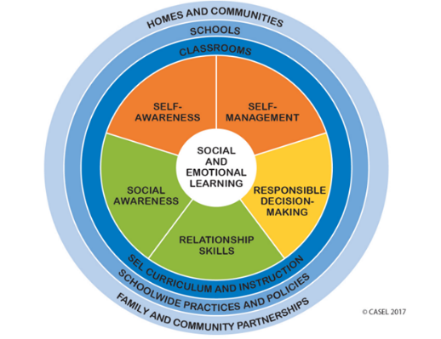
Arcola Elementary School •1820 Franwall Avenue, Silver Spring, MD • (301) 287-8585 • Principal: Mr. Emmanuel Jean-Philippe
Roscoe R. Nix Elementary School • 1100 Corliss St, Silver Spring, MD • (301) 422-5070 • Principal: Ms. Annette Ffolkes
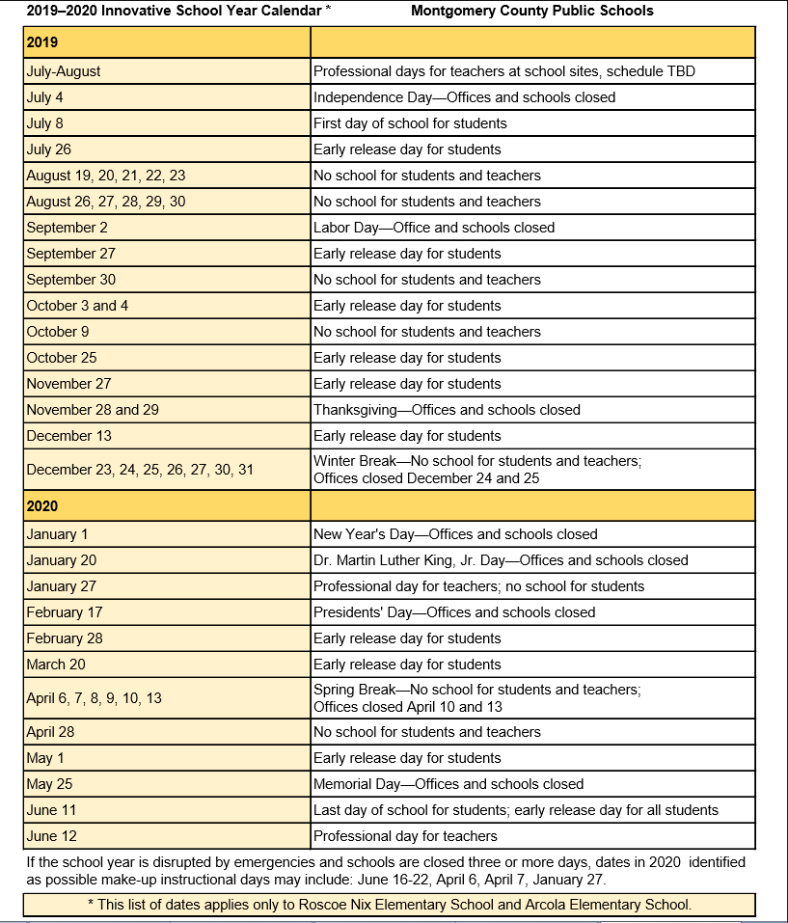
Extended School Year

