Improve Reading Comprehension
Help your child improve reading comprehension: a crucial reading skill, especially as he gets older & needs to glean information from books.

Here are five tips to improve reading comprehension in your early reader:
- Have him read aloud. This forces him to go slower, which gives him more time to process what he reads, which improves reading comprehension. Plus, he's not only seeing the words, he's hearing them, too. You can also take turns reading aloud.

- Provide the right kinds of books. Make sure your child gets lots of practice reading books that aren't too hard. She should recognize at least 90 percent of the words without any help. Stopping any more often than that to figure out a word makes it tough for her to focus on the overall meaning of the story.

- Reread to build fluency. To gain meaning from text and encourage reading comprehension, your child needs to read quickly and smoothly - a skill known as fluency. By the beginning of 3rd grade, for example, your child should be able to read 90 words a minute. Rereading familiar, simple books gives your child practice at decoding words quickly, so she'll become more fluent in her reading comprehension.

- Supplement class reading. If your child's class is studying a particular theme, look for easy-to-read books or magazines on the topic. Some prior knowledge will help her make her way through tougher classroom texts and promote reading comprehension.

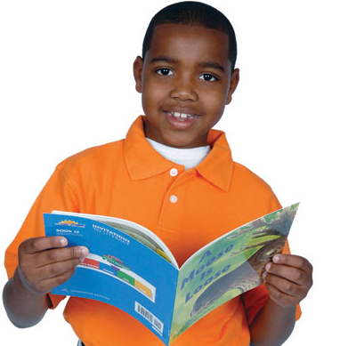
- Talk about what he's reading. This "verbal processing" helps him remember and think through the themes of the book. Ask questions before, during, and after a session to encourage reading comprehension. For example:
Before: "What are you interested in about this book? What doesn't interest you?"
During: "What's going on in the book? Is it turning out the way you thought it would? What do you think will happen next?"
After: "Can you summarize the book? What did you like about it? What other books does it remind you of?"

