|  |  |
| --- | --- |
|  |  |
|  |  |
|  |  |
|  |  |
|  |  |
|  |  |
|  |  |
|  |  |
|  |  |
|  |  |
|  |  |
|  |  |
|  |  |
|  |  |
|  |  |
|  |  |
|  |  |
|  |  |
|  |  |
|  |  |
|  |  |
|  |  |

We are a united, multi-cultural community of students, families, and educators committed to cultivating a love of learning, developing the character of great people and empowering children with the knowledge and skills to become productive citizens in the 21st century.

***Gator Gazette***

***November 2013***

### Glenallan Elementary School

**“*Where Gators Go Above and Beyond”***

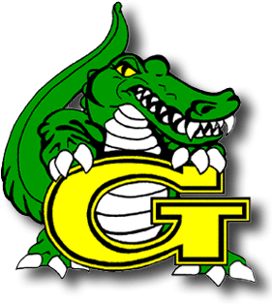

Dear Glenallan Families,

The month of November ends with Thanksgiving. Happy Thanksgiving to you and your families! Thanksgiving marks the occasion of two very different people coming together to sit down at one table and feast together. Glenallan is made up of so many different types of people, and our biggest strength lies in our diversity. Your child not only receives a great education but has the fortunate experience of learning from and growing up together with so many different children. As we consistently tell the Glenallan students learning can take place anywhere and all of us are teachers. We encourage our students to always be listening carefully to the words of people inside and outside of school because everyone you meet knows something that you don't. Be willing to learn from them. **If we are not learning, we are not living.**

During the month of November, we will continue to focus on exposing students to extraordinary learning opportunities and continuing to providing parents with opportunities to have a voice in their child’s educational experience.

* All Glenallan students (Kindergarten – Grade 5) will participate in an “Hour of Coding” during the second week in December in the STEM academy and in their classrooms. Please read more information on page 2 about coding and also the 7 tips to bring STEM learning into the home at the end of the Gazette.
* Parent Involvement Meeting on Wednesday, November 13 from 9:00 to 10:00 a.m. will focus on supporting you with your understanding of math curriculum 2.0 and how you can support your child at home.
* Congratulations to our 4th Grade students for doing an outstanding job during their visit to University of Maryland.
* Over 260 parents celebrated with us during the Halloween and Fall Festival activities! This demonstrates that we are truly becoming the community school that we all aspire to be.

This year, I am extremely thankful to be a part of such a dedicated and hardworking staff. The Glenallan staff is committed to providing an environment where all children and families are valued and where dynamic instruction and diversity in learning opportunities is thriving. I am thankful to be part of a community made up of different cultures that has all embraced the great responsibility of shaping the minds and influencing the character of the children of Glenallan. Happy Thanksgiving!

Respectfully,

Mr. Moran



**A School Where Character Counts**

Congratulations to those Students that earned Character Counts for the month of October, when we focused on the character trait **RESPONSIBILITY. Student names are below and are also on the school sign.**

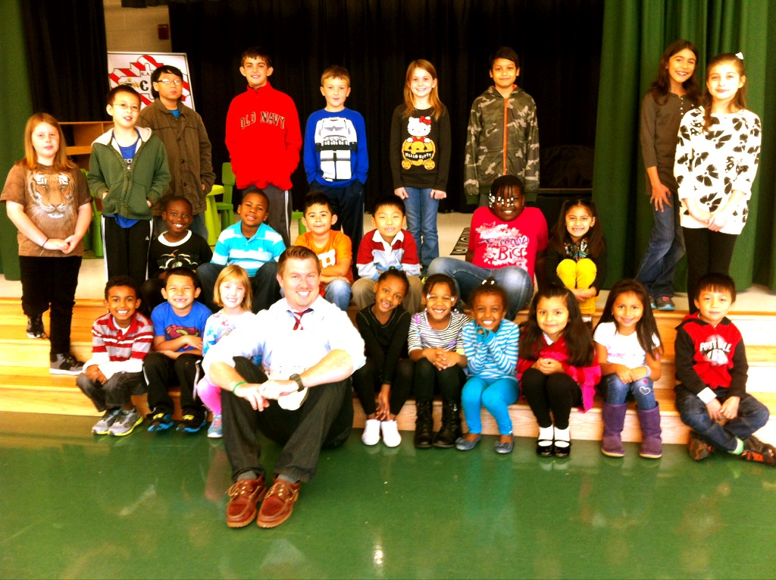

Janiah Proctor, Noami Demessie, Payton Morris, Bao Dinh, Jayden Martinez, Allison Ferrel, Samara Ley, Euel Dereje, Liliana Salguero, Nataly Reyes, Edwin Guzman, Sylvia Aguti, Edem Egbarin-Aho, Nathan Lee, Mohamed Ouattara, Ana Claire Edhegard, Joey Caporizzo, Kimberly Mallari, Jackson Navas, Valeria Mendoza Robles, Ansumana Tarawallie, Brad Vansandt, Sophie Pinard, Ana Smith, Marcela Perez-Armas, Josh Buendia



***One School, One Community, One Goal……….The Success of Every Glenallan Gator***



**All Gators will Participate in the “Hour of Code”**

**“Everybody in this country should learn how to program a computer . . . because it teaches you how to think.”- Steve Jobs**

During the week of December 9 – December 15 2013 all students in grades kindergarten through grade 5 will doing an hour of coding. This is a part of Computer Science Education Week, which is a celebration geared to encourage interest in the computer science and to show that anyone can learn the basics. We believe this is a wonderful opportunity to expose students to the way technology works and how it helps us to creatively solve problems. As you know, today, we’re surrounded by technology. Many students have their own tablets and phones—and yet, few are learning how computers actually work. Simple computer science activities can help nurture creativity and problem solving skills. By getting a feel for computational thinking early, students will have a foundation for success in any future career path.

**Important Facts About the Importance of Computer Science Education**

Students who learn introductory comput­er science show improved math scores.

• 90% of K-12 schools in the U.S. do not teach computer science.

• In many countries (including China, the United Kingdom and Australia), computer science is—or soon will be—required.

• All students can learn the basics, starting in elementary school, but fewer than 10% of students (and just 4% of female students, 3% of students of color) take computer science classes.



**News from First Grade –** *Mrs. Correa, Mrs. Ralph, Mrs. Lozzi, Ms. Rodriguez and Mr. Cord*

##### It has been a wonderful and exciting few months here at Glenallan!  We have been working so hard and are having a lot of fun learning about each other! First graders are reading texts at level and continue to progress at their own pace. Small group instruction in reading and math provides engaging learning experiences for all students and enables teachers to tailor instruction to the individual skills and needs of the students. In reading, the students have been using illustrations and text to identify the story elements of literary texts. Students have learned how to use text features to navigate and understand informational text. Our Gators have become real authors! They have worked extremely hard to complete their first narrative piece. Students have been following the writing process and will continue to revise, edit, and publish their writing.  The students are able to use multiple addition and subtraction strategies to solve number sentences and word problems. They have been collecting, organizing and interpreting data using tally charts, pictographs, and bar graphs. Did you hear about the bats in the first grade classrooms? Students were introduced to this mysterious mammal recently. Inquiry-based teaching methods were employed to dispel the myths that often surround bats and to teach the importance of bat conservation.



**News from Second Grade –** *Mrs. Navas, Ms. Shider Mrs. Grotewold, Mrs. Treichler, and Ms.Muhammad*

Second graders had a successful end of the first marking period!  They used collaboration and fluency to develop many concepts.  Students have learned about landforms on continents and the ocean floor.  They have written books about healthy eating and nutrition.  Students have also learned about good deeds and acts of kindness and the effects these have on others.  In the next marking period, students will enjoy learning about concepts such as addition and subtraction with 2 digit numbers, folktales, and writing like a scientist.  They will also create a stringed instrument in Music and S.T.E.M.  Please send in materials such as empty boxes, toilet paper rolls, and other recyclables that could be used for this project. You can support your child’s learning by checking their homework each night and being available to discuss what was learned in school.  Have your child read every day and read to your child every day!  Second graders must become fluent with solving basic facts.  You can help your child by using flashcards or asking them about their strategies. 



***One School, One Community, One Goal……….The Success of Every Glenallan Gator***

### Glenallan Elementary School

**“*Where Gators Go Above and Beyond”***

***Gator Gazette***

***November 2013***



**News from Third Grade –** *Ms. Davies, Ms. Edhegard, Mrs. Ghee, and Ms. Nansimbi*

The students in third grade are making great progress!  Here are some ways that you can help your child at home. Please continue to:

1. Check your child’s homework, (journal and math sheet), each day and encourage your child to do his/her best work.
2. Complete and return important forms promptly.
3. Take interest in what your child is reading. Ask questions about the reading and provide your child with positive feedback about their reading.

**Daily Homework consists of**: a math sheet, a homework journal content area focus, and reading for 15-20 minutes.

**Reminder:** Parent/Teacher conferences are being on held on Monday, November 11th and Tuesday, November 12th (or another date if previously arranged with the teacher). Please be sure to confirm your conference with your child’s teacher as soon as possible.

**Fun learning experiences**: Some educational activities you can share with your child this November are to read family recipes together and when you are grocery shopping, your child can estimate costs of Thanksgiving dinner items using addition, multiplication, and division.



**News from Fourth grade –** *Mrs. Mayer, Mrs. Hubbard, Ms. DeFrehn and Mrs. Walsh*

It is amazing how fast quarter one flew by! After your parent-teacher conference please review your child’s grades with him/her. This would be a good time to have a conversation about academic goal setting for the second quarter.

Reading — In the next few weeks we will be studying plays and poetry. We will identify the characteristics of each and compare the similarities and differences. Please monitor your child’s reading at home. They should be reading for at least 25 minutes each night and recording what they read on their reading log (due every Friday).

Math — Students will be learning different strategies to multiply up to a four-digit by a one-digit number. They will also learn area and perimeter formulas and how to apply them to a variety of problems. It would benefit children to work towards mastery of their multiplication and division facts.

Writing — Students will be delving into various styles of poetry and creating their own pieces.

Science — We will continue to learn about living and nonliving things, categorization in nature, and ecosystems.

Special Events and Reminders:

* Look for information in your child’s binder about our upcoming field trip on December 20th to the Newseum.
* With the weather changing daily, please be sure your child comes to school dressed appropriately for outdoor recess.



**News from Fifth Grade –***Ms. Gottshall, Mrs. Billings, and Ms. Jameson*

The fifth grade team is excited to meet with you during parent conferences on November 11 and 12th. Please confirm with your child’s teacher that you are able to attend the day and your time slot for your conference. The Thinking and Academic Success Skills (TASS) we have been focusing on this quarter is flexibility and collaboration. Flexibility is being open and responsive to new and diverse ideas and strategies and moving freely among them. Collaboration is working effectively and respectfully to reach a group goal. What does this look like in the classroom? In reading, we are forming and adjusting opinions about characters and events based on the author’s use of hyperbole (exaggeration) in tall tales. We are in the process of writing a proposal to MCPS on an energy efficient roller coaster by using the creative thinking skill of flexibility when analyzing sources. Students have been flexible in collaborative groups following the engineering plan by designing, and making a model of a roller coaster. In math, students are demonstrating flexibilities by using strategies to read, write, and compare decimals, to determine the method of computation based on the understanding of place value and properties of operations, as well as discussing in small groups, reasonable responses by comparing strategies to help understand a problem.



***One School, One Community, One Goal……….The Success of Every Glenallan Gator***

We are a united, multi-cultural community of students, families, and educators committed to cultivating a love of learning, developing the character of great people and empowering children with the knowledge and skills to become productive citizens in the 21st century.

***Gator Gazette***

***November 2013***

### Glenallan Elementary School

**“*Where Gators Go Above and Beyond”***



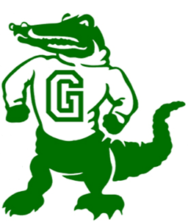

|  |  |
| --- | --- |
|  |  |
|  |  |
|  |  |
|  |  |
|  |  |
|  |  |
|  |  |
|  |  |
|  |  |
|  |  |
|  |  |



**Monthly Reading Strategy** *from Mrs. Monti and Ms. Ziadi*

When you and your child are reading together, what strategies do you notice he or she is using? Are they stretching out their words, skipping words and going back, and asking themselves if what they read makes sense? Below is a list of strategies your child uses in school. Please encourage your child to use these strategies when reading with them!







**Physical Education News –** *Mr. Kogok*

Greetings from the Physical Education Department.  Thank you to everyone who came out for our Fun Run and Jump Rope For Heart/Hoops For Heart Event.  We raised over $1400 ! During the second quarter our little ones in Kindergarten and first grade are learning to throw a ball underhand.  Second graders are learning an overhand throw.  Our older students are learning to throw and catch while moving in dynamic situations.    All of our students should be practicing the skills taught in PE class when they are home.  Please help them to practice and master these skills. Parents please make note of the day of the week your child has Physical Education and be sure they wear sneakers on that day……even if it is raining, snowing , picture day ,  etc. etc.  Remember that you can always put their sneakers in their backpack if you need them to wear boots due to the weather.   Thank you so much for your support.



***One School, One Community, One Goal……….The Success of Every Glenallan Gator***

### Glenallan Elementary School

**“*Where Gators Go Above and Beyond”***

***Gator Gazette***

***November 2013***

|  |  |
| --- | --- |
|  |  |
|  |  |
|  |  |
|  |  |
|  |  |
|  |  |
|  |  |
|  |  |
|  |  |
|  |  |
| The Glenallan Science Club works on preparing the school gardens for planting. Thank you to Mrs. Alvarado and Mrs. Vanegas for your leadership of the Glenallan Gardeners |  |



**News from Kindergarten-***Ms. Yetter, Ms. Miller, Mrs. Frank, Mrs. Beckett, and Ms. Ali*

The Kindergarteners have been hard at work getting used to the school routines and responsibilities. They have done such a great job so far. We had a great field trip to the farm first quarter and successful Halloween parties. Thank you to all the parents that have helped out so far. The kindergarten teachers are looking forward to meeting each of the parents and discussing your child’s progress so far this school year at parent teacher conferences. The kindergarten teachers would like for you to continue working on identifying letters and naming letter sounds for all the letters in the alphabet. Practice the word wall words at home as well, if you do not have a copy of these please ask your child’s teacher. Continue to read to your child every night and find the kindergarten word wall words in your books. Work with your child on counting and identifying numbers. Talk with them about the seasons and the changes the weather has made, they will be able to tell you a lot about this. Thank you for all you do!!!



**MUSIC –** *Mr. Tilkens* 

Thank you to everyone who donated their recyclables! The recyclables will be used in the month of November for Music and STEM lessons. 2nd grade students have been learning about the instrument families and how sound is produced. The students will be exploring different ways of making sounds and ultimately making their own percussion instruments in STEM.

This is a reminder to all 4th and 5th grade students in chorus. The winter concert will be held on Wednesday December 18th at 7pm in the Glenallan all purpose room. Dress for the instrumentalists and chorus will be white tops and black bottoms. Students should be accessing the practice files for chorus by going to the website: <http://ztilkens.wix.com/glenallanchorus> , you can also access the site by going to the main Glenallan website, clicking the “Classrooms” link and then “Music”

Congratulations to Maha Melicio, Tiffany Begazo, and Francesca Gasasira who were chosen out of 26 students to represent Glenallan in the 2013-2014 South Honors Chorus. We are very proud of them and know that they will do a great job!

Reader’s Theater is busy preparing for their performance of “One eyes, two eyes, three eyes”, an adaptation of a Grimm fairytale. The performance will go on sometime in December and will be open to parents and family.

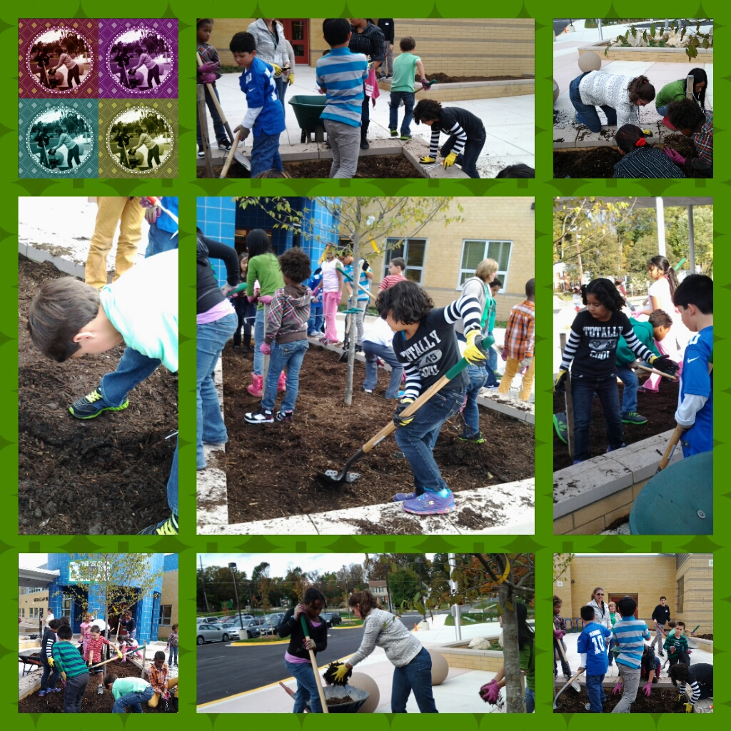



***One School, One Community, One Goal……….The Success of Every Glenallan Gator***

***Gator Gazette***

***November 2013***

### Glenallan Elementary School

**“*Where Gators Go Above and Beyond”***

### Glenallan Elementary School

**“*Where Gators Go Above and Beyond”***



|  |  |  |  |
| --- | --- | --- | --- |
|  |  |  |  |



November 11 Half Day for Students: Dismissal 12:35

November 12 Half Day for Students: Dismissal 12:35

November 13 Parent Involvement Meeting 9:00 a.m.

November 20 2nd Grade to Strathmore

November 22 Pancakes with the Principals

November 27 Half Day: Thanksgiving Holiday

November 28 No School: ThanksGiving

November 29 No School: Thanksgiving



**Character Counts:**

The character trait for the month of November is **Gratitude.** Staff will be looking for students demonstrating respect at school, in the community, and focusing on it through instruction.

**Hats and Gloves**

If you are in need of hats or gloves, come to the office and see Mrs. Hirst or Mrs. Brashers

|  |  |  |
| --- | --- | --- |
|  |  |  |



**Community Day Drop-In Coffee with Dr. Starr**

On Thursday, November 21, 2013, Superintendent Joshua Starr will be spending the entire day in the Downcounty Consortium (DCC)—Montgomery Blair, Albert Einstein, John F. Kennedy, Northwood, and Wheaton clusters. As part of this Community Day, Dr. Starr will hold a drop-in coffee for all elementary school staff in the DCC at Oakland Terrace Elementary School, 2720 Plyers Mill Road in Silver Spring. The coffee will run from 7:15 to 8:15 a.m. and will be an opportunity for staff to meet and talk with Dr. Starr in an informal setting. I hope you will be able to drop by and join Dr. Starr on the morning of November 21.Other Community Day events on November 21 will include school visits by Dr. Starr throughout the day; an afternoon coffee for secondary school staff in the DCC at Northwood High School from 3:15 to 4:15 p.m.; and a Town Hall meeting for parents and community members from 7:30 to 9:00 p.m. at Montgomery Blair High School. Additional information about Community Days is available on the MCPS website at [www.montgomeryschoolsmd.org](http://www.montgomeryschoolsmd.org), search “Community Days.”



**MyLunchMoney.com**

myLunchMoney.com is a service which allows parents to make prepayments to their child’s cafeteria account with a credit/debit card using the Internet. Once the account is established, you can check balances, view student purchases, set up recurring payments, and receive low balance e-mail notification. Prepayments will generally be available at the school the next day. Go to [www.myLunchMoney.com](http://www.mylunchmoney.com/) and click on ***“Enroll Now.”*** For more information, click here to refer to **Frequently Asked Questions (**[**English**](http://www.montgomeryschoolsmd.org/departments/foodserv/debitsystem/mlmfaq.pdf) **or** [**Spanish**](http://www.montgomeryschoolsmd.org/departments/foodserv/debitsystem/spamlmfaq.pdf)**)**.

***Important Dates for the Gators in November***

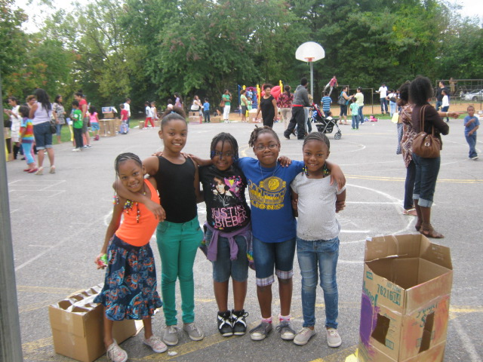

*As we express our gratitude, we must never forget that the highest appreciation is not to utter words, but to live by them.*  
[John F. Kennedy](http://www.brainyquote.com/quotes/authors/j/john_f_kennedy.html)