|  |  |
| --- | --- |
|  |  |
|  |  |
|  |  |
|  |  |
|  |  |
|  |  |
|  |  |
|  |  |
|  |  |
|  |  |
|  |  |
|  |  |
|  |  |
|  |  |
|  |  |
|  |  |
|  |  |
|  |  |
|  |  |
|  |  |
|  |  |
|  |  |

### Glenallan Elementary School

**“*Every Gator Rises to Extraordinary Excellence”***



**Important May 2014 Dates**

**May 20 – PTA Meeting 7:00 p.m.**

**May 21/May 22 – Kindergarten Orientation**

**May 26 -Memorial Day – No School**

**May 28 – Spring Concert 7:00 p.m.**

[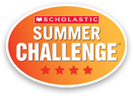](http://www.scholastic.com/ups/campaigns/src-2013)

Dear Glenallan Families,

The inaugural year in the “new” Glenallan Elementary School is almost over. In one year time, I feel that are students, parents, and staff feel it is home. I believe we have begun to create a true “community school” where we share the belief that positive relationships lead to positive academic and character results. We have only a few weeks left and it is important that we end the school year with success and strength. This year we have begun to implement progressive educational initiatives such as our STEM academy and STEM centric learning, exposure to 21st century learning such as coding and robotics, focus on engaging students in intellectual discussions and exposure to experiences such as college visits, speakers from various careers, and beginning to teach children with their interests in mind. This is just the beginning and our momentum will lead to “big things to come for the Glenallan Gators.”

At the end of the school year I am always reminded of the quote "The true meaning of life is to plant trees, under whose shade you do not expect to sit.” I believe that together as one community we have planted some beautiful trees that will grow tall and strong and stand for the rights things in our world. Thank you for all your support this school year!

**Glenallan Featured in the National Education Association NEA Magazine**

Glenallan Elementary is featured in the National Education Association Magazine's 2014 spring issue [http://www.nea.org/home/58863.htm](https://webmail.mcpsmd.org/owa/redir.aspx?C=SU1LuCS0M0SFL-xD8IugKaosy2mXQtFIzXCLfEDDgL0WsWv4SgR1PjHsc5tBwqHxw41ZWfuywsg.&URL=http%3a%2f%2fmontgomeryschoolsmd.us8.list-manage.com%2ftrack%2fclick%3fu%3d6deb70d38552b1f0f33e8822a%26id%3dd6379a7550%26e%3d812572a00f) On the cover, is Glenallan 4th grader Justice Elliot.  Justice is a wonderful representation of the motivation, enthusiasm, and perseverance of all of our students.  This article represents our community's shared vision of providing a well-rounded and personalized education experience for every Glenallan student.  This recognition is a credit to our extraordinary students, committed and exceptional staff, and you our encouraging and supportive parents. Please join me in celebrating our wonderful school community.  This recognition will be used as motivation as we continue to work together to implement an educational experience that develops well rounded learners of high character.



**Summer School at Glenallan!!!!**

Students who will be in grade 1, grade 2, and grade 3 next school year are eligible to attend summer school at Glenallan. This is a great opportunity for an extra month of teaching and learning for the Gators. Information will be coming home on Monday for you to register your child.



**Kindergarten Orientation**

Kindergarten Orientation for Incoming Glenallan Kindergarteners will be held on Wednesday, May 21, and Thursday, May 22. This is an opportunity to build relationships with the staff, fellow parents, and your child’s future classmates. Important information will also be provided about the instructional program, and of course, registration information for Kindergarten. Please contact Mrs. Brashers to schedule a time for your child to attend kindergarten orientation. She can be reached in the main office at 301-929-2014. Please note that there will be no school for Kindergarten students on both May 21 and May 22.



**Message from the Glenallan Reading Team – Mrs. Monti and Ms. Ziadi**

Last summer, Glenallan participated in the **Scholastic Summer Reading Challenge*.*** The Summer

Reading Challenge is a free reading program dedicated to stopping the “Summer Slide” and encouraging kids to read more books during the summer months. This past summer we read the most minutes in the state of Maryland! Go Glenallan! Our name was recorded in the book of *Guinness World Records.* This summer let’s try to read the most minutes in the whole country.

It is important to keep in mind that even though summer is quickly approaching, that does not mean that reading and learning has to stop! Studies have shown that children who read in the summer gain a month of reading proficiency while those that do not read tend to lose two to three months of reading development.

This summer, we are encouraging our Gators to participate in the **Scholastic Summer Reading Challenge** for the second time. This challenge begins on **May 5th, 2014** and will continue throughout the summer. The theme this year is “Reading Under the Stars.” As students log their reading minutes online, they will participate in weekly space-theme challenges, unlock fun facts about constellations, as well as earn digital rewards. We are going to make sure our students are reading and ready for the 2014-2015 school year. More information will be sent home soon about the **Scholastic Summer Reading Challenge**. Go Gators!



***One School, One Community, One Goal……….The Success of Every Glenallan Gator***

***Gator Gazette***

***May 2014***



**First Grade News – Mrs. Correa, Ms. Rodriguez, Mr. Cord, Mrs. Lozzi, and Mrs. Ralph**

The 1st grade team wants to thank all the staff and parents who came out to help with the Bird House making activity and for coming along with us to the National Building Museum. The first graders were so excited to finally go and have great STEM-related experiences. Our last scheduled field trip will be in June when we go to the Maryland Science Center but we are trying to organize one more field trip to Brookside Gardens. Stay posted! This month we encourage you to support your children in the gains they have made in reading. The reading target is to read on a level 16 by the end of the year. Please make sure they are reading nightly. In math we continue to add and subtract one and two digit numbers drawing tens and ones to help us solve the problem. We will also begin geometry and compare shapes by talking about their attributes; how many edges or vertices? In science and writing we learn and write about electricity. We will write an informative piece about electricity. In Social Studies we are learning the difference between human, natural and capital resources as well as goods and services. We also continue learning how we can conserve our natural resources. We just finished up our poetry unit, we hope your children talked about wonderful words and amazing adjectives, which are examples of alliteration. Thanks again for your support.



**Second Grade News – Mrs. Navas, Mrs. Grotewold, Ms. Shider, Mrs. Treichler, and Ms. Muhammad**

For the rest of the marking period we will focus on the skills of effort, motivation, and persistence.  Students will be learning what these words mean and applying them to their own learning.  Students will be examining their own accomplishments to see what was their motivation and how did  they use effort.  They will write about their accomplishment and create a timeline to show what happened chronologically.  Students will also research about a famous person in history who used effort, motivation and persistence in order to be successful in their lives.  Then they will compare themselves to the famous person.  As we study effort, motivation, and persistence students will be setting goals and using effort to reach their goals.  You can encourage this at home too!  Please share with your child about a time when you were motivated toward a goal and used effort/persistence to reach the goal!  Ask your child to tell you about a goal they have at school or at home!



**Message from School Counselor: Mrs. Lyons**

This month in Guidance Mrs. Lyons held Guidance lessons in grades (3-5). The lessons highlighted Internet safety. Each student was given an Internet safety pledge. We discussed the pledge and related the pledge to real life issues. Students were given the opportunity to dialogue about the importance of being safe online. In addition, students were able to view the NetSmartz videos that reinforced the following:

* Not sharing personal information to someone you have never met in person.
* Never meeting a stranger in person.
* Informing parents if someone has said something to make you feel uncomfortable or afraid.
* Setting up rules for going online with parents.

Parents, the Internet has drastically changed the way that children interact with the world. They have access to in-depth knowledge, tools to express their creativity, and people from all over the world. Yet along with offering a fascinating, new way to connect with the world, the Internet also offers new risks such as:

Cyberbullying

Exposure to inappropriate material

Online predators

Revealing too much personal information [**more**](http://www.netsmartz.org/InternetSafety)http://www.netsmartz.org/NetSmartz_v3/images/issue/orange-arrow.gif

As parents, you can create ground rules and discuss your expectations for appropriate online communication. Learning to recognize the warning signs of these risks will allow trusted adults to intervene and lessen potential negative impacts. By acting as a resource, parents and guardians can help make the Internet a safer place for their families. As a parent or guardian, you shouldstay well-informed about current issues to understand what your children are experiencing on and off the Internet. If they are social networking, instant messaging, using webcams, or gaming, help them use these tools safely by learning how to use them yourself. Children whose parents and guardians regularly talk to them about personal safety are more likely to exhibit responsible behavior on their own. The NetSmartz web-site invites you to learn about the issues surrounding your children’s online lives. Then use the discussion starters to help you begin a dialogue about safety with your children.



***One School, One Community, One Goal……….The Success of Every Glenallan Gator***

***Gator Gazette***

***May 2014***

### Glenallan Elementary School

**“*Every Gator Rises to Extraordinary Excellence”***

***Gator Gazette***

***May 2014***

|  |  |
| --- | --- |
|  |  |
|  |  |
|  |  |
|  |  |
|  |  |
|  |  |
|  |  |
|  |  |
|  |  |
|  |  |
|  |  |



**News from Third Grade-***Ms. Davies, Ms. Edhegard, Mrs. Ghee, and Ms. Nansimbi*

**Zoo Field Trip**: Our students have been researching topics to develop opinions for writing. In science this quarter, we have been discussing different habitats. In addition we have learned how plants and animals adapt in order to survive in the different climates. As a culmination of our science unit we will be traveling to the National Zoo on Friday, May 23rd, 2014.

**Multiplication Facts**: As you know, the goal is for 3rd graders to know all products, from memory, of 2 one-digit numbers. Please continue to practice these facts, daily, with your child.

**Telling Time:** Please practice having your child to tell time on an analog (non-digital) clock to the nearest minute. Also, create real life elapsed time problems for your child to solve. For example: You woke up at 7:30 this morning and left your house for school at 8:50. How much time has passed?

**Donations Needed:** Your children have been hard at work at school! As a result, we are in need of additional Clorox wipes, tissues, pencils, post-it notes, and erasers. We truly appreciate any items that you might be able to contribute. Thank you in advance!!

**A Few More Weeks:** As school is drawing to a close, we need to remind students that they need to continue to focus and put forth their best efforts to be the best student they can be.

As always, please let us know if you have any questions or concerns!



**News from Fifth Grade – Ms. Gottshall, Mrs. Billings and Ms. Jameson**

Happy Spring!!! We hope you and your families had a wonderful spring break. Well, it is almost that time of the year; the countdown to the 5th Grade Promotion. Go ahead and get your calendars out so that you can mark the dates of the upcoming events.

**May 27** – 5th / 6th grade Mixer at Lee Middle School 5:00- 7:00 – students received a flyer from the Lee Principal, Kimberly Hayden Williams when she came to Glenallan to meet the incoming 6th graders on April 22.

**May 28** – Chorus Performance 7-8:30

**June 3**- Field Day

**June 5** – Third Annual Talent Show 6:30-8:30 at Kennedy High School

**June 10** – Awards Ceremony

**June 11** – Promotion Ceremony 10:00 – 12:00 at Kennedy High School

Please contact us if you have any questions regarding these events. We look forward to a fun and exciting end of the school year as the 5th grade students reflect and celebrate on their years spent as a Glenallan Gator.



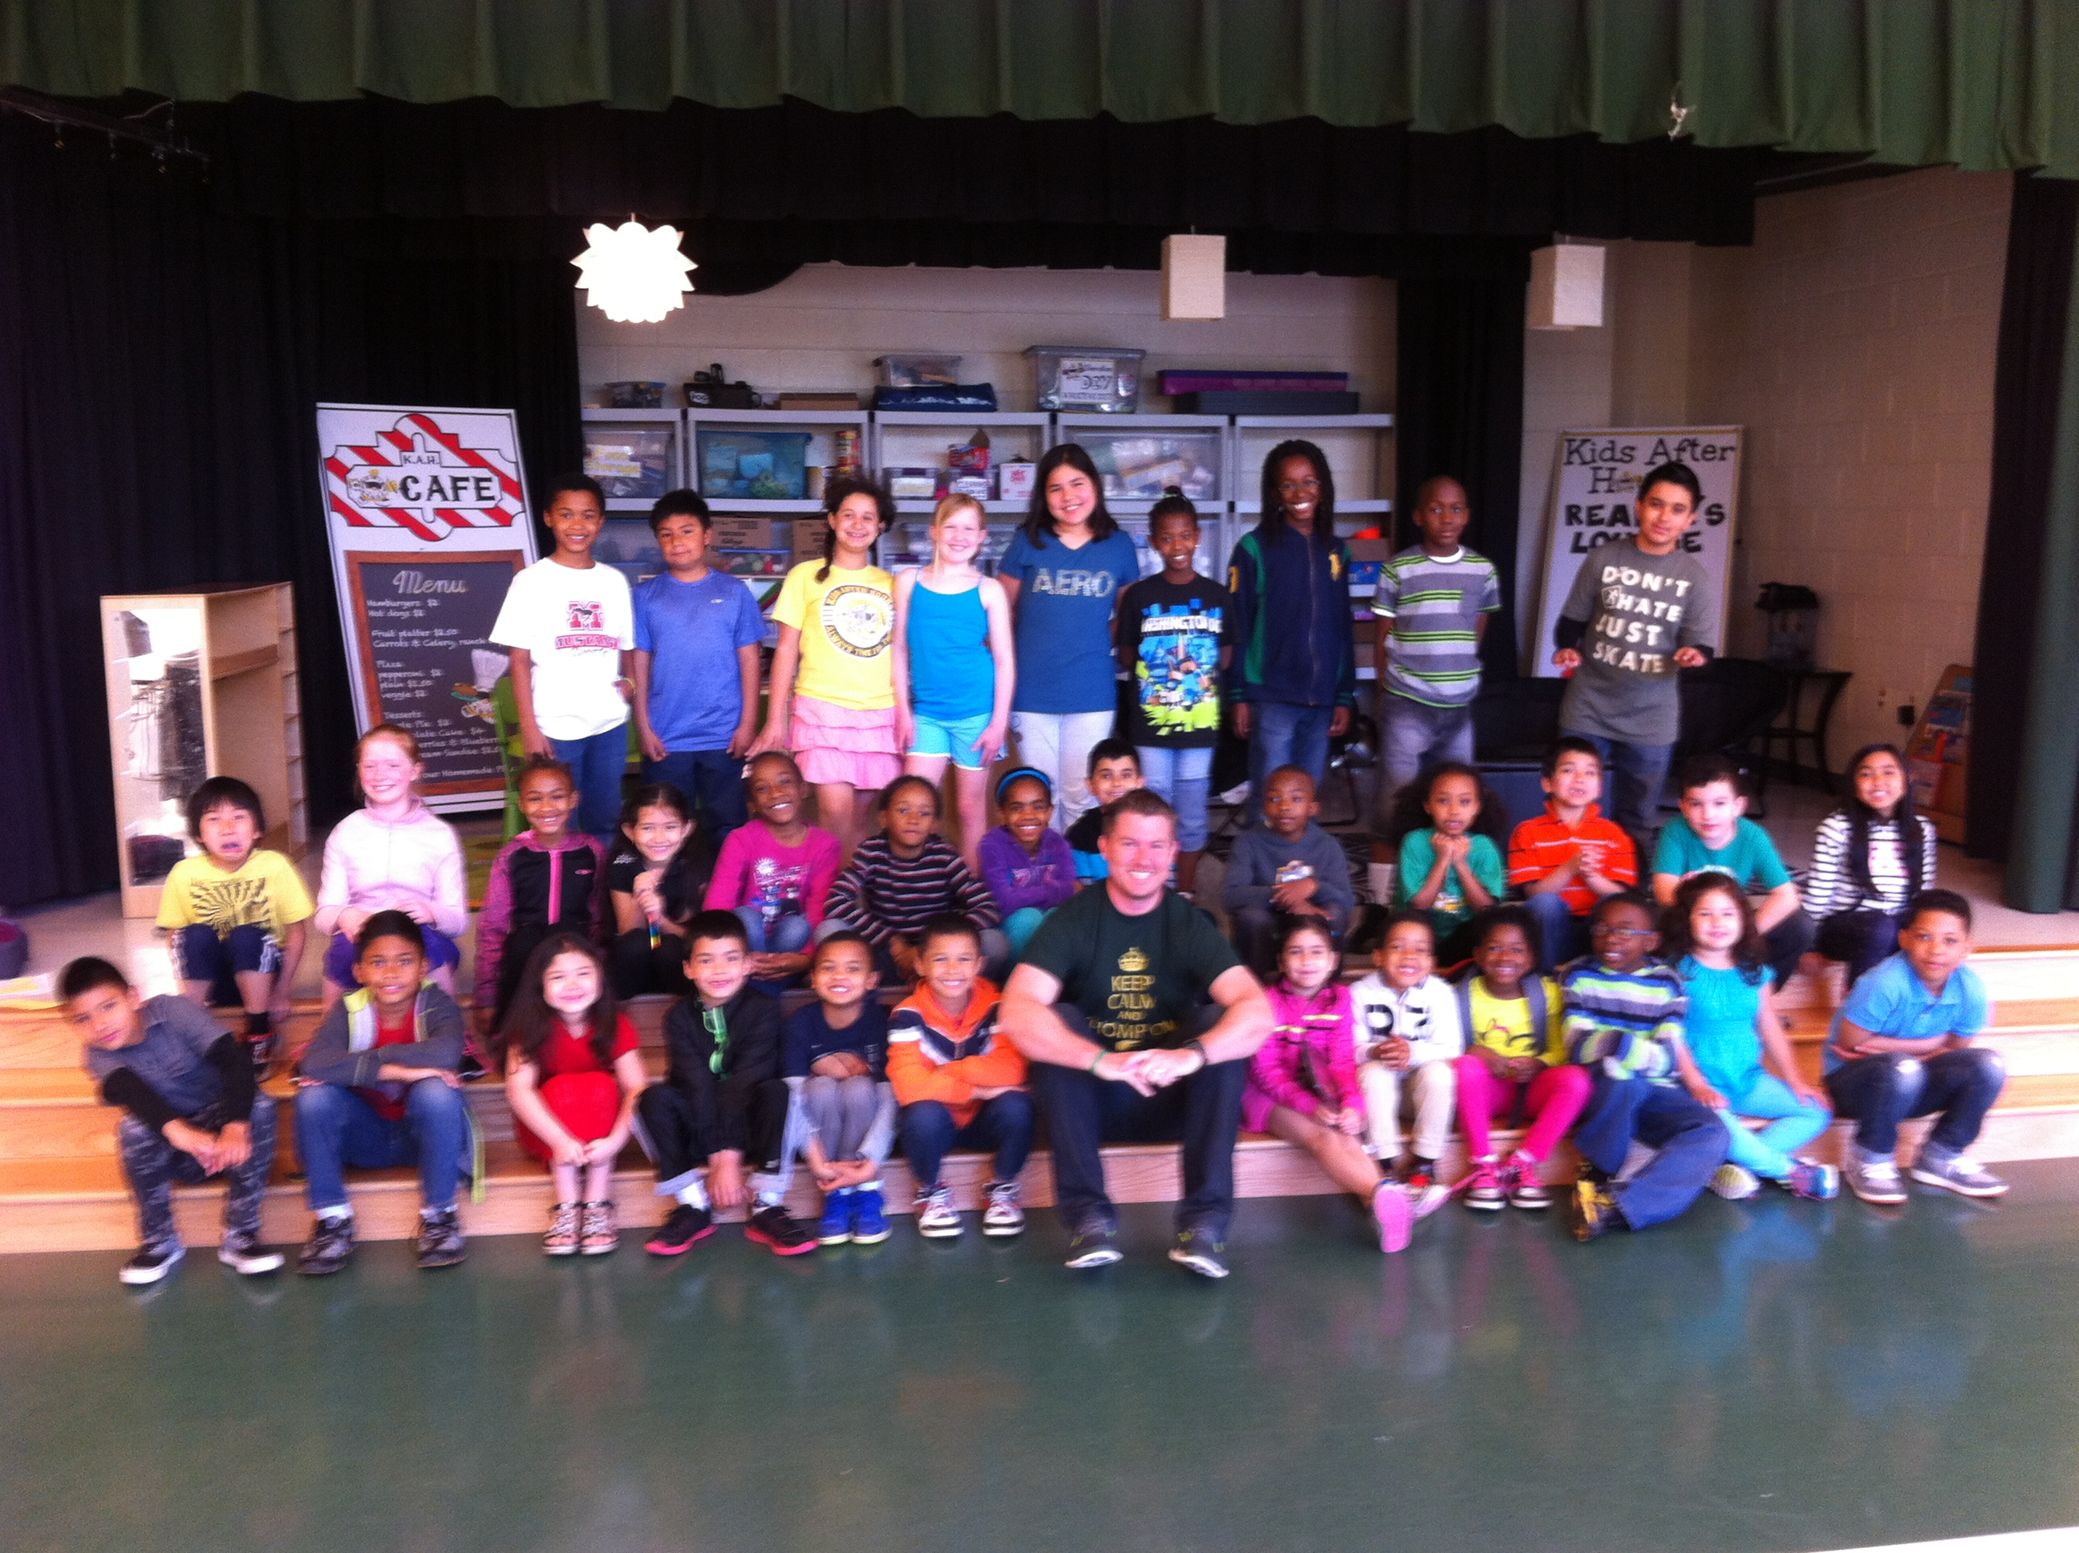



***One School, One Community, One Goal……….The Success of Every Glenallan Gator***

### Glenallan Elementary School

**“*Every Gator Rises to Extraordinary Excellence”***

|  |  |
| --- | --- |
|  |  |
|  |  |
|  |  |
|  |  |
|  |  |
|  |  |
|  |  |
|  |  |
|  |  |
|  |  |
|  |  |
|  |  |
|  |  |
|  |  |
|  |  |
|  |  |
|  |  |
|  |  |
|  |  |
|  |  |
|  |  |
|  |  |
|  |  |
|  |  |
|  |  |
|  |  |
|  |  |
|  |  |
|  |  |
|  |  |
|  |  |
|  |  |
|  |  |
|  |  |

### Glenallan Elementary School

**“*Every Gator Rises to Extraordinary Excellence”***





**News from The ART ROOM – Mrs. Vanegas**

**Please Save the Date!!** Students in K- 2 ,PEP and Head Start will be having an **Art Show Opening** at Glenallan on **Wednesday, May 28th starting at 6:30 pm** this is the same night as the Choral concert. The art show will be up until 4pm, Friday, May 30th . We hope you can come out and see what wonderful things our younger student have produced!

**Congratulations** go out to our students whose art work was displayed in the Elementary Arts Fair at Lakeforest Mall. Those students in **4th grade** were Anja M, Andy N, Bryan M, Tafawa . Jr, Andrea V, Sophie J, Sophie P, Gerald M, Gabryel A, Ryan L, Michael G, Brian M. Karem S, Ashley N, Joseline C**, 3rd graders** Ariho N, Rachel I, Alex N, Ysaak W, Yaphet L. **Head Start** students were Lazarus C, Angel F, Jahirah C, Jeremiah T, Isabella C, Mai-Liw G, Anthony G.



**News from The Glenallan Media Center – Mrs. Bean and Mrs. Marley-Emery**

April is Poetry Month! Many of our Gators are reading, writing, and publishing poetry. Some of their favorite poets are Shel Silverstein and Jack Prelutsky. Ask them about their own writing and their favorite poet. This marking period students will also be working on research inquiry projects. They will be using many online resources to find information and publish their findings. 2nd graders will choose an accomplished person to research. 3rd graders will write a newsletter article about an issue they are interested in. 4th graders will research a self-selected science inquiry question to write an informational article and an opinion piece. 5th graders will be looking to the future in researching a career of their choice. They will be creating a powerpoint to describe their career choice and how it might change, or even exist, in the next 15-20 years!



**News from The Glenallan STEM Academy- Mrs. Joa**

As our first year at the STEM Academy comes to a close students continue to engage in more engineering activities that further enhance their knowledge of science, technology, engineering and math. Here is an overview of what students have to look forward for the last quarter!

Kindergarten- Seeds and Growth: Students explore the world of agricultural as well as environmental engineering by analyzing the life cycle of plants. Students will also plant and grow their own seeds!

First grade – Designing Water Filters: Students become environmental engineers by creating water filters that can effectively clean polluted/contaminated water.

Second Grade- Designing Lighting Systems: Students love this unit, where they get to become optical engineers and create a lighting systems to light the inside of an Egyptian tomb!

Third grade- Improving a Play Dough Process: Students currently work as chemical engineers on changing low quality play dough into high quality play dough.

Fourth grade – Designing Submersibles: Students become ocean engineers by designing, creating and testing their own submersibles!

Fifth grade – Maglev Systems/ NXT-G (robotics): Students are in the process of completing their own Maglev Transportation tracks and vehicles, once finished with the unit they will begin exploring the world of robotics!



**News from Music – Mr. Tilkens**

The Spring music concert featuring our instrumentalists and chorus, is fast approaching. The concert will take place at 7pm on Wed May 28th in the Glenallan APR. Students should arrive at 5:45 pm for a final rehearsal. I appreciate parent cooperation getting the students to this earlier-than-usual rehearsal.  Students that are only in band should arrive no later than 6:30 PM. Dress is white top, black bottom. 5th grade has recently been learning about what qualities make up a good song and even got a chance to pick their own promotion song. 4th Grade is perfecting singing partner songs and rounds. 3rd grade continues to work on their recorder skills. Each third grade class is at a different spot in the recorder karate program, but I am very pleased with their progress considering all the lost snow days. Kindergarten and 1st Grades have been hard at work training their ears in "directional hearing". Students have been play games called "Which sound am I" and "Where am I?" that help with how students make sense of the sounds that they hear. Second grade has been practicing their sight singing and playing xylophone to popular songs.  
**\*Special invitation to 5th grader students!**  
If you are fifth grade student who is not in chorus, you are cordially invited to perform the 5th grade promotion song: Wavin' Flag by K'naan as part of our Spring music concert on Wed May 28th in the Glenallan APR. No need to RSVP, when it comes time to sing the song, I will extend the invitation for any graduating 5th graders to come up on stage.



***One School, One Community, One Goal……….The Success of Every Glenallan Gator***

***Gator Gazette***

***May 2014***

### Glenallan Elementary School

**“*Every Gator Rises to Extraordinary Excellence”***



|  |  |
| --- | --- |
|  |  |
|  |  |
|  |  |
|  |  |
|  |  |
|  |  |
|  |  |
|  |  |
|  |  |
|  |  |
|  |  |

|  |  |
| --- | --- |
|  |  |
|  |  |
|  |  |
|  |  |
|  |  |
|  |  |
|  |  |
|  |  |
|  |  |
|  |  |
|  |  |
|  |  |

**Spring 2014 Parent Academy Schedule**

Registration is open for the 2014 spring session of the MCPS Parent Academy. Parent Academy workshops give parents useful tips and tools to support their children’s success in and out of school. A wide array of topics will be covered during the spring season including: college entrance exams, effective parenting strategies, cybersafety and social media.

**Gaithersburg Book Festival**

The 2014 Gaithersburg Book Festival will be held on Saturday, May 17, 2014, on the grounds of Gaithersburg City Hall. The festival features a great lineup of authors and activities for children of all ages. Several members of the MCPS community will be conducting readings at the festival, and there will be many programs, workshops, and activities in the Children’s Village that are designed to promote interest in reading and writing. For more information about the festival, visit [www.gaithersburgbookfestival.org](http://www.gaithersburgbookfestival.org). A blurb is provided below.

**MCPS Special Education Summit Set for May 17**

MCPS parents, staff, and community members are invited to the Special Education Summit, *Leading the Way Today*, *Partnering for a Better Tomorrow*. The summit will take place on Saturday, May 17, 2014, 8:15 a.m. to 2:30 p.m. at Rockville High School. The summit will feature resources and workshops for families of students with disabilities. Families also will have an opportunity to meet representatives from various MCPS offices and Montgomery County agencies and nonprofit organizations. Please share this information with your school community. Registration for the summit can be completed at [www.mcpsparentacademy.org](http://www.mcpsparentacademy.org). A blurb is provided below.



May 20 PTA Meeting 7:00 p.m.

May 21 K Orientation: No School for Kindergarten

May 22 K Orientation: No School for Kindergarten

May 26 Memorial Day: No School

May 28 Spring Concert and Arts Show

May 30 Pancakes with the Principals

June 3 Field Day Grade 3 – 5

June 4 Glenallan Talent Show

June 5 Field Day Grade Head Start - 2

June 11 5th Grade Promotion



**Character Counts:**

The character trait for the month of May is Caring**.** Staff will recognize students who demonstrate honesty at school, in the community, and focusing on it through instruction.

[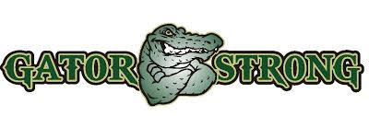](http://www.google.com/imgres?imgurl=http://rbhs.lexington1.net:8044/wp-content/uploads/2013/06/Gator-Strength.jpg&imgrefurl=http://rbhs.lexington1.net:8044/2013/2042/&h=366&w=1157&tbnid=x15ttBgCzMx_JM:&zoom=1&docid=k2kd1J3Rbch_pM&ei=pAU-U7WsD8Tx0gGzxICACg&tbm=isch&ved=0CEIQhBwwEzhk&iact=rc&dur=1294&page=6&start=99&ndsp=22)

|  |  |  |
| --- | --- | --- |
|  |  |  |

