|  |  |
| --- | --- |
|  |  |
|  |  |
|  |  |
|  |  |
|  |  |
|  |  |
|  |  |
|  |  |
|  |  |
|  |  |
|  |  |
|  |  |
|  |  |
|  |  |
|  |  |
|  |  |
|  |  |
|  |  |
|  |  |
|  |  |
|  |  |
|  |  |

**Vision: We are a united, multi-cultural community of students, families, and educators committed to cultivating a love of learning, developing the character of great people and empowering children with the knowledge and skills to become productive citizens in the 21st century.**

***Gator Gazette***

***March 2013***

### Glenallan Elementary School

**“*Where Every Gator Go Above and Beyond”***



Dear Glenallan Families,

Every once in a while you have the opportunity to show people exactly who you are. There comes a time when the talking stops and it is simply time to perform. The seldom opportunity to show people who you are simply through your actions. It is important that our students, our school, our community thrive on these opportunities. On March4, Glenallan Elementary School has this opportunity. The Maryland School Assessment provides our proud community the chance to make a statement. This statement is one that I believe will exceed the expectations of everyone who are invested in GES. The MSA dates are as follows;

|  |  |  |
| --- | --- | --- |
| Date | Grade Level | Section |
| March 4 | Grade 3/Grade 4 | Reading |
| March 5 | Grade 3/Grade 4 | Reading |
| March 6 | Grade 5 | Reading |
| March 7 | Grade 5 | Reading |
| March 8 | Grade3/Grade 4 | Math |
| March11 | Grade3/Grade 4 | Math |
| March 12 | Grade 5 | Math |
| March 13 | Grade 5 | Math |

We held our second annual “Pep Rally” today. It was a special moment to see the school united in Glenallan green and hear and see our “Gator Pride.” The Kennedy High School Cheerleaders and the Paint Branch Drum Line joined us to celebrate the pride in being a Glenallan Gator. Listening to the students make motivational speeches and sing inspirational songs was a memorable event. It’s a special thing to be a Glenallan Gator and you could hear that through the way we believe in one another.

I believe very strongly that our students, your children, are ready to show what they know. I know that your children believe in themselves because this message has echoed throughout the hallways of Glenallan Elementary School since the school doors opened in August. It has been a wonderful experience to watch your students create and adopt a vision that is defined by believing that any goals are attainable, and what many students have thought is impossible is possible. These are a special group of students and your support has played a significant role in preparing them for this opportunity to demonstrate the progress of our journey. I encourage you to help your students prepare themselves for the test. Please help them to realize that all that counts is putting forth your best effort into performing to your potential and to **be the best they can be** and success will surely follow.

It has been said that Thomas Edison made over 10,000 attempts to light the light bulb. In response to being asked by a friend what if he had stopped at 9,999 he said, “Many of life's failures are people who did not realize how close they were to success when they gave up. As with all academic and character challenges, our perseverance and belief will lead to Gator Success!



This is what ood Character Looks Like – Congratulations Character Count Winners for February

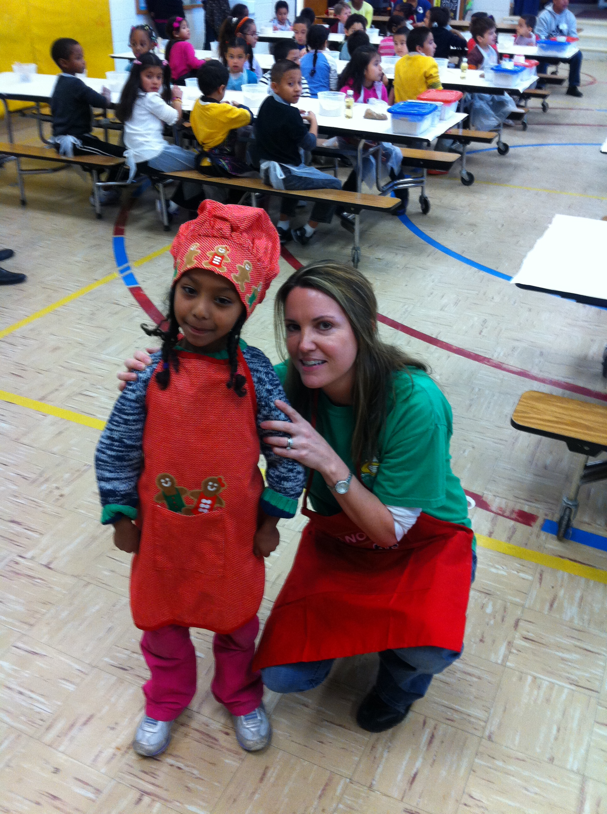



***One School, One Community, One Goal……….The Success of Every Glenallan Gator***





**Tools for Critical Thinking at Home**

Focus on your child’s higher level thinking ability! Glenallan staff members are using higher level thinking questions from Bloom’s Taxonomy to develop students’ ability to think critically. Exposing your child to questions from all levels of Bloom’s Taxonomy will help him/her to think at a higher level.

**Level One: Knowledge/Remember**

• What do you remember about _________________?

• How would you describe _____________?

• Describe what happens when ________________.

**Level Two: Comprehension/Understand**

• How would you compare/contrast _________________?

• What can you infer from ___________________?

• What is the main idea of _____________________?

**Level Three: Application/Apply**

• Do you know of another situation where _________________?

• How would you change ______________________?

• How could you show your understanding of __________________?

**Level Four: Analysis/Analyze**

• Discuss the pros and cons of __________________.

• What inference can you make?

• What was the purpose of _________________?

**Level Five: Synthesis/Create**

• What alternatives would you suggest for _______________?

• Predict the outcome if _______________?

• How would you improve ___________________?

**Level Six: Evaluation/Evaluate**

• Do you agree with the outcomes? Why?

• What can you say to defend the actions _________________?

• What information can you use to support ____________________?



**News from Kindergarten-***Ms. Yetter, Ms. Ziadi, Mrs. Frank, Mrs. Beckett and Ms. Ali*

The kindergarteners have been working very hard and have come a long way in their reading

comprehension and writing. We are working on retelling a story using details, such as characters,

setting, problem, solution, and the main idea. We have begun identifying text features in non-fiction books and how they help the reading understand the information. These include a table of contents, title, labels, captions, real pictures, and headings. In writing we have begun creating our own non-fiction descriptive reports about animals. We will soon be making how-to books as well which describe the process in making a product.

In math we have explored 2 dimensional shapes (square, rectangle, triangle, circle, and hexagon) and 3 dimensional solids (rectangular prism, cone, pyramid, cube, sphere, and cylinder). Identify these shapes in your world around you. Continue to read, practice word wall words, count, identify and write numbers to 31 and complete homework. Thank you for all your support. Anytime you would like to come in and support you are more than welcome!



***One School, One Community, One Goal……….The Success of Every Glenallan Gator***

**

### Glenallan Elementary School

**“*Where Gators Go Above and Beyond”***

***Gator Gazette***

***March 2013***

C:\Users\moranpet\AppData\Local\Microsoft\Windows\Temporary Internet Files\Content.IE5\XNLVGHPW\MC900339222[1].wmf



**Tips to Promoting a Growth Mindset For Your Child**

When we think about our students, we are focusing on their effort and strategies. Focusing on process (and not just product) allows our students to remain motivated and effective. Praise and effort also promotes a growth mindset of motivation and resilience. It is important to remember that what we say to our students has a strong impact on their learning, motivation and mindset. When talking to your child about homework, classwork, projects, or an upcoming test, instead of saying, “It’s going to be easy,” foster a growth mindset by saying:

➢ Work hard, you will get it!

➢ Take your time and read each question carefully.

➢ I know you can do it!

➢ I think you are prepared.

➢ This looks like what we did yesterday. Use those same skills on this problem.

➢ You are a hard worker and will do well.

➢ I like the way you’re working hard and focusing on this task.

➢ You will get this, even if you don’t have it yet!

➢ If it is easy for you now, then your hard work paid off!

➢ This is important, so stick with it.

➢ If it isn’t working, try another strategy.

➢ It is okay if you make a mistake, it’s not okay to stop trying.

➢ I believe in you; you can do it!



**Math News** *Mrs. Stewart*

C:\Users\moranpet\AppData\Local\Microsoft\Windows\Temporary Internet Files\Content.IE5\E87SGBJS\MC900139725[1].wmf

MAP-P (primary math) and MAP-M (math Gr3-5) for the winter is complete! The MAP program is an individualized computer assessment for students of all grade levels. MAP stands for Measurement of Academic Progress. The program adjusts the questions based on the success of the student in that skill area. The more questions answered correctly, the hard the questions become- it is designed to be challenging! Students complete the MAP test 3 times a year and have just completed the 2nd testing round. We use the Fall scores as a baseline for each student and compare their Fall score to their Winter scores. We celebrate students for increasing their score from the previous season.

Mr. Moran recognized students in grades 3-5 for making progress of 5 or more points at the last awards assembly. Since the awards assembly grades K-2 completed the MAP testing and have shown admirable progress. Our younger students showed focus and commitment while being challenged during the MAP assessment. The majority of the students made progress - each point should be celebrated! If you haven't already, please ask your child about their performance and congratulate them on a job well done. The next MAP session will take place in May and I anticipate seeing just as much progress from Winter to Spring!



**Second Grade News –** *Mrs. Navas, Mrs. Grotewold, Mrs. Treichler, and Mrs. Johnson*

Our focus on “Change” continues in March with an exciting science project!  Classes will be observing the growth of brine shrimp (very small shrimp that live in salt water).  Be sure to ask your child about this very interesting opportunity.  The Moon Journals are going well.  Thank you for helping your child observe the moon when it is their turn to do so.

Homework Tip:  Students should complete their homework independently.  We encourage parents to check over the homework to make sure it is complete and the directions have been followed.  Thank you for your help with this!



***One School, One Community, One Goal……….The Success of Every Glenallan Gator***

***Gator Gazette***

***March 2013***

### Glenallan Elementary School

**“*Where Gators Go Above and Beyond”***



***Gator Gazette***

***March 2013***

|  |  |
| --- | --- |
|  |  |
|  |  |
|  |  |
|  |  |
|  |  |
|  |  |
|  |  |
|  |  |
|  |  |
|  |  |
|  |  |

**Message from the Grade 5 Team –** *Mr. Leitzel, Mrs. Billings*, and Ms. Jameson 

March is here, which means our students will be taking the MSA test.  Here are several helpful tips for our students that will help to ensure they will do their best throughout testing!  Please review these tips with your child each morning before testing on the following dates:  Reading (Wednesday March 6th and Thursday March 7th)  Math (Tuesday March 12th and Wednesday March 13th)

**Tip #1**:  Get to sleep each night before testing at a reasonable time.  Students who get a good night's sleep will feel more alert throughout testing and will be able to focus more clearly on their work.

**Tip #2**: Eat a healthy breakfast in the morning at home or school and get to school on time.

**Tip #3**: Read multiple choice style questions and answer choices at least 2 times before choosing an answer.  Revisit the text to gather important supporting details when writing BCR questions.

**Tip #4**: Pace yourself appropriately to finish all questions in each session of testing.  (Don't get stuck on one question or problem for too long)

**Tip #5**:  Be confident in all the skills that your teachers taught you this year.  You will do GREAT!!!

As we progress throughout the school year we are in need of supplies in the following areas. (Tissues and disinfecting wipes)  Classes are also beginning to run out of student pencils that were ordered for the school year.  1 or 2 packs of wooden pencils should be more than enough to help your child finish the school year if he/she is in need of more pencils.  Any donation you can make to your child's class will be greatly appreciated!



**News from Fourth Grade-** *Mrs. Mayer, Ms. DeFrehn, and Mrs. Hubbard*

It is that time of year when your child and the class may need their supplies replenished. Be sure to make sure your child has a working binder with dividers labeled: math, reading, writing, science, social studies, and spelling/vocab. A parent should help their child clean out and organize the binder weekly. Please donate to your child’s teacher any supplies that you can from the list below: tissues, paper towels, Clorox wipes, pencils, wide ruled notebook paper

WAX MUSEUM PREPARATION: In writing, our mini lessons will focus on researching and writing a speech about an influential person. Please help your child choose a book at your local library. Further information will be sent home with you child in the next week.



**News from Reading and Media Team** – Mrs. Raiford, Mrs. Bean, and Ms. Smith

Thank you for your participation and support in Reading Night! It was great to see over 150 families attend the event. We were pleased to see children so excited about reading. Each child had the opportunity to listen and speak to author, Shawn Stout, which encouraged them to want to write their own books! They participated in the “Gator Book Swap” and received two news books to add to their home libraries. Children and parents worked together to make their very own bookmarks to take home. Finally, families explored and learned how to access online resources to enrich reading experiences at home, specifically the program *PebbleGo*. To use this program at home, go to <http://www.pebblego.com> (Login: glenallan Password: school) Overall, Reading Night was a huge success and we couldn’t have done it without you and your commitment to your child’s learning! Thanks again!





***One School, One Community, One Goal……….The Success of Every Glenallan Gator***

### Glenallan Elementary School

**“*Where Gators Go Above and Beyond”***

|  |  |
| --- | --- |
|  |  |
|  |  |
|  |  |
|  |  |
|  |  |
|  |  |
|  |  |
|  |  |
|  |  |
|  |  |
|  |  |

### Glenallan Elementary School

**“*Where Gators Go Above and Beyond”***







March 1 Gator Pep Rally 10:00

March 3 – 4 MSA Reading Grade 3 and Grade 4

March 5 – 6 MSA Reading Grade 5

March 7 MSA Math Grade 3 and Grade 4

March 9 MSA Math Grade 3 and Grade 4

March 10 – 11 MSA Math Grade 5

March 13 McTeachers Night New Hampshire Ave.

March 18 Grade 1 Field Trip: Recycling Center

March 21 Grade 4 Field Trip: Univ. of Md

March 22 Pancakes with the Principals

March 23 Spring Break

– April 2



**Character Counts:**

The character trait for the month of March is **Perseverance.** Staff will be looking for students demonstrating respect at school, in the community, and focusing on it through instruction.

***“Always bear in mind that your own resolution to succeed is more important than any one thing.”   
―*** [***Abraham Lincoln***](http://www.goodreads.com/author/show/229.Abraham_Lincoln)

[](http://www.google.com/url?sa=i&rct=j&q=Gators&source=images&cd=&cad=rja&docid=OV_55onkedAxjM&tbnid=2XhqYaQa87TltM:&ved=0CAUQjRw&url=http://www.geibelcatholic.org/athletics/Pages/default.aspx&ei=ehIZUdHHLdCM0QG89YHgCw&bvm=bv.42080656,d.dmQ&psig=AFQjCNG81OHwyi3H4l7P9214i94DWg2AmA&ust=1360683980748525)

**Parent Engagement Survey**

***Important Dates for the Gators in March 2013***

MCPS will be conducting a parent engagement survey, beginning on March 1, that will focus on parent and guardian perceptions of their child’s school and education. The information provided will help our schools better understand your involvement in your child’s education and improve connections between schools and families. A random sample of families at all grade levels in each MCPS school will be asked to participate in the survey. If you are selected, the information will be sent directly to your home with instructions on how to complete the survey. The survey will be available March 1 through May 24, 2013. The survey is translated into six languages: Amharic, Chinese, French, Korean, Spanish, and Vietnamese. Families will receive the survey in the language they have indicated is spoken at home.

**Community Meeting on the MCPS Strategic Plan Set for March 5**

Montgomery County Public Schools will hold a Community Meeting on the Strategic Plan—*Our Call to Action:* *Pursuit of Excellence—*onTuesday, March 5, 2013, from 6:30 to 8:30 p.m. in the auditorium at the Carver Educational Services Center, 850 Hungerford Drive in Rockville. MCPS is in the process of revising the plan and would like to hear your thoughts on how the school system can update the plan and ensure that all students are equipped with the skills and resources they need to thrive academically and socially. The event is free and open to the public. Free childcare (ages 4 and up) and interpretation services will be provided. Please contact the Office of Community Engagement and Partnerships at 301-279-3074 if you have any questions. This information can be accessed at [montgomeryschoolsmd.org/curriculum/math/](http://www.montgomeryschoolsmd.org/curriculum/math/)