|  |  |
| --- | --- |
|  |  |
|  |  |
|  |  |
|  |  |
|  |  |
|  |  |
|  |  |
|  |  |
|  |  |
|  |  |
|  |  |
|  |  |
|  |  |
|  |  |
|  |  |
|  |  |
|  |  |
|  |  |
|  |  |
|  |  |
|  |  |
|  |  |

**Vision: We are a united, multi-cultural community of students, families, and educators committed to cultivating a love of learning, developing the character of great people and empowering children with the knowledge and skills to become productive citizens in the 21st century.**

***Gator Gazette***

***January 2013***

### Glenallan Elementary School

**“*Where Every Gator Go Above and Beyond”***



Dear Glenallan Families,

We have completed our first full week in 2013! How you start something is important to its final outcome. The students and teachers are re-energized from the winter break and have returned with the enthusiasm, motivation, and positive spirits that make Glenallan extraordinary. I encourage you to take some time and reflect on where we were exactly one year ago. We were moving into an old building, leaving on school buses from our community, and facing the unique challenges of establishing new routines and new expectations in the middle of the school year. In just one year, with the help of you and your children, we have transformed a building into our home. It’s a different place than it was a year ago. Its physical appearance has improved of course, but the hallways echo with students and teachers who love to learn and love to teach. In just months, we will return to our community, to a state of the art school that our students and you, our supporting parents, deserve. Always remember that it’s the people that make the school and whether we are at Fairland Holding School or we are at a shiny new building, We are Glenallan!

The third quarter begins on Wednesday, January 23, 2013. A focus of this quarter that is built into the instructional curriculum is the academic success skills - effort, persistence, and goal-setting. I encourage you to discuss goals with your children, create a plan to achieve them, and how to respond when they don’t reach their goal the first time. Our Gators need to be intrinsically motivated to attain goals and learn how to be persistent when success doesn’t come easy. The start of January is of course a great time to share New Year’s Resolutions or goals for 2013 with their teachers and parents. Many of these goals are posted on bulletin boards throughout the building. It’s important that we talk about goals, monitor them, and have our students understand the relationship between hard work and achieving success. Please discuss these goals at home so there is a unified message from both home and school.

Curriculum 2.0 continues to be taught successfully in kindergarten through grade 3. The level of student engagement continues to increase as teachers become more dynamic at facilitating discussions, encouraging deeper and more creative thinking, and students explore, discover and problem solve in teams. In the next school year, curriculum 2.0 will be implemented in the fourth and fifth grades and teacher preparation begins now. Curriculum 2.0 empowers our students, connects content, and helps in fostering creativity. Each marking period focuses on different thinking skills. These skills focus on how we think. Two things that excite us as educators are creative and critical thinking which are essential to building the foundation of college and career ready students.

* **Creative thinking** involves putting facts, concepts, and principles together in new ways and demonstrating a novel way of seeing or doing things. During creative thinking, students may disregard accepted principles.
* **Critical thinking** involves being objective and open-minded while thinking carefully about what to do or what to believe, based on evidence and reason. During critical thinking, students deeply question and apply accepted principles.

“[We will open the book. Its pages are blank. We are going to put words on them ourselves. The book is called Opportunity and its first chapter is New Year's Day.](http://thinkexist.com/quotation/we_will_open_the_book-its_pages_are_blank-we_are/205156.html)”-*Edith Lovejoy Pierce* As a community, we are going to write a great 2013!

Respectfully,

Mr. Moran



This is what ood Character Looks Like

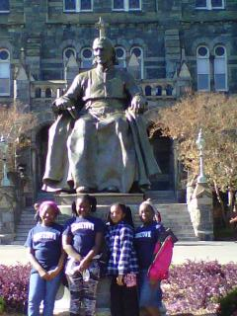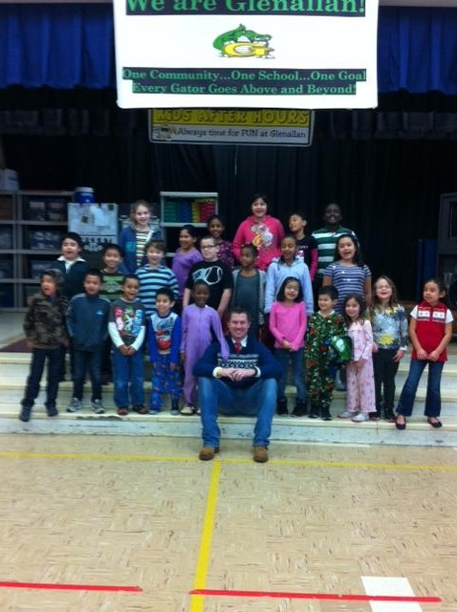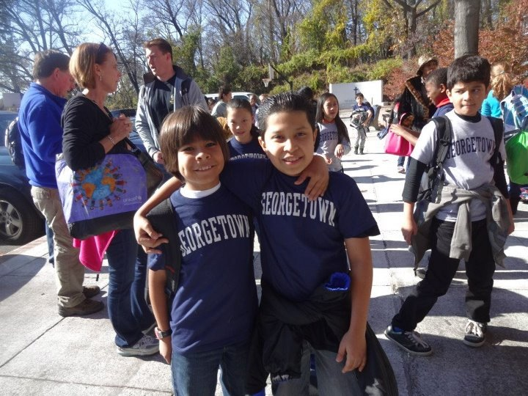



***One School, One Community, One Goal……….The Success of Every Glenallan Gator***



**News from First Grade –** *Mrs. Correa, Mrs. Ralph, Mrs. Lozzi, Ms. Rodriguez and Mr. Cord*

Happy New Year and Welcome Back! Thanks so much to all the parents and families who made it here for gingerbread houses! We hope you all had a wonderful Winter break spending time with family and friends. We are right back to working hard here in First Grade and the students will be taking their reading tests throughout the month of January. Please continue to read books every night with your child and make sure you ask questions about what he/she has read. When students bring home their guided reading books in the plastic bag, please make sure they are returned the very next day. It's amazing to see how far the students have come with their reading skills since the beginning of the year! We are also working on addition/subtraction problems in math so any help and support you can give with these skills is greatly appreciated. There will be a spelling test every other Friday so be sure to look for the students' new words in their folders every other Monday. We are really looking forward to a successful second half of the school year with all of you.



**News from Second Grade –** *Mrs. Navas, Mrs. Johnson, Mrs. Grotewold, and Mrs. Treichler*

It has been a very busy time for second grade gators! They have spent several weeks developing strategies to add and subtract. If your child hasn’t shown you a cool way to add or subtract yet, ask them about it! Second graders are also becoming fluent with their basic addition and subtraction facts. Please help your child by quizzing them with flashcards. Students have spent several weeks creating stories that retell a traditional folktale. In the coming weeks, they will be recording themselves as they read the story to make a podcast. Students should read for 20 minutes at home each night. Please help your child by providing books, a quiet place to read, and a designated time for reading.



**News from the 3rd Grade Team** – *Ms. Davies, Ms. Gottshall, Ms. Langrock, and Ms. Edhegard*

Thank you for all of your continued support!

**Donations**: As we get ready to begin the 3rd Marking Period of school, our supplies are starting to run low. We would love for any donations of pencils and tissues.

**Cursive**: We will begin learning cursive letters during the month of February. Please be ready to ask your child to show you the letters they have learned.

**Fractions**: The students in third grade are beginning to learn about fractions. We will be using some of the strategies we have already learned to help us with this area of study. Please continue to practice the

multiplication and addition strategies they have learned.

As always, please let us know if you have any questions or concerns!



**News from the ESOL Department** – *Mrs. Chavis, Mrs. Alvarado, Mrs. Wagner and Mrs. Bobo*

The ESOL department is preparing for the English Language Proficiency Test (ELPT). This is a high stakes assessment used by the County and the State of Maryland to monitor and determine the progression and attainment of the English language by our students who are English Learners (EL). The testing window begins on January 14, 2013 and ends on February 15, 2013. The Maryland State Department of Education requires that this test is given to all EL students in grades K-12 including students who exited from the program before 2010 who did not meet the benchmark requirement. All EL students must reach a target score on the ELPT in order to exit the ESOL program. The ELPT will assess the production of the English language in four domains; listening, speaking, reading and writing. This assessment measures (through the 4 domains) the production of English within the subject content areas such as math, science, social studies, and language arts. The test will also assess how the ELs communicate for social and instructional purposes. Therefore, there is not anything specific to study. However, it is important that the students get a good night’s sleep, a healthy breakfast and arrive on time to ensure a great productivity. We look forward to the opportunity to administer this test to our English Learners!



***One School, One Community, One Goal……….The Success of Every Glenallan Gator***

**

### Glenallan Elementary School

**“*Where Gators Go Above and Beyond”***

***Gator Gazette***

***January 2013***



**News from Fourth Grade-** *Mrs. Mayer, Ms. DeFrehn, and Mrs. Hubbard*

In math we are working with fractions, mixed numbers, equivalent fractions, adding/subtracting fractions, and comparing and ordering fractions. Many of these concepts are new to fourth graders and they should review them each night. We will also be learning how fractions relate to decimals. Knowing basic multiplication and division facts helps students with mastering fraction and decimal concepts.

In reading our next genre study will be historical fiction. Afterwards we will have a short unit on test taking practices in order to prepare students for the MSA test in March. Fourth graders will then have a mini poetry unit focusing on the works of Eloise Greenfield.

In writing our mini lessons are focusing on grammar and the six traits of writing.

Students will be taking the MAP-R and MAP-M tests in January.



**News from Fifth Grade-***Mrs. Billings, Mrs. Jameson, and Mr. Leitzel*

Happy New Year to our fifth grade students and their families! Since we have returned from winter break, the fifth graders have been reflecting on the first half of the year and making some goals for the second half of the year.

On Tuesday, January 15th, Lee Middle School counselors will be visiting to distribute schedule cards for the fifth graders to complete. All schedule cards are due to their homeroom teachers by February 1st. It is important that schedule cards be returned on time in order for your child to receive his/her top choices of elective classes for next school year. Additionally, on Saturday, January 19th, there will be a registration breakfast at Lee Middle School for students and parents to attend. The breakfast will take place from 9 AM until 11 AM.

Agenda books are being passed out for the second half of the school year and students are encouraged to write down their daily homework in them and have a parent check it each night. Fifth grade students are also being encouraged to write down special dates and events in their agenda book, so they can share them with their parents.



**Counselors Corner -** *Mrs. Lyons*

In the month of December we focused on the character trait CARING. Caring is being kind and compassionate, expressing gratitude, helping others and showing forgiveness. Though the holiday season offered opportunities to teach and model caring, it is not the only time of the year we should focus on this important character trait. In the American Psychological Association article entitled What makes Kids Care? It states that parents are instrumental in raising a caring child by letting them know how much it means to you that they behave with kindness to others. For example, if you see your child doing something you think is thoughtless or cruel, you should let them know right away that you don't want them doing that. Speak to your child firmly and honestly. Keeping your focus on the unkind act will clearly justify what your child did was not very nice rather than your child not being a nice person. For example, Michael is crying. He is crying because you took his toy away. That was not a very nice thing to do. Not saying to your child you are not very nice.  
  
Actions speak louder than words, hence another way parents can teach children to be caring is by modeling the behavior. As parents you are the primary nurture. The nurturing you give to your child is caring. When children feel safe and secure they feel cared for and they are more likely to venture out and pay attention to the needs of others. Lastly, here are a few ways parents can teach children to care by doing the following:

- Read books that emphasize the value of caring.  
- Monitor your child's television viewing and encourage viewing programs that promote caring.  
- Find a meaningful way for your family to volunteer to help others  
When you teach kids to care, not only do they learn how to care about themselves, but they also learn how to care for others and make the world a better place.



***One School, One Community, One Goal……….The Success of Every Glenallan Gator***

***Gator Gazette***

***January 2013***

### Glenallan Elementary School

**“*Where Gators Go Above and Beyond”***



***Gator Gazette***

***January 2013***

|  |  |
| --- | --- |
|  |  |
|  |  |
|  |  |
|  |  |
|  |  |
|  |  |
|  |  |
|  |  |
|  |  |
|  |  |
|  |  |

C:\Users\moranpet\AppData\Local\Microsoft\Windows\Temporary Internet Files\Content.IE5\8HAZEXTO\MC900295393[1].wmf

**Reading Strategies and Tips from the Reading Team**

*Mrs. Raiford and Ms. Smith*

**Bring a Book! Take 2 Books!****Fairland’s Reading Night Book Swap**



Thursday, February 12th, 2013 6:45 – 8:00 P.M. in Fairland Cafeteria

Donate a favorite “old” book that is still in good condition and pick 2 new to you, gently used books to take home at Fairland’s Book Swap. Extra book donations will gladly be accepted ahead of time to be used during the swap.

All children must be accompanied by an adult.

We will also be having a special guest author, as well as other fun activities to do! We hope to see you there!



**Message from Math Content Coach –** *Mrs. Stewart*

What's new in Glenallan classrooms this month? Talk to your child and ask them what new strategy they learned in their classroom this week. Our upper grade students are working with fractions from 3rd grade through 5th grades. Fractions are super easy to incorporate into your daily routine. Have your child help you cook or bake - talk about fractions and what to do with various measuring tools. 1st and 2nd grade students are applying addition strategies. In 2nd grade students apply counting strategies to monetary values. Our Kindergarten students are strengthening their concepts of numbers, how they are organized, and how they are composed.   
As we are wrapping up the 2nd marking period, teachers are meeting to take a look ahead and prepare for the concepts, skills, and strategies needed for the 3rd marking period. Watch how your child is developing mathematically enabling them to become better and more efficient problem solvers!



**MUSIC –** *Mr. Tilkens*

During December and January the upper grades (3rd, 4th, and 5th) are focusing on learning to read music and break down the smaller parts that make up a song as a whole. Students have been studying and learning songs from around the world. Some of the songs they have learned are from: Russia, France, Germany and Jamaica. The lower grades have been working on experiencing music from different cultures with different rhythms and practicing good listening skills. These students have also been exploring what objects can be turned into instruments or make musical sounds.

Save the date! Friday, February 15th Phantom of the Music Room the musical presented by selected students from 4th and 5th grade. More information will be provided in the coming weeks. Congratulations to the Chorus and Instrumental music program who put on a successful and enjoyable winter concert!



**Physical Education News** – *Mr. Kogok*

Happy New Year to all our Gator Families from the Physical Education department. As we head into the 3rd quarter we will be getting out the tumbling mats, lowering the climbing ropes and mounting the balance beam...it's time for gymnastics and tumbling! All students will need to wear loose fitting, casual clothing that will allow them to climb, roll, stretch and move freely. We will also be launching our annual Jump Rope Fore Heart fundraiser soon so please be on the lookout for more news about that important event which raises funds for the American Heart Association.



***One School, One Community, One Goal……….The Success of Every Glenallan Gator***

### Glenallan Elementary School

**“*Where Gators Go Above and Beyond”***

|  |  |
| --- | --- |
|  |  |
|  |  |
|  |  |
|  |  |
|  |  |
|  |  |
|  |  |
|  |  |
|  |  |
|  |  |
|  |  |

### Glenallan Elementary School

**“*Where Gators Go Above and Beyond”***









**Character Counts:**

The character trait for the month of January is **Honesty.** Staff will be looking for students demonstrating respect at school, in the community, and focusing on it through instruction.

January 15 Lee Middle visits Grade 5

January 16 McDonalds Night 5:00 – 8:00 pm

|  |  |  |
| --- | --- | --- |
| January 21 |  | Dr. Martin Luther King’s Birth Day |

January 22 Professional Day – No School Students

January 23 First Day of Quarter 3

January 24 Pancakes with the Principals

January 28 Practice MSA Testing Grades 3 – 5

January 30 Mid Year Awards Ceremony

Kindergarten – Grade 2 9:45

Grades 3 – 5 10:55

January 31 Report Cards go home

**George B. Thomas Saturday School**

***Important Dates for the Gators in January 2013***

The core program of the George B. Thomas, Sr. Learning Academy, Saturday School offers tutoring and mentoring in reading/language arts, mathematics, and test-taking skills for students in grades 1-12. It takes place Saturday mornings from 8:30 to 11 a.m. at Kennedy High School.



**Brick Drive:**



If you are interested in purchasing a break, please contact Mrs. DePasquale directly at [jennifer.depasquale@gmail.com](mailto:jennifer.depasquale@gmail.com) Be part of continuing the tradition of Glenallan and building our new traditions!

**PTA UPCOMING EVENTS**

**January 16th** (Wednesday) - **McDonald’s Night (Glenmont Location – Randolph and Georgia)** 5:00 pm – 8:00 pm

**February 12th** (Tuesday) – PTA Meeting Reading Night with Guest Author 6:45 pm – 8:00 pm

**February 14th** (Thursday) – **Valentine’s Day–** Please work with you room parent to donate items and volunteer. Parties start at 2:15 pm



**\*\*\* Help Needed – Treasurer – Critical \*\***

The PTA needs someone to **shadow our Treasurer** and be willing to take on the role next year. It is really critical and greatly appreciated. Please contact [GlenallanPTA@gmail.com](mailto:GlenallanPTA@gmail.com) to let us know you can help.



**PTA Dates to remember:**

1. International Night April 26th (Volunteers needed to help)
2. Teacher Appreciation Week May 6 – 10th (Volunteers needed to help plan)

Instrumental Music Students Prepare for the Winter Concert

