|  |  |
| --- | --- |
|  |  |
|  |  |
|  |  |
|  |  |
|  |  |
|  |  |
|  |  |
|  |  |
|  |  |
|  |  |
|  |  |
|  |  |
|  |  |
|  |  |
|  |  |
|  |  |
|  |  |
|  |  |
|  |  |
|  |  |
|  |  |
|  |  |

**Vision: We are a united, multi-cultural community of students, families, and educators committed to cultivating a love of learning, developing the character of great people and empowering children with the knowledge and skills to become productive citizens in the 21st century.**

***Gator Gazette***

***February 2014***

### Glenallan Elementary School

**“*Where Every Gator Go Above and Beyond”***



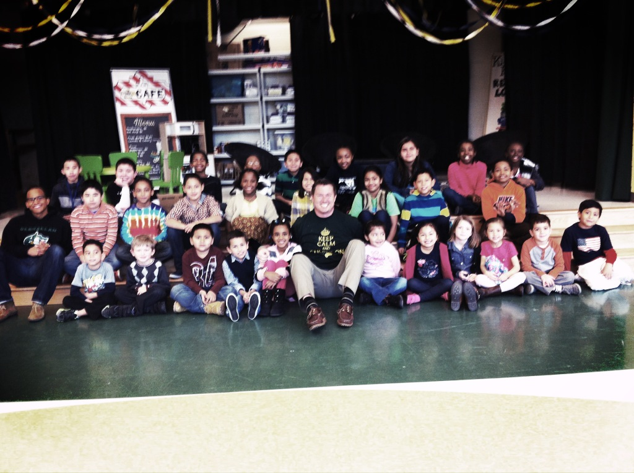

Dear Glenallan Families,

We are off to an exciting start in ’14! A couple of exciting things to share;

* Glenallan Elementary was recognized for being #1 in the State of Maryland for Scholastic’s Read for the World Record. The students read a total of 262,754.
* On Thursday, February 6, 2014 the National Education Association visited Glenallan to highlight in a future national article. GES was selected as a result of the progressive and creative instructional intiatives and our focus on the social emotional intelligence and well being of the Gators.
* Over 50% of our Kindergarten students are already meeting the end of the year reading goal of reading proficiently at a text level 4.

**Important Dates to Note:**

* **Tuesday, February 11th** is Family Math Night from 6:30 to 8:30 p.m. Please join us for dinner at 6:30 and then a very informative night where resources/strategies will be providing to use at home.
* **Friday, February 14th** is Valentines Day. Valentines Day parties will begin at 2:00 p.m. Please feel free to join us and celebrate with your child.
* **Wednesday, February 19th** is our next Parent Involvement Meeting. It will begin at 8:30 in the dual purpose room and coffee with be provided. Mrs. Graham, Staff Development Teacher will be discussing our instructional focus of intellectual discourse and ways to support your child with this at home.
* **Friday, February 28th** is an Early Dismissal day due to a teacher grading and planning day. Students will be dismissed at 12:35.

**Academic/Character Success to Celebrate**

The month of January was filled with evidence of success. In Kindergarten, the teachers have instilled confidence in their students’ ability to read. I continually hear them celebrating their own success saying, “Look what I learned!” or “Watch what I can do.” In Grade 1, I have seen students gain knowledge about our world, about other cultures, land features, and even knowing the names and locations of the continents! Having a global understanding will be important to their success in our society. In Grades 3, 4, and 5, 125 students were recognized for the growth they demonstrated on the MAP-r assessment which assesses their level of reading comprehension. 125 students increased five points or more! This is an increase from last year when 103 students at this time had increased 5 points or more. Please congratulate them, help them set goals for the remainder of the year, and remind them that each day is a chance for them to become smarter and learn something new!

At our mid-year awards ceremony, we gave 125 tee shirts to the students who have been recognized for character in their classes and around the school. I look forward to passing out 125 more at the end of the school year! The importance of character and developing the whole student is a significant focus for us. Please continue to speak to your students about their character and that being a good person is their most important job! Someone recently said to me, that special things are happening at Glenallan. I said you’re right; those special things are the Gators. Have a great February and I look forward

We are Glenallan!

Mr. Moran

Congratulations

To our January

Character Counts

Recipients! Look

For your Name

On the School

Sign



***One School, One Community, One Goal……….The Success of Every Glenallan Gator***



**Math News From -***Ms. Brophy*

Join us for Family Math Night



“Numbers Rule My World!”



**News from First Grade –** *Mrs. Correa, Mrs. Ralph, Mrs. Lozzi, Ms. Rodriguez and Mr. Cord*

We got the New Year off to a great start despite the challenges of all the snow days! First graders began talking about the weather as part of calendar activities in January and got to discuss how many snow days we’ve had. We learned that it can be really sunny and still be really cold! Please be sure to send your child dressed prepared for the cold. We completed MClass Reading testing and students saw how much growth they can make by reading and discussing books at school and at home. Make sure your child reads something every night, or that you read a story to them so they develop a love of reading. For the next few weeks in math we will be learning how to measure using non-standard units of measure, not rulers. Please help your child compare lengths of things using language such as shorter, longer or longest, or tallest. In Science we are learning about natural features such as mountains, waterfalls and sand dunes. We are recognizing the difference between natural features and manmade features. We are asking students to collect shoeboxes to decorate for Valentine’s Day, and the teachers are trying to build a time machine to bring Abraham Lincoln to school to visit to celebrate President’s Day.

Thank you for your continued support.



**News from Second Grade –** *Mrs. Navas, Ms. Muhammad, Mrs. Grotewold, Mrs. Treichler, and Ms. Shider*

Thank you so much for your support in making the Baltimore Aquarium field trip a success!  We couldn’t have managed without you!  We have more trips in the next few months and look forward to seeing you then.The third marking period will be very exciting for the students.  The concept of change is integrated throughout all subject areas.  Students will

examine changes in technology, transportation, and communication.  They will discuss changes in the sun,

the moon, plants, and brine shrimp.   Beginning in February, students will be responsible for observing the

moon at night.  When it is your child’s turn, please allow them an opportunity to observe the moon either in

the evening or earlyin the morning.  They will be describing what they saw to their classmates the following

day. Please be sure to read with your child every day.  You should both listen to your child read and read

aloud to your child! Begin having conversations about the books you have read together.  This is a great way to support what is happening during reading instruction at school!



**News from the Physical Education Department:** *Mr. Kogok and Mrs. Costa*

On Friday January 24th we held our Family Fun and Fitness Night.  It was great to see so many students and their families come out for a night of fun and challenging activities.  Between 350 and 400 people attended!  Thank you so much to all who came out. As we start the 3rd quarter all students will be focused on gymnastics related activities such as learning to support our body weight using our hands and arms , jumping and landing safely from various heights and both static and dynamic balance.  Parents can help their child succeed in Physical Education by making sure that their child has sneakers and comfortable casual clothing on the day of the week that they have P.E.    Even if there is snow or rain students still need sneakers on PE day.  Please send sneakers in their backpack if they must wear boots.



***One School, One Community, One Goal……….The Success of Every Glenallan Gator***

***Gator Gazette***

***February 2014***

### Glenallan Elementary School

**“*Where Gators Go Above and Beyond”***

Parents

Please take a minute the

Parent Math Newsletter

that goes home each Marking Period with your child. It give an overview of the concepts your child will be learning. It also includes the models and examples to help with your concepts at home.

**Who:** Glenallan Families

*All children must be accompanied by an adult.*

**When:** **Tuesday, February 11, 2014 from 6:30-8:00 p.m.**

A pizza dinner will be served from 6:00-6:30 p.m.

**Where:** Glenallan E.S. All-Purpose Room

**



**News from the 3rd Grade Team** – *Ms. Davies, Ms. Edhegard, Mrs. Ghee, and Ms. Nansimbi*

**Donations**: As we begin the 3rd Marking Period, our supplies are starting to run low. We would love for any donations of pencils, tissues, Clorox wipes and hand sanitizer.

**Cursive**: We have been learning cursive in 3rd grade. Please be ready to ask your child to show you the letters they have learned so far.

**Fractions**: The students in third grade are beginning to learn about fractions. We will be using some of the strategies we have already learned to help us with this area of study. Please continue to practice the multiplication and addition strategies they have learned.

As always, please let us know if you have any questions or concerns! Thank you for all of your continued support!



**News from Fourth Grade-** *Mrs. Mayer, Ms. DeFrehn, Mrs. Hubbard and Mrs. Walsh*

Our New Year has gotten off to a great start! Just like setting a New Year’s Resolution this would be a good time to have your child reflect on their academic progress and update their goal(s) for the second part of the year.

**Reading** — In the next few weeks we will be studying myths and fantasies. Students will examine characteristics of myths and fantasies and identify the relationship between characters and setting using details from the text. They will summarize a text to determine the theme. They will also compare similar themes and topics within literature. Please monitor your child’s reading at home. They should be reading for at least 25 minutes each night. After reading have your child record what they read on their reading log and complete the “Book Recommendation” on the back (due Friday).

Math — Students will identify equivalent fractions. They will also compare fractions with different numerators and denominators. Please continue to have your child work towards building mastery of all their basic facts: addition, subtraction, multiplication, and division. This will contribute to their full understanding of fractions, as well as their success in all areas of math.

**Writing** — Students will examine advertisements and evaluate how they influence consumers.

**Science/Social Studies** — We will study different aspects of the weather and the establishments of our first settlements in North America.

Special Events and Reminders:

* Look for information in your child’s binder about our Valentine’s Day parties on Friday, February 14th. Family members are welcome to join us!
* With the weather changing daily, please be sure your child comes to school dressed appropriately for outdoor recess.



**News from the Grade 5 Team –** *Ms. Gottshall, Mrs. Billings, and Ms. Jameson*

We hope that you and your families had a joyous winter break. Third quarter will be filled with many important events. First off, we would like to invite all parents of fifth grade students to our Family Life Parent Meeting on Tuesday February 25 at 4:30-5:30 in the dual purpose room; room 105. You will have the opportunity to review all of the materials that will be used during the Family Life Health Unit and ask the 5th grade team questions regarding the unit. Instruction will begin on March 28. All students will be receiving a parent permission slip to participate in the unit. If the student does not return a signed permission slip, they will not be able to participate. If you have any questions or concerns, please contact your child’s teacher.

* MSA testing is scheduled to begin on March 5. The reading test will be given on Wednesday March 5 and Thursday March 6. The math MSA will be given on Tuesday March 11 and Wednesday March 12. Please try to avoid making doctor or dental appointments on these days.
* Valentine’s Day Parties will be held on February 14 from 1:30-2:45. Class lists will be sent home so that students may make cards for their peers. If your child is bringing in cards to pass out, please make sure every student in the class receives a card. If you would like to donate food items or help during the party, please let your child’s teacher know.
* We look forward to seeing you on February 25 for the Family Life Parent Meeting!



***One School, One Community, One Goal……….The Success of Every Glenallan Gator***

***Gator Gazette***

***February 2014***

### Glenallan Elementary School

**“*Where Gators Go Above and Beyond”***



***Gator Gazette***

***February 2014***

|  |  |
| --- | --- |
|  |  |
|  |  |
|  |  |
|  |  |
|  |  |
|  |  |
|  |  |
|  |  |
|  |  |
|  |  |
|  |  |

**Exciting News from the Media Center –** *Mrs. Bean* 

New Books! We have about 20 new books which have been nominated for the 2014 Black-Eyed Susan book Award! **It is an award given to authors and/or illustrators of outstanding books chosen by Maryland students. The award seeks to promote literacy and lifelong reading habits by encouraging students to read quality, contemporary literature. I hope you and your children will enjoy these wonderful additions to our library collection.**



**Counselors Corner -** *Mrs. Lyons*

**Primary:**

In Guidance we have begun the Kelso Lessons. These lessons help students develop effective problem-solving skills. It will help them deal with conflict in a positive manner and help them make appropriate decisions. Knowing what to do will empower students to know how to make good choices.

Parent Tip: Help your child to identify the difference between a big and a small problem. Help them to understand that big problems are for adults and small problems they can try to solve on their own. For example, having a disagreement with a sibling about personal property, sharing a toy or deciding who will push the shopping cart at the grocery store. These are small problems that most kids can solve on their own. The Kelso lessons identify nine choices kids can use to solve a small problem.

1. Go to another game
2. Talk it out
3. Share and take turns
4. Ignore it
5. Walk away
6. Tell them to stop
7. Apologize
8. Make a deal
9. Wait and cool off

**Upper Grades:** Students learned about the new Peer Mediation program at Glenallan. At Glenallan Peer Mediation is a voluntary process in which students in grades 3-5 have the opportunity to talk through their conflicts with the help of trained student mediators, under the guidance of Mrs. Lyons the School Counselor. Peer Mediators do not take sides or place blame. They actively listen to all participants and help develop a resolution to the conflict. Confidentiality is an important aspect of Peer Mediation and the participants must agree to not discuss the mediation with anyone outside the mediation room. Confidentiality is important in order to prevent rumors and new conflicts. Peer mediation can positively impact our school in the following ways:

* Peer Mediation enables students to resolve conflicts in a non-punitive forum that encourages them to accept responsibility for their actions.
* Peer Mediation encourages students to resolve their own conflicts in a supervised setting.
* Peer Mediation improves school climate. The program improves communication among students and between students. It also decreases tension and preserves friendships.

All of these factors make schools a safer and more productive place.



**News from the Art Room –** *Ms. Vanagas*

The art show and concert in December was a great success and students in 3-5 grade showed off their talents. At this time most of your children are enjoying getting back to working with clay. For some it has been 2 years since they have worked with it as we did not have a kiln at the holding center. Everyone is so excited to be using clay. Stop in and check out our showcases in the front of the Music and Art room to see our wonderful masterpieces. In kindergarten we are focusing on shapes and the 3-D solids that match them. First graders are learning to thread a needle and sew a simple running stitch. Second and third graders are working on Portraiture. Fourth graders are learning about how to create contrast and value in a work of art. Fifth graders just finished making clay rattles and will move on to printing.

**Your children continue to amaze me with their wonderful works of art and I am really proud of the work they do!**



***One School, One Community, One Goal……….The Success of Every Glenallan Gator***

### Glenallan Elementary School

**“*Where Gators Go Above and Beyond”***

|  |  |
| --- | --- |
|  |  |
|  |  |
|  |  |
|  |  |
|  |  |
|  |  |
|  |  |
|  |  |
|  |  |
|  |  |
|  |  |

### Glenallan Elementary School

**“*Where Gators Go Above and Beyond”***







February 11 Family Math Night @6:30 p.m.

February 14 Valentines Day Parties@2:00

February 17 No School: President’s Day

February 19 Parent Involvement Meeting 8:30 a.m.

Febraury 19 Family Math Night Snow Date

February 25 Grade 5 Family Life Parent Meeting@4:30

February 26 Cluster Chorus Concert@Lee 7:00 p.m.

February 27 Gator Pep Rally

February 28 Half Day Dismissal 12:35



**Character Counts:**

The character trait for the month of February is **Citizenship.** Staff will be looking for students demonstrating respect at school, in the community, and focusing on it through instruction.

“[**We** all have an obligation as citizens of this earth to leave the world a healthier, cleaner, and better place for our children and future generations.](http://www.searchquotes.com/quotation/We_all_have_an_obligation_as_citizens_of_this_earth_to_leave_the_world_a_healthier%2C_cleaner%2C_and_bet/317141/)”

[](http://www.google.com/url?sa=i&rct=j&q=Gators&source=images&cd=&cad=rja&docid=OV_55onkedAxjM&tbnid=2XhqYaQa87TltM:&ved=0CAUQjRw&url=http://www.geibelcatholic.org/athletics/Pages/default.aspx&ei=ehIZUdHHLdCM0QG89YHgCw&bvm=bv.42080656,d.dmQ&psig=AFQjCNG81OHwyi3H4l7P9214i94DWg2AmA&ust=1360683980748525)

**McDonalds Night: Honoring Tiem Dang**

On March 12th, we will be holding our McDonalds Night at the McDonald’s in Glenmont shopping center. All purchases will go towards the Asthma Awareness in Tiem’s name. Please join us on this very special night where will be honoring Tiem and coming together as a community in his name.

***Important Dates***

***February/March 2014***

**Flu Prevention**

The 2014 flu season has arrived and Maryland, like many states, is experiencing a widespread outbreak of the virus. We are asking students and staff to take some simple steps to keep themselves healthy, and help prevent the spread of the flu.

The Centers for Disease Control recommends that everyone 6 months and older gets a flu vaccine.

1. Wash your hands often with soap and water, especially after you cough or sneeze, or use alcohol-based hand sanitizer. When coughing or sneezing, cover your nose and mouth with your sleeve or a tissue and throw the tissue in the trash.
2. Avoid touching your eyes, nose, or mouth to minimize the chance for infection.
3. Stay home from work or school if symptoms develop such as fever, coughing, sneezing, runny nose, headache, and body aches.

Superintendent Joshua Starr’s next Book Club will be held on Wednesday, Feb. 19, at 7 p.m. The book being discussed will be “Making Hope Happen,” by Shane Lopez, a senior scientist with Gallup, who will join Dr. Starr and other panelists for the event.To be a part of the live studio audience, please email [**pio@mcpsmd.org**](mailto:pio@mcpsmd.org) by Feb 18. The Book Club will be broadcast live on MCPS TV and streamed live on the web at [**www.mcpsbookclub.org**](http://www.mcpsbookclub.org).

