|  |  |
| --- | --- |
|  |  |
|  |  |
|  |  |
|  |  |
|  |  |
|  |  |
|  |  |
|  |  |
|  |  |
|  |  |
|  |  |
|  |  |
|  |  |
|  |  |
|  |  |
|  |  |
|  |  |
|  |  |
|  |  |
|  |  |
|  |  |
|  |  |

**We are a united, multi-cultural community of students, families, and educators committed to cultivating a love of learning, developing the character of great people and empowering children with the knowledge and skills to become productive citizens in the 21st century.**

***Gator Gazette***

***December 2012***

### Glenallan Elementary School

**“*Where Every Gator Go Above and Beyond”***

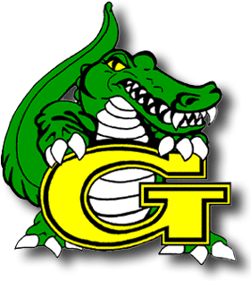

Dear Glenallan Families,

Season’s Greetings from the Gators! I hope that the season finds you in good spirits, good health, and excited for the opportunities that await our community. Every time during this year, I believe it is so important to focus on the importance, “That it’s not what you have, “it’s who you have. The people that make up our community are extraordinary. We have students who are motivated, enthusiastic about learning, and focused on becoming good people. We have a parent community that is supportive, encouraging, and proud of what Glenallan represents. We have a staff that is committed to the excellence of every student and works incredibly hard to ensure this goal is fulfilled. Who we have is what makes Glenallan extraordinary.

The unity of the Glenallan community members is a driving force of student success and a positive climate.

As we embark on the end of 2012, some people view this as only another turn of a calendar page. At Glenallan, we look at this as a bright and fresh beginning. With the beginning of 2013, we take a moment to reflect on what the year meant. 2012 for me could no better be defined by our ability to work together to create a world class learning environment under the challenge circumstances of calling a holding center home. I look forward to the opportunity ahead to work with you and your child to create the ideal **community school**. 2013 will surely be the year of the Gator!

As the year concludes we will evaluate our goals that were constructed in the summer and determine how we can grow our successes as a school. I encourage you do this with your child at home. There is nothing that provides more direction and focus for students than setting goals. I plan to reiterate this to the students as I meet with them in the New Year. Goals are merely dreams that have not been realized. I believe that the teachers and staff members of Glenallan are helping your children realize their dreams.

Enjoy the season and the company of your family and friends during the holidays. Happy Holidays!

Respectfully,

Mr. Moran



**A School Where Character Counts**

Congratulations to those Students that earned Character Counts for the month of November,

when we focused on the character trait **Gratitude.**

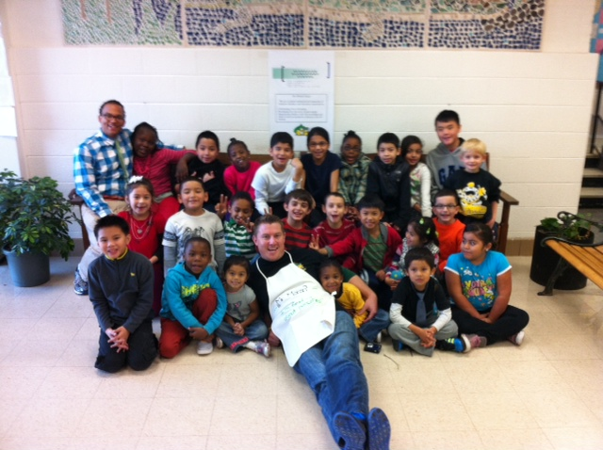

**Panorama View of the Future Main Entrance of the Home of the Gators**





***One School, One Community, One Goal……….The Success of Every Glenallan Gator***

C:\Users\moranpet\AppData\Local\Microsoft\Windows\Temporary Internet Files\Content.IE5\BRMFBPSL\MC900250864[1].wmf

**



**News from Kindergarten-***Ms. Yetter, Ms. Ziadi, Mrs. Frank, Mrs. Beckett, and Ms. Ali*

The kindergarteners have continued to make great progress! We are looking forward to the upcoming gingerbread baking family event on the 18th of December. Please let your child’s teacher know if you would like to come and help, the more the merrier! Continue reading every night and practice reading the word wall words. Also, practice the letters and the letter sounds at home. We have been working very hard on number recognition, counting, writing, and showing numbers. Continue to practice these skills at home. The weather is getting colder; please remember to send your child in a warm coat with gloves and a hat, because we do go outside at recess. We hope you all enjoyed your Thanksgiving holiday!

**News from First Grade –** *Mrs. Correa, Mrs. Ralph, Mrs. Lozzi, Ms. Rodriguez and Mr. Cord*

First Grade will be beginning a new reading and spelling program called Words Their Way this month! Every two weeks we will be focusing on a different spelling pattern using their first grade word wall words. Students will be given ten words that focus on this pattern and they will be tested on them the last Friday of the second week. Students are expected to practice these words at home and use them while writing. Please remind them to practice at home! First Grade is excited for our first family partnership event December 21st from 2:15-3:15 pm. We will be making Gingerbread houses!!! **Parents, please come and help volunteer in making our houses!!**  The students really enjoy this event and your attendance makes it even more special!! We look forward to seeing you there.

**News from Second Grade –** *Mrs. Navas, Mrs. Johnson, Mrs. Grotewold, and Mrs. Treichler*

Second graders have been very busy this month!  Here are some highlights from our classrooms:  Students have collected data and created graphs to show the data.  They have also analyzed graphs to explain the information shown.  One of our favorite graphs was about the number of pockets each child had on their clothing.  In science, students have learned about landforms around the world, landforms and regions of Maryland, and landforms on the ocean floor.  Learning about the ocean floor has been especially interesting.  Teachers have incorporated many hands on activities to help students learn and remember these concepts. Second graders have become experts on the food guide pyramid.  They can describe each food group and explain why it is important for health.  They are currently in the process of creating projects to share their knowledge with others.  Parents, please support your child with their homework by providing your child with a quiet space and time to work.  Also, please help your child remember to bring their folder and homework journal every day.

**News from the ESOL Team** – *Mrs. Chavis, Mrs. Alvarado, Mrs. Wagner and Mrs. Bobo*

The ESOL department is very happy to be working in the classrooms with all our fabulous

ESOL students. We welcomed returning students, as well as those who are new to Glenallan. In

fact, new students arrive each month! As a result, we have been allocated another ESOL teacher

(part time) and are pleased to introduce Ms. Jenise Bobo. She will be working with some of our

3rd, 4th, and 5th grade students. It has been busy. We have attended trainings, completed paperwork, worked out schedules, and continually plan with teachers. Now, we are completing accommodation plans for ESOL students. Accommodations are special provisions (as needed) to help the students access the full curriculum in the classroom. The accommodations are also used during all testing. We have met with teachers to make sure we document the correct accommodation for each individual ESOL student. Please look for a copy of these plans to come home soon. We are asking that you review these plans with your child again at home, sign and return acopy to the ESOL teacher. Feel free to call the school with any questions you may have. Any one of our ESOL staff will be able to help you. We are looking forward to an exciting year full of learning and fun in ESOL.



***One School, One Community, One Goal……….The Success of Every Glenallan Gator***

### Glenallan Elementary School

**“*Where Gators Go Above and Beyond”***

***Gator Gazette***

***December 2012***

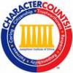



**News from Fourth Grade-** *Mrs. Mayer, Ms. DeFrehn, and Mrs. Hubbard*

Students are writing to inform. They are individually researching Native American tribes. Their research projects include note taking, composing paragraphs using these notes, and creating an informational pamphlet about their tribe. It is very important that all students memorize addition, subtraction, multiplication, and division facts. They will be tested on multiplication and division facts throughout this unit. In reading next week we will read our first Junior Great Books story, **The Gold Coin.** Students will write questions about the story and engage in discussions about the text.

**News from Fifth Grade-***Mrs. Billings, Mrs. Jameson, and Mr. Leitzel*

In fifth grade we are currently focusing on poetry in reading. Students are studying various forms of poetry to gain a deeper understanding of poems and to analyze how figurative language is effectively used by poets. Throughout the month of December students should be keeping on pace with their goal to read 25 books by the end of the school year. Students should currently have completed 10 book recommendations. We encourage parents to read over book recommendations to ensure that students are providing an acceptable summary of the book, before students turn them into their teachers.

In writing, students are beginning a project that focuses on winter holidays that are celebrated by their families. Students will take their ideas through the brainstorming process, write rough drafts, edit and revise their papers, and publish them in the computer lab.

We are currently focusing on geometry concepts in math. Students are learning about angles, two-dimensional shapes, three-dimensional shapes, and circumference of circles. We recommend that students continue to practice their basic math facts at home in addition to their nightly homework to continue to improve.

In math 6, students have been studying decimal operations and how to apply them to word problems. We will use our knowledge of decimal operations to help us recognize how decimals and fractions are related. Students are encouraged to take notes daily in class and study them to help prepare for quizzes and tests.



**Counselors Corner**

*Mrs. Lyons*

For the month of November we focused on the character trait GRATITUDE. Gratitude is being thankful for someone or something. Thanksgiving is a holiday that we highlight all of the things we are thankful for. However, we do not have to wait for the holidays to practice and understand the importance of teaching children how to be thankful. Dr. Rober Emmons, author of Thanks! How Practicing Gratitude Can Make You Happier, states that parents can model gratitude in several ways:

-Parents should recognize and label gratitude for example, "That was nice of you to hold the door for that lady at the store. I am sure she appreciated it."

-Thank your children and others when they do nice things or complete their chores.

-Express your appreciation of even the simplest things. For example, "It was nice to bake cookies together, and I loved that you helped your sister mix the ingredients."

-Letting your child know that when they give gratitude and receive it, it's nice to be acknowledged for what they have done.

When gratitude and being thankful and practiced on a regular basis, children learn to appreciate what they have and express it.

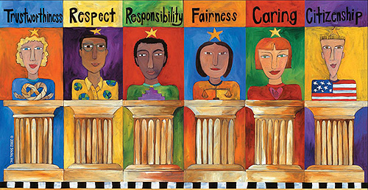



***One School, One Community, One Goal……….The Success of Every Glenallan Gator***

***Gator Gazette***

***December 2012***

### Glenallan Elementary School

**“*Where Gators Go Above and Beyond”***



|  |  |
| --- | --- |
|  |  |
|  |  |
|  |  |
|  |  |
|  |  |
|  |  |
|  |  |
|  |  |
|  |  |
|  |  |
|  |  |

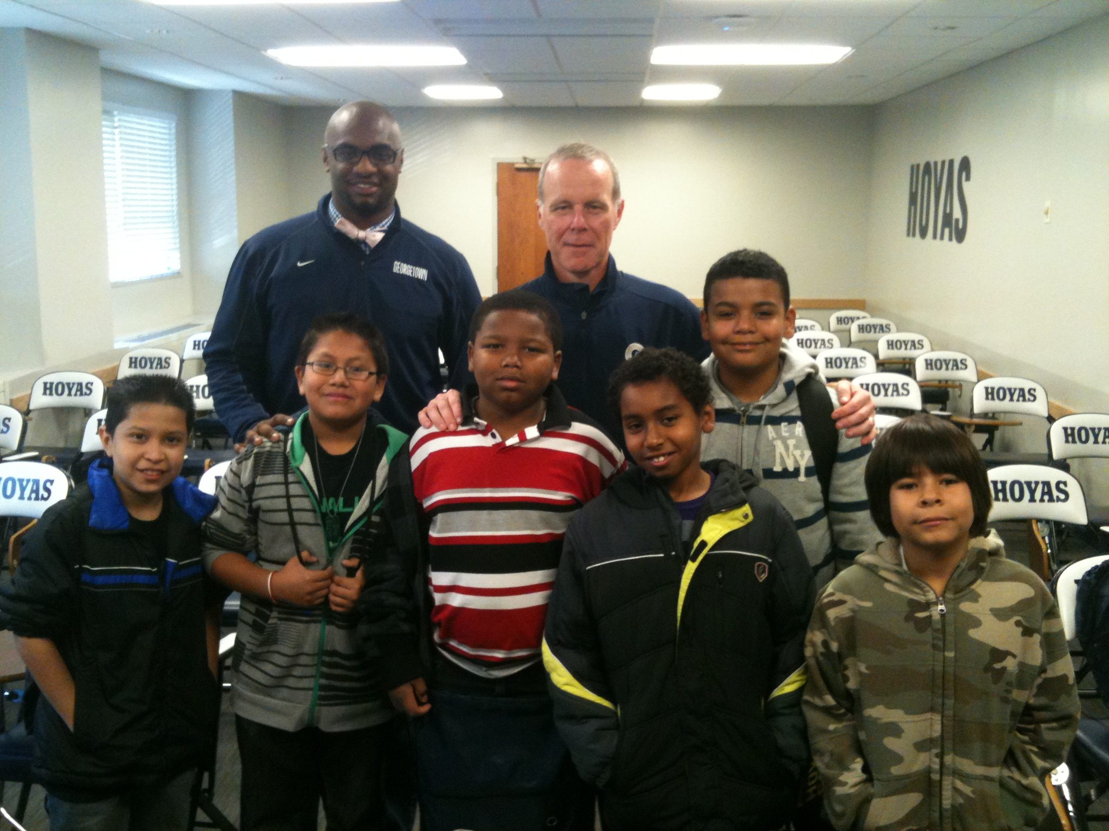

**Reading Strategies and Tips from the Reading Team**

*Mrs. Raiford and Ms. Smith*

Parents and Guardians,

It is so important to read a book with your child every single night. Before reading, ask your child to predict what the story will be about. During reading, make sure your child is using reading strategies to help them better understand the story. After reading, discuss the book with your child. Ask your child critical thinking questions about the story, such as “How do you know…” “Why do you think…” etc. Not only is it important to read a book every night, it is also important to make sure the book your child is reading is appropriate and interesting to them.

Here are some helpful strategies to make sure your child is reading the “perfect book”:

* Choose an author or topic you like
* Look at the picture on the cover.
* Read the title. Does it look interesting?
* The Five- Finger Test:
  + - Hold up your fist.
    - Put one finger up each time you come to a word you do not know.
    - If there are more than five fingers up at the end of the page, the book is too hard.
    - Choose a book that was read aloud in class.

**\*Save the Date* February, 12th –Love a Book Night- More details coming soon.**



**Message from Math Content Coach –** *Mrs. Stewart*

Please join us at Glenallan's Math Night on Tuesday December 11th at 7pm. During this event we will explore the changing MCPS curriculum, share strategies students are using in the classroom, and play games and activities related to math for you to use with your children at home. I encourage you to bring your children with you, so you can learn some games and activities together. Many teachers will be attending that night as well, so they will be looking forward to seeing you. This is a great opportunity for you and your children to get excited about math and see how you can practice strategies at home.



**News from Grade 3 –** *Ms. Davies, Ms. Edhegard, Ms. Langrock, and Ms. Gottshall*

Thank you for all of your continued support!  Please continue to:

1. Check your child’s homework folder each day and encourage your child to do his/her best work.
2. Complete and return important forms promptly.
3. Take interest in what your child is reading. Ask questions about the reading and provide your child with positive feedback about their reading.

**Field Trip**: On Monday, December 10th, we will be taking a trip to Toby’s Dinner Theatre to see the play Alexander.

**Multiplication and Division**: The students in third grade are learning many strategies for solving problems. We are really impressed that they are using these strategies to help them to learn rather than memorize facts.

**Research:** During our writing block and the Media Center time, our students have been conducting research. The students are excited about the process of research. Please ask your child about their research topic.

As always, please let us know if you have any questions or concerns!



***One School, One Community, One Goal……….The Success of Every Glenallan Gator***

### Glenallan Elementary School

**“*Where Gators Go Above and Beyond”***

***Gator Gazette***

***December 2012***

|  |  |
| --- | --- |
|  |  |
|  |  |
|  |  |
|  |  |
|  |  |
|  |  |
|  |  |
|  |  |
|  |  |
|  |  |
|  |  |





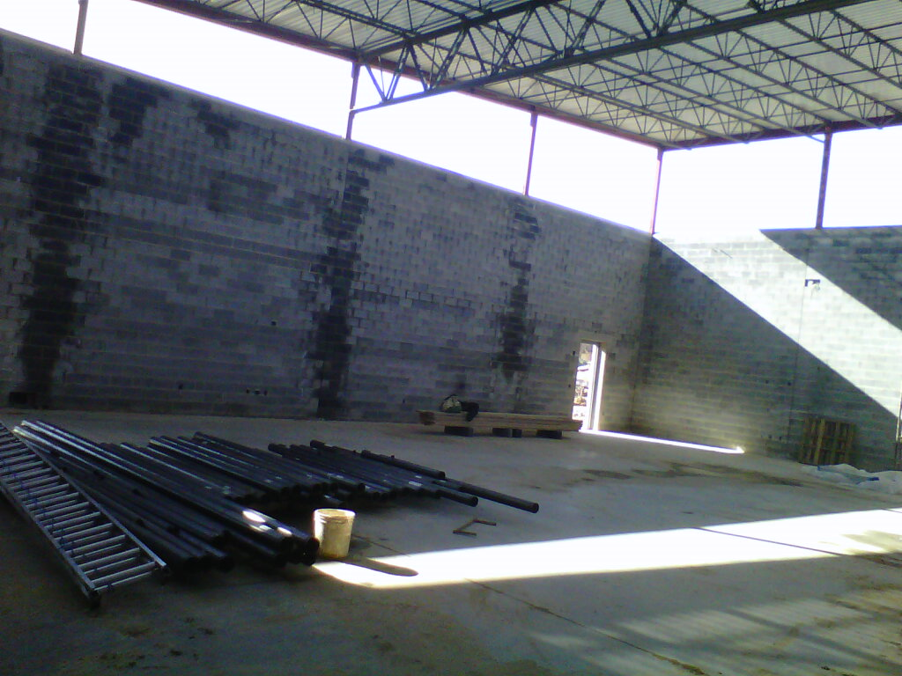

**Media Center News**

If you haven’t seen the bulletin board outside the Media Center, please stop by. Third graders made pledges to better themselves and their community. They researched health and community related topics that interested them and then made pledges to make the world a better place. Fourth graders are continuing their research on Native American tribes and fifth graders are creating travel brochures using online databases and Microsoft Publisher. Second graders are learning about traditional stories from around the world and how they are retold through many generations of people. First graders are using the online database, Pebble Go, to research animals and cultures and kindergartners have been excited to use the Promethean Board to visually enhance their learning.



**MUSIC –** *Mr. Tilkens*

Music Notes: December

My **Kindergarteners** have been learning songs in English and Spanish about animals, counting and the days of the week. They even got a chance to write their own song as a class using rhyming words.

**First grade** is getting an eclectic taste of music while learning about musical opposites. Students have displayed that they know the difference between loud and soft, fast and slow, and long and short.

**Second Graders** had a tremendously successful trip to the Strathmore. We looked great and were among the best behaved schools at the event. Now second grade is moving on to reading songs using hand signs or “solfeggio”.

**Third grade** is working hard preparing for recorders! The students will have the chance to start learning the flute-like instrument early next year, but first must show me that they can read music on a five note staff and name all the letters of the musical alphabet.

**Fourth Grade and Fifth Grade** are working on partner songs. Partner songs are created when two melodies are combined that use the same chords. Students have to work together and concentrate hard, so they can stick with their part.

***Chorus/Instrumental music:*** This is a reminder that the chorus and instrumental music program will hold their annual winter concert at 7pm on Wednesday, December 19th at Kennedy High School auditorium. Chorus and band members should report to the Kennedy High School Band room (Once you walk in the building stay to your left and follow the hallway) no later than 6:30 and should remember to wear a white top and black bottoms.



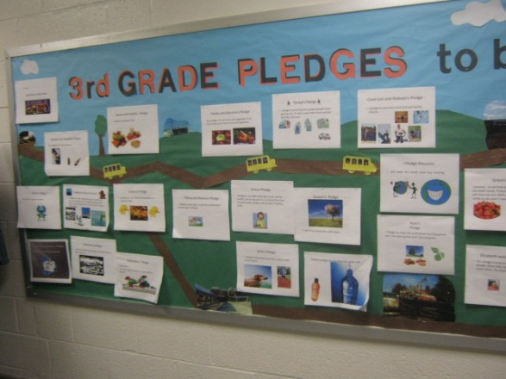



**ART –** *Mrs. Vanegas*

Kindergarteners are learning about three dimensional art and getting their hands dirty while experimenting with clay. First grade is also learning about sculpture and how to make paper three dimensional. Second graders are exploring and creating a still life at NGAkids.gov. All grades continue to dig deeper into the elements of art and principals of design. Looking for something to do with those old jigsaw puzzles?

Here is a link that shows how to make winter ornaments for a tree or window.

Go to <http://familycrafts.about.com/od/treeornaments/ss/puzsnowflake.htm>



Physical Education News – Mr. Kogok

As we have moved into the second quarter in Physical Education, the primary grades (k-2) are focusing on throwing and catching underhand and overhand. The students are learning the proper hand position and arm extension as well as how to track a ball in flight. Our older students are learning to throw overhand to moving targets and in dynamic situations. Our 3-5th grade students will be learning volleyball skills soon. As the weather has turned colder we have fewer opportunities to get outside but we are having fun learning new skills together in the all-purpose room. Happy Holidays to all our Glenallan Families!

The New Glenallan Gym



***One School, One Community, One Goal……….The Success of Every Glenallan Gator***

### Glenallan Elementary School

**“*Where Gators Go Above and Beyond”***

***Gator Gazette***

***December 2012***

### Glenallan Elementary School

**“*Where Gators Go Above and Beyond”***





**George B. Thomas Saturday School**

***Important Dates for the Gators in December 2012***





**Character Counts:**

The character trait for the month of December is **Caring.** Staff will be looking for students demonstrating respect at school, in the community, and focusing on it through instruction.

December 11 Math Night @7:00

December 13 Dr. Starr’s Community Day Events

December 18 Kindergarten Family Event@9:30 APR

December 19 Holiday Concert@ Kennedy 7:00 p.m.

December 21 First Grade Family Partnership 1:15

Dec. 22 – Jan. 2 Winter Break

**Hats and Gloves**

If you are in need of hats or gloves, come to the office and see Mrs. Hirst or Mrs. Brashers

|  |  |  |
| --- | --- | --- |
|  |  |  |

The core program of the George B. Thomas, Sr. Learning Academy, Saturday School offers tutoring and mentoring in reading/language arts, mathematics, and test-taking skills for students in grades 1-12. It takes place Saturday mornings from 8:30 to 11 a.m. at Kennedy High School.



**Math Night** 

**Join the Glenallan Community for Math Night**

*Sponsored by your PTA*

**When:** Tuesday December 11th 6:45 pm – 8:00 pm

**Where: Glenallan Elementary School Multi-Purpose Room**

**What:**

* Encouraging/Exploring multiple strategies
* Curriculum 2.0 and Math Block Structures
* Activities for parents to play with their children
* Home – How can I help my child?



**Brick Drive: Extended Until December 21**



If you are interested in purchasing a break, the deadline has been extended until December 21st. Be part of continuing the tradition of Glenallan and building our new traditions!



**Superintendent’s Community Day:**

December 13 Einstein High School @ 7:30 p.m.

Join Superintendent Dr. Starr to discuss and share ideas for the future of our schools. Childcare and interpretation will be provided.

*“No act of kindness is too small. The gift of kindness may start as a small ripple that over time can turn into a tidal wave affecting the lives of many.”*

