|  |  |
| --- | --- |
|  |  |
|  |  |
|  |  |
|  |  |
|  |  |
|  |  |
|  |  |
|  |  |
|  |  |
|  |  |
|  |  |
|  |  |
|  |  |
|  |  |
|  |  |
|  |  |
|  |  |
|  |  |
|  |  |
|  |  |
|  |  |
|  |  |

### Glenallan Elementary School

**“*Every Gator Rises to Extraordinary Excellence”***



**Important April 2014 Dates**

April 8 - PTA Meeting @6:30 p.m.

April 9- Parent Involvement Meeting @8:30 a.m.

April 11 – School PEP Rally @ 9:30 a.m.

April 14 – 21 Spring Break

April 22- Return from Spring Break

***Gator Gazette***

***April 2014***

Dear Glenallan Families,

The fourth and final marking period has begun! With the disruptions to our schedule due to snow, it is so important that we maximize every minute of teaching and learning. The staff is committed to ensuring that our final quarter is filled with enthusiasm, creative and engaging learning, and working together as a team so that every student meets and exceeds their academic and character goals. I ask that you join us in this mission by encouraging your child to give their very best each day, focus on being motivated and focused learners, and bring the great character that our students have become recognized for throughout the county. Remember that every day is an opportunity for the Gators to get smarter and continue to develop into great people. **Please note that we will be in school on Monday, April 21 and the final day will now be on Friday, June 13.**

Together, let’s make a statement this last quarter. That Glenallan Elementary School is the best elementary school in Montgomery County Public Schools as a result of a community that shares one goal…that Each and Every Gator rises to Extraordinary Excellence! We are the Glenallan Elementary School!

Respectfully,

Mr. Moran

**Congratulations to Our Community!**

I am very proud to share with you the recent Gallup Data that shows Glenallan continues to be one of the top schools in the entire county in regards to student and staff engagement and student hope. Below is the student engagement data from last school year, this school year, the score for MCPS, and the score for the nation. **Student Engagement** is defined as the involvement in and enthusiasm for school, the reflection of how well students are known and how often they have the opportunity to do what they do best. These scores are out of 5.0 and demonstrate that the Glenallan students are highly engaged and committed to academic success.

|  |  |  |  |
| --- | --- | --- | --- |
| Student Engagement Score  2012 – 2013 | Student Engagement Score  2013 - 2014 | MCPS Student Engagement Score  13 – 14 | National Student Engagement Score  13 - 14 |
| 4.55 | 4.56 | 4.36 | 4.39 |

**Student Hope** is defined by the ideas and energy we have for the future drives effort, academic achievement, credits earned, and retention of students of all ages. Glenallan continues to be a high hope school where students believe that they have the potential to reach any future goal with support and dedicated hard work.

|  |  |  |  |
| --- | --- | --- | --- |
| GES Student Hope Score  2012 – 2013 | GES Student Hope Score  2013 - 2014 | MCPS Student Hope Score  13 – 14 | National Student Hope Score  13 - 14 |
| 4.56 | 4.54 | 4.44 | 4.42 |



**Safety Reminders**

Please consider updating your contact information so we are able to contact you at the most convenient number. In case of emergency, make the primary phone number the one that you can be reached at during the day time. Your primary number is the one you receive automated phone calls from Glenallan. If there is an emergency during the school day, you will be made aware of safety procedures through the automated phone call system. If you would like to update this number please contact the main office at (301) 929-2014



**P.T.A. Meeting Tuesday, April 8, 2014**

The April PTA Meeting will begin at 6:30 p.m. on Tuesday, April 8 in Room 150. The topic will be how to support the Glenallan instructional focus of discourse that builds critical thinking, builds global understanding, and social emotional intelligence. Dinner and child care will be provided.



**Parent Involvement Meeting April 9, 2014**

On Wednesday, April 9th from 8:30 – 10:00 a.m. will be our monthly parent involvement meeting in Room 150. The focus for this meeting will be cyber safety and cyber civility. As opportunities to use technology increases, it is important that our students understand how to use technology safely and appropriately.



Respectfully,

Mr. Moran



***One School, One Community, One Goal……….The Success of Every Glenallan Gator***



**First Grade News – Mrs. Correa, Ms. Rodriguez, Mr. Cord, Mrs. Lozzi, and Mrs. Ralph**

First Grade is excited to move into the last quarter of the year. In the last quarter of First Grade we will be focusing on how we can help the environment such as conserving natural resources. We will also be focusing on goods and services as well as how markets operate. In Math first graders we will be learning about addition and subtractions with 2 digit and 1 digit numbers. We will also be learning about 3-dimensional shapes, 2-dimensional shapes and time.

We would like to thank all the parents who helped volunteer in our Bread Making field trip on March 26th. It was a great success because of your support! Another upcoming field trip that will be happening in April is our Home Depot visit on Friday, April 11th, 1:35-3:00p.m. This field trip will be an in-school field trip and we need chaperones!!!! Please come and help our students engineer and construct birdhouses! We would greatly appreciate it! The Building Museum field trip has also been rescheduled for Wednesday, April 23rd.

First Grade would like to wish all families a very happy Spring break! Please remember to practice reading with your child every day! Studies show that reading improves academic performance as well as provides time for you and your child to spend time together. Also don’t forget that any situation can become a math situation that your child and you can solve together. We appreciate all your support at home! It truly makes a difference.



**Second Grade News – Mrs. Navas, Mrs. Grotewold, Ms. Shider, Mrs. Treichler, and Ms. Muhammad**

Despite the disruptions during the third marking period, students were very productive and they learned a lot!  We continued with our theme of “change” by experiencing the life cycle of the brine shrimp.  Students created habitats suitable for brine shrimp then we waited for the dormant cysts to hatch.  If your child hasn’t yet told you about the brine shrimp, ask them!  Another highlight of the last month was students’ study of changes over time in topics such as homes, transportation, clothes, etc.  Each student chose a topic and researched to find out what it was like long ago, in the past, and today.  Then students stated an opinion (i.e.  Homes today are better than they were in the past) and wrote to support their opinion.  Ask your child to tell you about their topic and how it changed over time!  Another area of change students studied was time.  In math, students learned to tell time to the nearest five minutes.  They can also describe time in different ways (quarter to five, four forty-five).  Please help your child to continue practicing time whenever the opportunity arises!

Math in the next weeks will focus on strategies for addition and subtraction.  Please encourage your child to show you **their** strategies.  All place value strategies are acceptable!  Do not feel the need to teach your child any other ways to add or subtract- our curriculum allows for students to create their own problem solving approaches.  Thank you!

**Reminders:**

Homework journals should return to school every day!

Please check to see if your child is running low on supplies such as glue sticks, pencils, and crayons.

Feel free to contact us with any questions!



**Message from Math Content Coach- Mrs. Brophy**

Thank you to all of the Glenallan families and staff that attended Family Math Night on Tuesday, February 14, 2014! Our Gators are true problems solvers because they are able to show their thinking in multiple ways. It is so important to do math at home with your children and continue to make real life connections. Try the problem below and see how many different strategies your family can use to find the solution. Happy Problem Solving!

A carpenter is a person that builds and repairs wooden objects and structures.

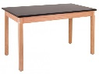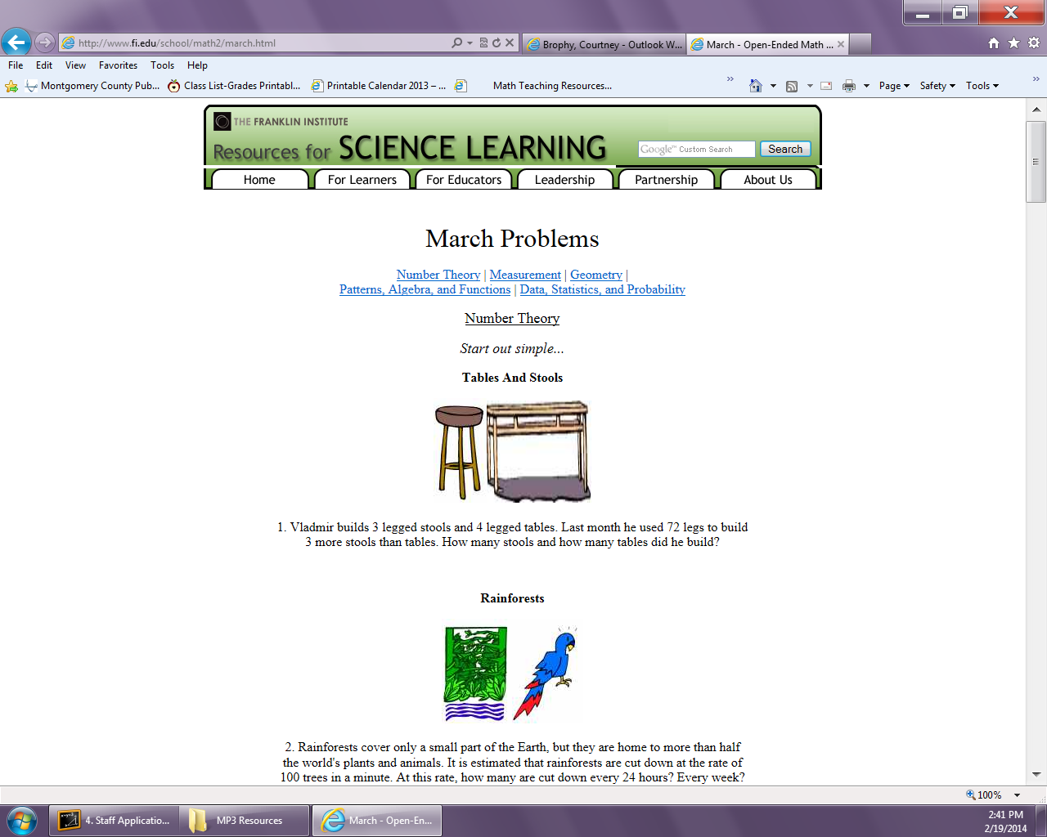

He builds 3 legged stools and 4 legged tables. Last month he used

72 legs to build some stools and tables. How many stools and tables did he build?



***One School, One Community, One Goal……….The Success of Every Glenallan Gator***

***Gator Gazette***

***April 2014***

### Glenallan Elementary School

**“*Every Gator Rises to Extraordinary Excellence”***

|  |  |
| --- | --- |
|  |  |
|  |  |
|  |  |
|  |  |
|  |  |
|  |  |
|  |  |
|  |  |
|  |  |
|  |  |
|  |  |



**News from Third Grade-***Ms. Davies, Ms. Edhegard, Mrs. Ghee, and Ms. Nansimbi*

**Author’s Breakfast**: The third grade team would like to thank our wonderful parents and staff for making our Author’s Tea a success! Our third graders worked diligently on their realistic fiction stories, as they became true authors and illustrators. Your continual support is sincerely appreciated, and we are extremely proud of their efforts.

**Reading:** In marking period four, students will be exploring the characteristics of traditional literature to compare folktales and myths. Please continue to read daily with your children at home, and investigate which types of texts they enjoy. Family discussions about literature can enrich the relationship with your child, in addition to building vocabulary and self-confidence.

**Math:** By the end of the year the goal is for 3rd graders to know all of their basic multiplication facts from memory. Please encourage your child to show you different ways to solve multiplication/division equations at home. There will also be a strong focus on two step word problems that involve all operations.

**Writing/Science:** Students will research a topic and draft their findings in an informative paragraph that explains both sides of an issue. This writing unit connects with science and will also prepare our third graders for a field trip to the zoo in May. They will weigh the pros and cons of animals living outside their natural habitats, and be challenged to take a stance on whether there should be zoos.

**Social Studies:** In social studies, students will define the elements of a budget and develop a plan that shows how money is obtained. Don’t be surprised if this topic leads to discussions about an allowance, which would help your child make real world connections to practical financial decision making.



**News from Fourth Grade-** *Mrs. Mayer, Ms. DeFrehn, Mrs. Hubbard and Mrs. Walsh*

**Reading** — Over the next few weeks we will explore the major differences between poems, plays, and prose. Students will examine poetry and discuss how authors use similes and metaphors as a way to add description to their work. In addition, students will do a brief novel study using the book **Shiloh. **25 Book Recommendations are due by May 31st in order for students to earn a special reward.**

**Math** — Students will be focusing on Geometry concepts during the next few weeks. Students will classify and record angles, and solve problems involving angle measurement. They will also draw 2-dimensional figures based on properties of their lines and angles. **\*\*As always, please have your child practice their basic facts: addition, subtraction, multiplication, and division. This will contribute to their continued success in all areas of math.**

**Writing** — Students will continue to work on the Memoir piece they began at the end of quarter 3. They will then analyze the components of poetry to develop ideas when composing. Students will draft poems which reflect real or imagined life experiences.

|  |
| --- |
| **Science** — Students will explore the observable properties of solid matter, identify, describe, and compare the observable physical properties of rocks, and investigate and use data to determine whether a mixture or a new material is formed  **Social Studies** – Marking period 4 begins with a focus on the structure of government in Maryland. Students will explore the Maryland State Constitution, the Office of the Governor, and the importance of the Maryland Court of Appeals. |



**News from Fifth Grade – Ms. Gottshall, Mrs. Billings and Ms. Jameson**

The 4th quarter project for the 5th graders will be **Careers: Present and Future Inquiry**. The purpose for this assignment is for the students to learn and apply thinking and academic success skills in the context of an interdisciplinary project. They will choose an occupation to research and formulate detailed questions to begin their inquiry. Then, students will gather facts about their selected occupation and seek answers to their detailed questions. In addition, students will develop and administer surveys and interviews. This first-hand account information, as well as digital resources, will serve as evidence to develop their reasons. After gathering information, students will analyze their research to determine whether they believe the occupation will or will not exist in 15-20 years. As a result, they will draft a thesis statement and begin to organize reasons to support their thesis. Additionally, students will revise and edit their writing based on coherence and conventions. Their final product will be a Power Point presentation. The content will be explored throughout the marking period in social studies, science, and art to build a conceptual understanding for the inquiry.



***One School, One Community, One Goal……….The Success of Every Glenallan Gator***

### Glenallan Elementary School

**“*Every Gator Rises to Extraordinary Excellence”***

***Gator Gazette***

***April 2014***

|  |  |
| --- | --- |
|  |  |
|  |  |
|  |  |
|  |  |
|  |  |
|  |  |
|  |  |
|  |  |
|  |  |
|  |  |
|  |  |
|  |  |

### Glenallan Elementary School

**“*Every Gator Rises to Extraordinary Excellence”***



**Snow Days**





**Character Counts:**

The character trait for the month of April is Caring**.** Staff will recognize students who demonstrate honesty at school, in the community, and focusing on it through instruction.

April 8 PTA Meeting @6:30 p.m.

April 9 Parent Involvement Meeting @6:30

April 9 Report Card Distribution

April 11 School PEP Rally @ 9:30 a.m.

April 14 – 20 Spring Break

April 21 Return from Spring Break

April 25 4th Grade Field Trip:Convention Center

|  |  |  |
| --- | --- | --- |
|  |  |  |

The purpose of this message is to inform you about final changes being made to the school calendar in order to make up some of the instructional time we lost due to snow days. Under a plan approved by the Maryland State Department of Education, Montgomery County Public Schools will hold school on Monday, April 21, 2014 (Easter Monday) and Friday, June 13, 2014, which will now be the last day of school for students. The last day for staff will be Monday, June 16. None of the remaining snow days will have to be made up under the state-approved plan.  
  
The staff and I understand that holding school on Easter Monday will be an inconvenience for many families in our school community. However, the Board of Education and Dr. Starr felt that this plan was the best way to ensure that we would make up two days of meaningful instructional time and cause the least disruption to our community's summer plans.

**International Night**

The date for International Night will be held on May 15, 2014 from 6:30 – 8:30 @ Glenallan ES! This is such an excellent community event that celebrates our greatest strength, the many cultures that make up our school family.



**Kindergarten Orientation**

Kindergarten Orientation for Incoming Glenallan Kindergarteners will be held on Wednesday, May 21, and Thursday, May 22. This is an opportunity to build relationships, learn about Glenallan, and register your child for school. Please contact Mrs. Brashers to schedule a time for your child to attend kindergarten orientation. She can be reached in the main office at 301-929-2014



**Parents vs. Staff Basketball Game**

Thank you to all community members that participated in the parents vs. teachers’ basketball game. It was a great opportunity for our community to come together

**Important Dates for Gators in April 2014**

[](http://www.google.com/imgres?imgurl=http://rbhs.lexington1.net:8044/wp-content/uploads/2013/06/Gator-Strength.jpg&imgrefurl=http://rbhs.lexington1.net:8044/2013/2042/&h=366&w=1157&tbnid=x15ttBgCzMx_JM:&zoom=1&docid=k2kd1J3Rbch_pM&ei=pAU-U7WsD8Tx0gGzxICACg&tbm=isch&ved=0CEIQhBwwEzhk&iact=rc&dur=1294&page=6&start=99&ndsp=22)

and enjoy one another’s company. We raised 1,500 dollars that will go to supporting the Glenallan students. A special thanks to Mrs. Welsh, Kids After Hours, Mr. and Mrs. DePasquale, Ms. Bobb, Mr. Fox, Mrs. Correa, Mr. Cord, and all parents and teachers that planned and organized this event. We will be making this an annual event.