|  |  |
| --- | --- |
|  |  |
|  |  |
|  |  |
|  |  |
|  |  |
|  |  |
|  |  |
|  |  |
|  |  |
|  |  |
|  |  |
|  |  |
|  |  |
|  |  |
|  |  |
|  |  |
|  |  |
|  |  |
|  |  |
|  |  |
|  |  |
|  |  |

**Vision: We are a united, multi-cultural community of students, families, and educators committed to cultivating a love of learning, developing the character of great people and empowering children with the knowledge and skills to become productive citizens in the 21st century.**

***Gator Gazette***

***April 2013***

### Glenallan Elementary School

**“*Where Every Gator Go Above and Beyond”***



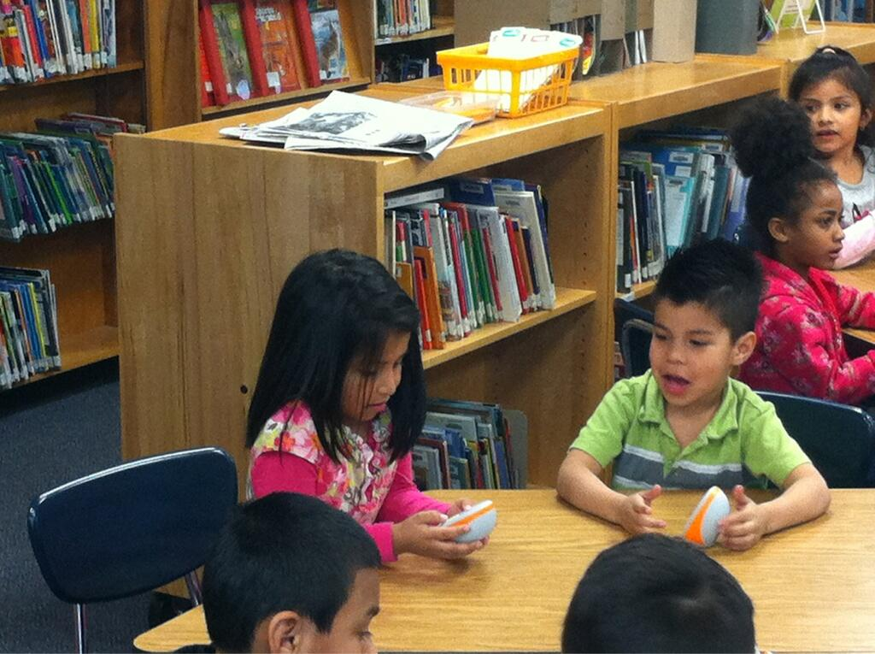

Dear Glenallan Families,

We are making the final turn and preparing to head home. It’s hard to believe that it’s the fourth marking period and that we have been at the Fairland Holding Center for nearly a year and a half. During the month of March, we focused on perseverance as our character trait. I strongly believe that perseverance could be a character trait that best defines our students, our community, and our staff. We have been a constant example of not letting challenging circumstances define who we are, but instead using them as opportunities to highlight the best in each of us. Examples of this occurred throughout March. The students persevered through the Maryland School Assessment with nearly every 3rd, 4th, and 5th grade student meeting the goal on their effective effort rubrics. Their reward for this was the opportunity to dunk Mr. Scott and I, and enjoy some ice cream. Mr. Scott and I persevered through some unseasonably cold temperatures.

It is so important that we recognize the Gators for putting 100 percent effort into what they do, regardless of the outcome. There is no substitute for giving your best! The teachers persevered by not allowing the distractions of state and county assessments deter them from providing great teaching and in turn, significant learning opportunities. In Kindergarten, students discussed the habitat and the differences between animals and human. They are clearly engaged by science and social studies and it is building a global knowledge at an early age. In Grade 1, the first graders were engaged in discussions about the environment and were making connections to their family’s culture. It is clear that the first graders love learning and if you love something you become good at it. In Grade 2, the students are exploring the life cycle of brine shrimp, changing conditions and making predictions of how water temperature impacts how they hatch. Watching the students successfully learn and discuss complex topics is so impressive and is a result of what we believe students can learn and do. We believe our kids are capable of anything if given great teaching, the right resources, and the time to ask questions. The Kindergarten, First, and Second grade teachers do an outstanding job facilitating discussions and ask questions that help students to discover and explore with their peers. The earlier students can build this life skill the more success they will experience academically and socially.



**Gallup Data**

Montgomery County Public Schools launched a partnership with Gallup in 2012 to measure employee and student engagement, and to use the results to help guide the school system’s improvement efforts. The Gallup student poll is a 20-question survey of students in grades 5 through 12 that measures their hope, engagement, and well-being--actionable targets linked to student achievement, retention, and future employment. I wanted to share our results with you because it is truly something for our community to celebrate. First, Glenallan is a “High Hope School” (one of 10 among elementary school in the county) A high hope school is one where students feel proud of their school, believe they can meet their goals and are highly engaged. Below are three data points to celebrate:

**-School Work is Important 85% of Glenallan Students Strongly Agree vs. 49% of MCPS Students**

**-Opportunity to do my best at what I am good at 70% of Glenallan Students Strongly Agree vs. 37% of MCPS Students**

**-School is Committed to my Strengths Glenallan Students Strongly Agree 75% vs. MCPS students 36%**

**Change in School Hours – 2013 – 2014 School Year**

When we moved to the Fairland Holding Center, we had to move our school hours to

9:30 a.m. to 3:45 p.m. to accommodate transportation. Our parent community has done

an extraordinary job meeting this challenge. We will be moving our school hours back to

8:50 a.m. to 3:05 p.m for the 2013 – 2014 school year. This means that our students will

begin to enter the building around 8:30 a.m. More information regarding scheduling will

come out over the summer. However, I wanted to make you aware of this change back to

our normal school hours.

Students Using Technology to Vote on Playground

**Early Closure to Move: June 13. 2014 Closure at 1:15**

The schedule currently runs through a half day on Friday, June 14, 2013.  This means that we will have a half day on Thursday, June 13, 2013.  This information will be communicated to parents on Friday.  Following spring break, on Friday, April 5, a memo will go out with the details of our moving plan.  It will be very similar to the structure we used when moving to Fairland.



***One School, One Community, One Goal……….The Success of Every Glenallan Gator***



**Simple Ideas to Help Your Child Learn Sight Words**

**Reading Specialiast -** Mrs. Raiford and Ms. Smith

Sight words are words that cannot be learned through pictures or stretching out their sounds. They appear frequently in all books. It is important for your child to learn these words and become automatic in identifying them. Here are some fun ways to expose your child to the words.

1. Write the words on index cards or small pieces of paper to create flashcards for your child to review.
2. If you carry a purse or a bag, place a set of the words inside of it. When you have to wait in line at the grocery store, bank, sitting in a restaurant, etc.. Take the words out and review them.
3. Write the words your child needs to learn on sticky notes. Stick them anywhere your child goes! You can stick them on the wall near their bed to review before going to sleep and when waking up, in the bathroom to review during bath time, on the wall near the dinner table to review during breakfast, lunch, and dinner, etc…
4. Take words your child is having difficulty with and place them on the car seat back in front of your child. As you are driving, your child will be staring right at the words! You can ask him/her to read them to you.
5. Lay the words flat on the floor in a little path. Have your child read each word as they hop to or step on it to follow the path. If you have stairs at home, put a word on each step and have your child say each word as they climb the stairs.
6. Make two sets of word cards and play “memory” or “Go Fish” with them.
7. Lay 3-5 cards facing up so that your child can see them. Play rhyming games such as “I’m thinking of a word that rhymes with me, but it begins with /w/” (we)
8. Play “What’s Missing”. Lay 3-4 words on the table and have your child read the words and then close his/her eyes. Remove one of the words. Ask your child to open their eyes and identify the word

that was missing. Then take a turn closing your eyes!



**News from Kindergarten-***Ms. Yetter, Ms. Ziadi, Mrs. Frank, Mrs. Beckett and Ms. Ali*

Happy spring!! Take time at home to recognize your child’s hard work in making our descriptive

reports. Your children worked extremely hard going through the writing process to draft, edit, and

produced final copies of a non-fiction book about an animal. Continue to practice reading and writing

word wall words and read every night. Please begin to focus on comprehension when reading a story. Have the students retell the story beginning, middle, and end, the problem and solution, and characters and setting in a story.

In math your children have become masters in identifying and describing 2-dimensional (circle, triangle, square, rectangle, hexagon) and 3-dimensional solids (sphere, cone, pyramid, cube, rectangular prism, cylinder). We will use our knowledge with these to build a city with the Clark group LLC on April 12th.

Look out for the Kindergarten newsletter that will be going home on April 12th, this will highlight specific topics we will be learning and important dates to look for in quarter 4. Kindergarten orientation for new incoming kindergartener’s will be held on May 2nd and May 3rd. Mark these days in your calendar, there will be no school for the current kindergarteners. Keep up the great work at home and come in and check out what we are doing in kindergarten any time.



***One School, One Community, One Goal……….The Success of Every Glenallan Gator***

**

### Glenallan Elementary School

**“*Where Gators Go Above and Beyond”***

***Gator Gazette***

***April 2013***

C:\Users\moranpet\AppData\Local\Microsoft\Windows\Temporary Internet Files\Content.IE5\XNLVGHPW\MC900339222[1].wmf



**Tips to Promoting a Growth Mindset For Your Child**

When we think about our students, we are focusing on their effort and strategies. Focusing on process (and not just product) allows our students to remain motivated and effective. Praise and effort also promotes a growth mindset of motivation and resilience. It is important to remember that what we say to our students has a strong impact on their learning, motivation and mindset. When talking to your child about homework, classwork, projects, or an upcoming test, instead of saying, “It’s going to be easy,” foster a growth mindset by saying:

➢ Work hard, you will get it!

➢ Take your time and read each question carefully.

➢ I know you can do it!

➢ I think you are prepared.

➢ This looks like what we did yesterday. Use those same skills on this problem.

➢ You are a hard worker and will do well.

➢ I like the way you’re working hard and focusing on this task.

➢ You will get this, even if you don’t have it yet!

➢ If it is easy for you now, then your hard work paid off!

➢ This is important, so stick with it.

➢ If it isn’t working, try another strategy.

➢ It is okay if you make a mistake, it’s not okay to stop trying.

➢ I believe in you; you can do it!



**First Grade News** – *Mrs. Correa, Ms. Rodriguez, Mrs. Ralph, Mrs. Lozzi, and Mr. Cord*

Welcome back from Spring Break, and we hope you all had a nice and relaxing time with family and friends. It's hard to believe that we are in the 4th quarter of school already! The students have been working really hard towards their goal of reading at a level 16 or above by June. Please ask your child what level he/she is on and read every night to make sure this goal is accomplished. We believe in the students and know they can do it! We have been adding and subtracting 2-digit numbers in math and flash cards are a great resource for practicing facts at home. We had a great time at the Recycling Center and we hope that the students are applying what they have learned at home to help our environment. Are you recycling at home? :) Please continue to check your child's folder, homework, and backpack each night. We appreciate your continued support with our first graders and look forward to working with you this last quarter of school.



**Second Grade News –** *Mrs. Navas, Mrs. Grotewold, Mrs. Treichler, and Mrs. Johnson*

Our focus on “Change” continues in March with an exciting science project!  Classes will be observing the growth of brine shrimp (very small shrimp that live in salt water).  Be sure to ask your child about this very interesting opportunity.  The Moon Journals are going well.  Thank you for helping your child observe the moon when it is their turn to do so.  Homework Tip:  Students should complete their homework independently.  We encourage parents to check over the homework to make sure it is complete and the directions have been followed.  Thank you for your help with this!

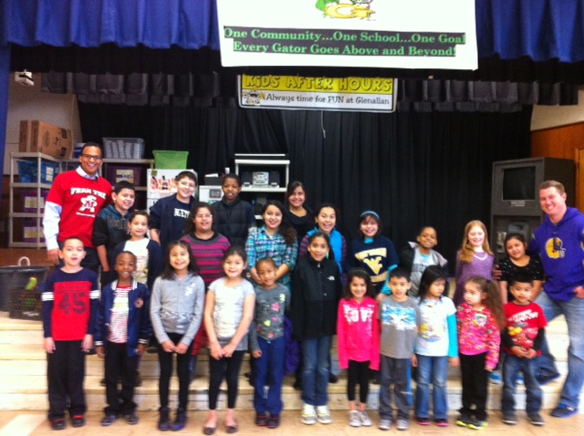



***One School, One Community, One Goal……….The Success of Every Glenallan Gator***

***Gator Gazette***

***April 2013***

### Glenallan Elementary School

**“*Where Gators Go Above and Beyond”***



***Gator Gazette***

***April 2013***

|  |  |
| --- | --- |
|  |  |
|  |  |
|  |  |
|  |  |
|  |  |
|  |  |
|  |  |
|  |  |
|  |  |
|  |  |
|  |  |

**Message from the Grade 3 Team -***Ms. Davies, Ms. Gottshall, Ms. Edhegard, and Ms. Langrock* 

Thank you for all of your continued support!

**Author’s Breakfast**: The third grade students have been working very hard to write their realistic fiction stories. On **Wednesday, April 10th at 9:35 am**, we will be inviting the families of our third grade students to share these stories at our Author’s Breakfast. The Author’s Breakfast will take place in each 3rd grade classroom.

**Multiplication Facts**: By the end of the year the goal is for 3rd graders to know all products, from memory, of 2 one-digit numbers.

**Reading at Home:** Please continue to read daily with your children at home.

As always, please let us know if you have any questions or concerns!



**News from Fourth Grade-** *Mrs. Mayer, Ms. DeFrehn, and Mrs. Hubbard*

**We have some important events coming up! Please mark your calendars!!!**

* Report Cards go home with your child on Thursday, April 11th. Parents please take the time to review with your child his/her grades, sign the envelope, and have your child return it to his/her teacher.
* University of Maryland field trip on Friday, April 12th. Be sure to have your child bring a bag lunch, dress appropriately for the weather, and wear comfortable shoes for walking.
* Wax Museum at Kennedy High School on Wednesday, May 1st. Your child should arrive dressed to perform his/her speech by 6:45. Please contact his/her teacher if you have any questions.

**What we are studying in Quarter Four**

* Biographies
* Plays
* Poetry
* Math Transition Unit: Fractions
* Science: Chemistry – Matter
* Social Studies: United States and Maryland Government



**News from Physical Education** – *Mr. Kogok*

In Physical Education, the students in 3rd, 4th, and 5th grade have been learning line dances and having a great time. Students have been focused on learning the sequences of movement, formation and coordinating movements with others. Our younger students have been working on fundamental jumping patterns such as jumping for height and jumping for distance as well as jumping with a self -turned rope. We all are looking forward to warmer weather and the chance to get outside a little more often. Have a wonderful spring break.



**News from Art** – *Mrs. Vanegas*

Well things are certainly hoppin’ in the art room. Please **SAVE THE DATE**! Glenallan will be having a school wide Art Show on May 14th the same night our PTA will be having their Volunteer Appreciation Night. Please come out and support us. If you are interested in helping out with the hanging of the art show and the preparation of art work please contact me by email [debbie_s_vanegas@mcpsmd.org](mailto:debbie_s_vanegas@mcpsmd.org)  or call the school 301-929-2014. Hablo español. Se puede mandar correo electrónico en español si usted desea ayudar. I will start hanging the show the week before the art show on the 7th of May. Another event coming up sooner than the Glenallan Art Show will be the County wide Elementary and Middle School art show taking place at Lake Forest Mall on April 17th opening at 6pm and running through Sunday, April 21st  closing at 5pm.



***One School, One Community, One Goal……….The Success of Every Glenallan Gator***

### Glenallan Elementary School

**“*Where Gators Go Above and Beyond”***

|  |  |
| --- | --- |
|  |  |
|  |  |
|  |  |
|  |  |
|  |  |
|  |  |
|  |  |
|  |  |
|  |  |
|  |  |
|  |  |

### Glenallan Elementary School

**“*Where Gators Go Above and Beyond”***







April 9 PTA Meeting 7:00 @Fairland

April 11 Report Card Distribution

April 11 Ice Cream Social 6:00 @Wheaton Park

April 12 4th Grade Field Trip to UMD

April 15 – 16 5th Grade MSA Science

April 17 McTeachers Night Glenmont

April 17 Kindergarten Field Trip: Woodlawn Manor

April 25 Take your Daughter and Son to Work Day

April 26 Pancakes with the Principals

April 26 International Night@Kennedy 6:30 p.m.



**Character Counts:**

The character trait for the month of April is Fairness**.** Staff will be looking for students demonstrating respect at school, in the community, and focusing on it through instruction.

***“Always bear in mind that your own resolution to succeed is more important than any one thing.”   
―*** [***Abraham Lincoln***](http://www.goodreads.com/author/show/229.Abraham_Lincoln)

[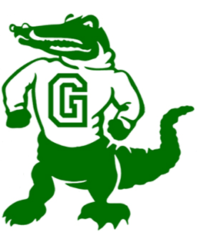](http://www.google.com/url?sa=i&rct=j&q=Gators&source=images&cd=&cad=rja&docid=OV_55onkedAxjM&tbnid=2XhqYaQa87TltM:&ved=0CAUQjRw&url=http://www.geibelcatholic.org/athletics/Pages/default.aspx&ei=ehIZUdHHLdCM0QG89YHgCw&bvm=bv.42080656,d.dmQ&psig=AFQjCNG81OHwyi3H4l7P9214i94DWg2AmA&ust=1360683980748525)

**Parent Engagement Survey**

***Important Dates for the Gators in April 2013***

MCPS will be conducting a parent engagement survey, beginning on March 1, that will focus on parent and guardian perceptions of their child’s school and education. The information provided will help our schools better understand your involvement in your child’s education and improve connections between schools and families. A random sample of families at all grade levels in each MCPS school will be asked to participate in the survey. If you are selected, the information will be sent directly to your home with instructions on how to complete the survey. The survey will be available March 1 through May 24, 2013. The survey is translated into six languages: Amharic, Chinese, French, Korean, Spanish, and Vietnamese. Families will receive the survey in the language they have indicated is spoken at home.

 MCPS Partnering with Spanish News Agencies

MCPS is partnering with several Spanish news agencies to provide timely information to Spanish-speaking families.  Univision Washington airs a weekly educational segment, *Edúcalos: Es el Momento*, produced by MCPS TV and featuring students, teachers, and parents from our community*.* The show airs every Wednesday night at 6:00 p.m. on Channel 14.  La Nueva 87.7 FM airs a 60-second *Informe Educativo* segment throughout the day promoting programs and services within MCPS.  And every two weeks, *Washington Hispanic* publishes a column from Superintendent Joshua Starr (*La Columna del Superintendente*), presenting news and information for members of the community.  The segments described above also can be found online at [www.montgomeryschoolsmd.org/es/news](http://www.montgomeryschoolsmd.org/es/news).