August 1, 2014

The following is the philosophy of Charles Schultz, the creator of the "Peanuts" comic strip. You don't have to actually answer the questions.

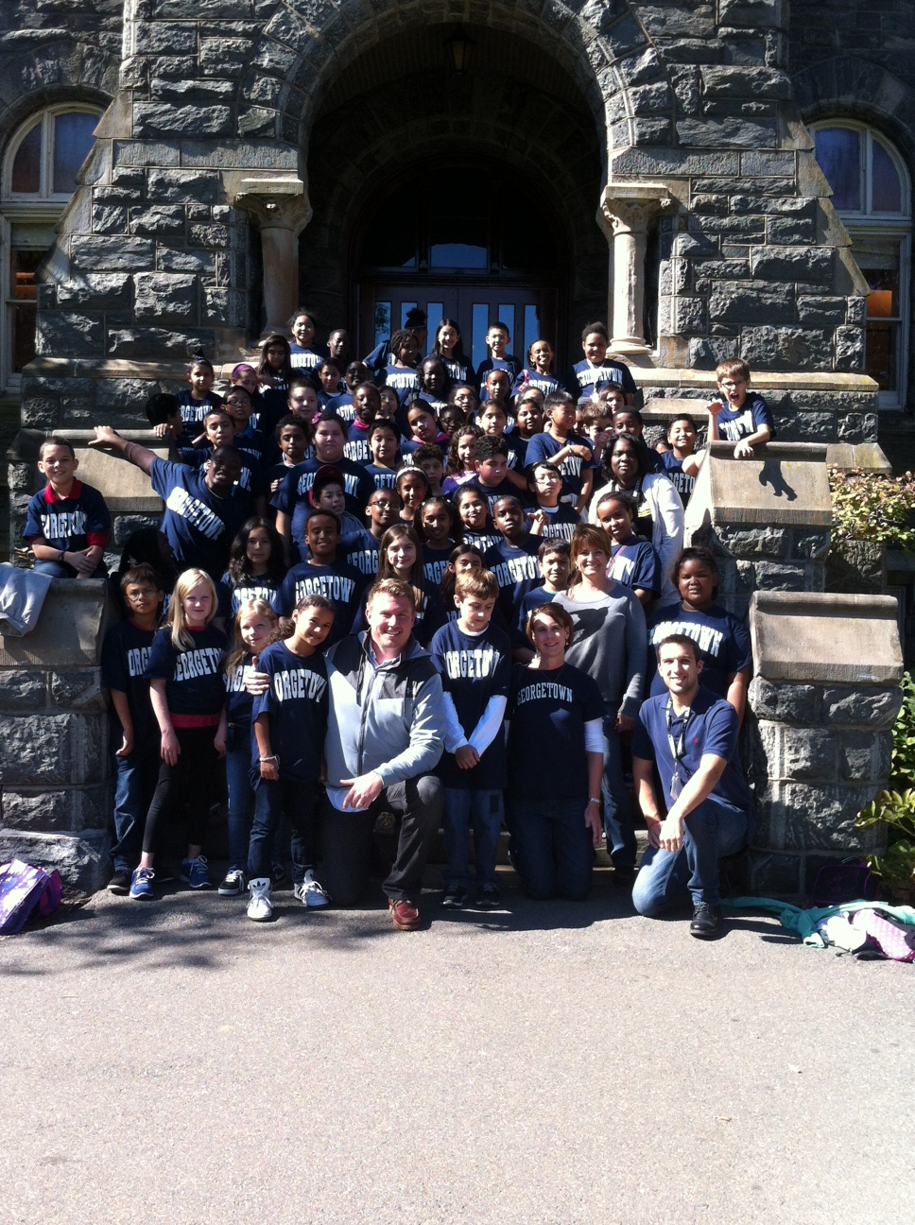

1. Name the five wealthiest people in the world.

2. Name the last five Heisman trophy winners.

3. Name the last five winners of the Miss America Pageant.

4. Name ten people who have won the Nobel or Pulitzer Prize.

5. Name the last half dozen Academy Award winners for best actor and actress.

6. Name the last decade's worth of World Series winners.

How did you do?

The point is, none of us remember the headliners of yesterday. These are no second-rate achievers. They are the best in their fields. But the applause dies. Awards tarnish. Achievements are forgotten. Accolades and certificates are buried with their owners.

ffffff_dot**Here's another quiz. See how you do on this one:**

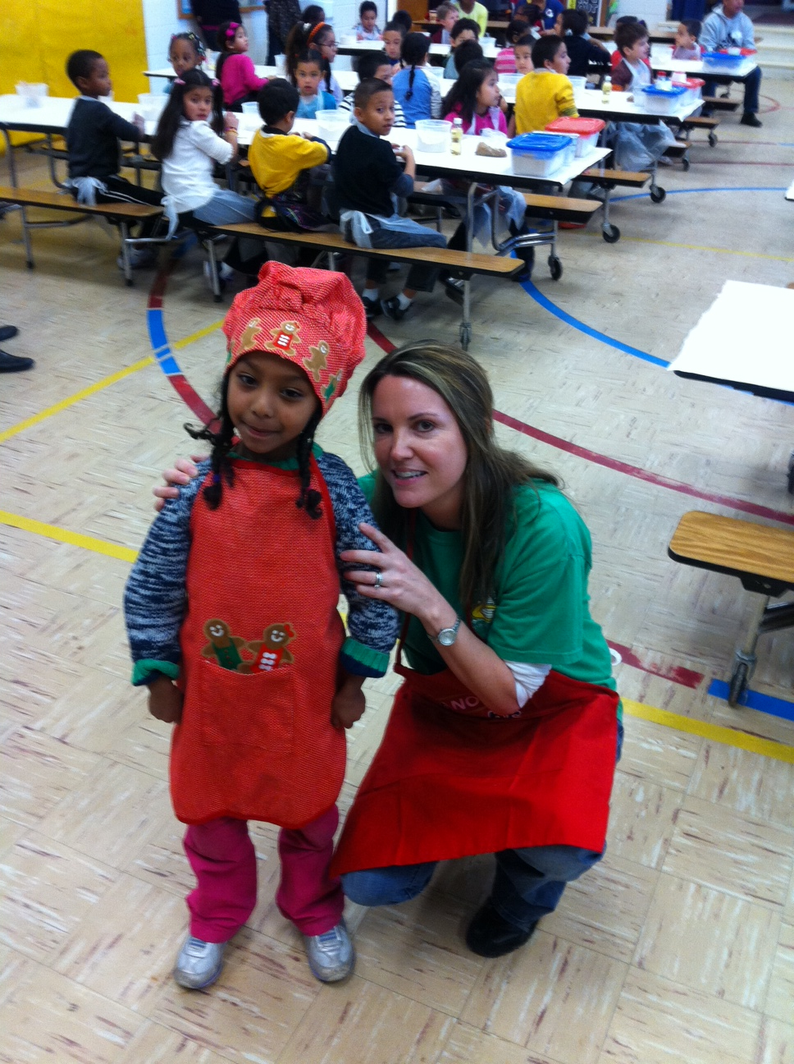

1. List a few teachers who aided your journey through school.
2. Name three friends who have helped you through a difficult time.
3. Name five people who have taught you something worthwhile.
4. Think of a few people who have made you feel appreciated and special.

5. Think of five people you enjoy spending time with.

**Easier?**

**The lesson: The people who make a difference in your life are not the ones with the most credentials, the most money, or the most awards. They are the ones that care. Your children, our students will remember us as teachers and parents and the significance we play in their lives. Together, let’s make this, the year that every Glenallan Gator Reaches Excellence.**





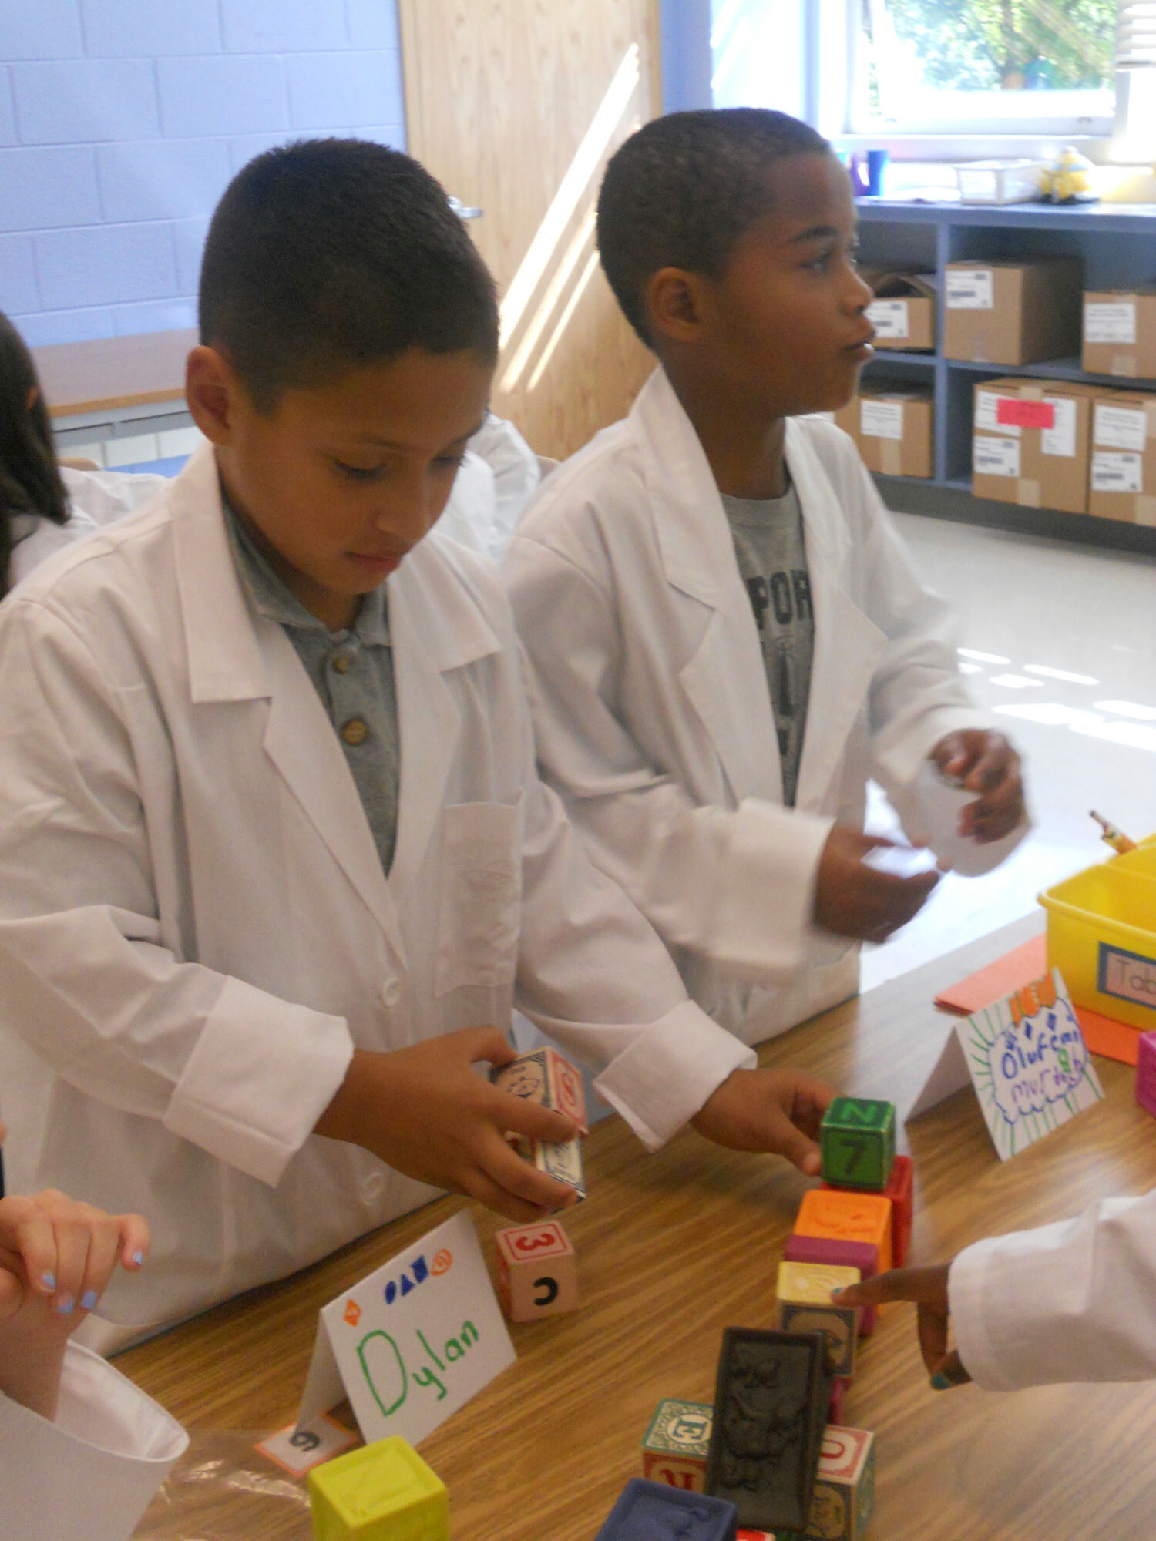

**Glenallan Elementary School**



**12520 Heurich Road**

**Silver Spring, Maryland 20902**

We are One Community...One School...with One Goal...

“Focused on Every Gator Reaching Excellence”

|  |  |  |
| --- | --- | --- |
| Dear Glenallan Families,  I’m truly excited and extremely proud to welcome you and your child to the 2014 – 2015 school year. Welcome to the Glenallan Elementary School, your community school, the “Home of the Gators.” Together, we spent the last school year moving into a new building and transforming it into a nurturing, positive environment where we share the belief that positive relationships lead to academic excellence. The staff and I want to thank you for partnering with us during  a year of change. We experienced the excitement of a new building, the challenges of developing new routines and processes in a large facility, and the full (K-5) implementation of Curriculum 2.0. Challenges and change are never easy, but they serve as a test to determine what we are capable of and what a group of people can accomplish when they share ideas, communicate effectively, and work together as a team. Our community continues to prove that it is capable of doing extraordinary things.  The evidence of our collective efforts is clear as we were recognized as one of the **top five schools** in the district for student engagement, student well-being, and student’s feelings of hope for the future - for the second year in a row. This data was collected through a Gallup survey of students, parents and staff and is available on our website. Glenallan was recognized by the Washington Post for our progressive implementation of our STEM Academy and by the National Education Association (NEA) for our focus on student relationships and creating equal access to unique learning opportunities. Finally, our student achievement in math and reading continues to show significant progress in the past two years as evidence by our growth in multiple assessments. This student success is attributable to your support of your child and teacher, the relationships we have developed as a community, and the belief that each of our students is  capable of excellence. We have persevered through the excitement and distractions of change. It is now simply time to focus on one thing, providing a learning experience as excellent as any, not only in Montgomery County, but across our Nation.  We will continue our momentum of building a world class educational program by providing the following;   * Well planned, creative, and engaging classroom lessons that are designed to meet student’s individual learning needs * Engaging students in meaningful and intellectual discussions that demonstrate their ability to think critically * The second year of our Science, Technology, Engineering, and Math (STEM) academy where students engage in hands-on interactive learning that requires working in teams, knowledge of new state of the art technology, and challenges them to discover new things by utilizing the multiple ways they learn. * Exposure to unique learning opportunities in the Arts, Coding and Robotics, and motivational experiences such as college visits and opportunities to hear from speakers from various career fields.   It continues to be our goal to create a community school that is united by the belief that the connection between Glenallan Elementary and you, the parents, serves as the foundation for school success. It is important that you know you have a voice at Glenallan. Your ideas, input, and opinions are welcome as we create a place of learning that is reflective of not some, but all. I believe very strongly that relationships are the key ingredient in teamwork and the foundation of a successful education.  The other day I was outside at recess during our summer school program. I spent some time talking with a group of soon to be 4th grade students. I asked one student if he was excited for school to begin and he said, “yes, this is going to a “**big”** year for me.” I went home and spent the evening thinking about that remark. Every year as our children pick up school supplies or a new shirt for the first day of school, they are filled with the hope that this will be “a big year for them”- the year they get smarter, the year they get an A in Math, the year they are recognized for their character, the  year they get up in front of an audience and sing or play a new instrument, and the year they make you, their families proud. Together, let’s fulfil this hope for every student. My grandfather always used to tell me, “Expect big things, and big things will happen.” I expect big things for the Gators this school year!  Respectfully,  Peter Moran  Principal |  |  |

# **Glenallan Community Vision**

We are a united, multicultural community of students, families, and educators committed to; cultivating a love of learning, developing the character of great people and empowering children with the knowledge and skills to excel as productive citizens in the 21st century.

For an at home activity to spread the understanding of our community vision, please have a discussion with your our child about the meaning of this statement.

# **Glenallan Community Mission**

We are One Community...One School...with One Goal...The Success of Every Gator.

# **Staff Updates**

We are happy to welcome the following new members to the Glenallan team. All are well qualified in their disciplines, and I am certain each new staff member will contribute to maintaining a positive school climate and strong instructional program.

|  |  |
| --- | --- |
| **Staff Member** | **Position** |
| Ms. Erica Jackson | PEP Collaboration Teacher |
| Ms. Kate Amin | Head Start Teacher |
| Mrs. Sarah Genua | Grade 2 Teacher |
| Mrs. Linda Oh | Academic Intervention Teacher |
| Ms. Kayleigh Komara | Grade 2 Teacher |
| Mr. Brett Maley | General Music Teacher |

We are sorry to say good-bye to several Glenallan staff members and wish them the very best in their new positions. Ms. Beth Yetter, kindergarten teacher became a school counsellor in MCPS, Ms. Jameson, 5th Grade Teacher accepted another teaching position in MCPS, Mr. Tilkens, Music Teacher, accepted a middle school music teaching position, and Ms. Muhammad, 2nd Grade Teacher, became a teacher in D.C. Public Schools. Mrs. Monti, took a year of leave to be with her family in Florida. In addition, the following teachers will be taking their knowledge, experience, and ideas to new teaching positions at Glenallan:

|  |  |
| --- | --- |
| **Staff Member** | **Position** |
| Ms. Nicole Ziadi | Reading Specialist |
| Mrs. Gloria Diallo | Kindergarten Teacher |
| Ms. Yvette Bobb | Special Education Paraeducator |
| Mrs. Stephanie Wallis | PEP-Comprehensive Teacher |
| Mrs. Amanda Carbone | Kindergarten Teacher |
| Mr. David Sabia | Grade 4 Teacher |

**Student Enrollment – We Are Growing!!!**

Our student enrolment has increased by over 100 students in the last year. We are preparing for a potential significant increase in enrolment. To date our total school enrolment is 618 students. Currently, we have 121 kindergarten students enrolled, with the potential of many more enrolling in the next month. If the numbers do increase, we will be working to ensure class sizes meet MCPS guidelines. Below is a table that shows our current enrolment numbers and average class sizes:

|  |  |  |  |  |  |  |
| --- | --- | --- | --- | --- | --- | --- |
| Grade | K | 1 | 2 | 3 | 4 | 5 |
| Enrollment | 121 | 96 | 104 | 88 | 91 | 89 |
| Avg. Class Size | 20 | 18 | 17 | 22 | 23 | 26 |

**College Readiness and Motivation Initiative**

Glenallan Elementary will continue to work to provide students with experiences to research and visit local universities. Last year, our fourth grade students visited the University of Maryland and our fifth grade students visited Georgetown University. In addition, we held career day when professionals from many different sectors and industries came to discuss their collegiate and professional experience with students. It is never too early to set goals!

**P.T.A. Meetings**

**Please mark your calendars for PTA meetings for the 2014 – 2015 school year. The dates are as follows:**

|  |  |  |  |
| --- | --- | --- | --- |
| **Date** | **Time** | **Location** | **Topic** |
| September 9, 2014 | 6:30 pm | All Purpose Room | Back to School Night |
| October 7, 2014 | 6:30 pm | All Purpose Room | Family Math Night |
| December 2, 2014 | 7:00 pm | All Purpose Room | Family Reading Night |
| January 6, 2015 | 6:30 pm | All Purpose Room | Social Emotional Intelligence |
| February 3, 2015 | 6:30 pm | All Purpose Room | PARCC |
| May 12, 2015 | 6:30 pm | All Purpose Room | Volunteer Appreciation |

**School Hours**

**First day of school begins on Monday, August 25, 2014.**

School Hours (Kindergarten – Grade 5) **8:50 a.m. – 3:05pm**

**Head Start Hours 8:50 a.m. – 12:50 a.m.**

Teacher Hours **8:00 a.m. - 3:30 p.m.**

Students Enter the Building **8:30**

Morning Announcements **8:50**

Instruction Begins **No later than 8:55**

* The late bell rings at 8:50. Students arriving to school after this bell rings MUST report to the main office to order lunch and get a late pass to class.
* Dismissal begins at 3:05.

**Morning/Arrival: Breakfast**

All students at Glenallan Elementary School will have the opportunity to eat breakfast in their classrooms each morning at no charge. Breakfast will include milk, juice or fruit, and an entrée such as French toast sticks, bagels, breakfast sandwiches and yogurt. Breakfast will be delivered to the classrooms and students will eat in their classrooms as they arrive at school. This program, titled ‘Maryland Meals for Achievement’ (MMFA), is funded with money from the Federal School Breakfast Program and the Maryland State Department of Education. Our school is one of 40 Montgomery County Public Schools that will be offering this wonderful classroom breakfast program. We invite your child to start the day ready to learn by joining his or her classmates for a nutritious breakfast at school each morning. Students will be able to enter the building at 8:30 a.m. and report directly to their classroom to finish their breakfast before teaching and learning begins. If you have questions, please feel free to contact the school office (301) 929-2014.

**Dismissal Process**

We are committed to an organized and safe dismissal process. Staff will be stationed on the inside and outside of the school to supervise this process. Our kindergarten through grade 2 students will be the first to be dismissed at 3:00. All kindergarten bus riders will be placed in lines and walked out through the doors to the bus loop. They will be the first students on buses so they can be in the front of the bus so they are in close proximity to the bus driver and patrols. Grade 1 and Grade 2 students will follow. They will exit through the same blue doors that go directly to the bus loop. (All bus stop locations/pick up times/drop off times are at the end of the summer mailing)

All car riders will be dismissed from the front of the building, where they will be escorted by staff members to their car. All walkers will be dismissed from the black top adjacent to the playground. Kindergarten – Grade 2 Teachers will accompany their walkers and have an exchange system that ensures safety and security when parents/siblings pick up their child. Grade 3 – Grade 5 walkers/car riders will be dismissed at 3:05 and will exit through separate doors then the primary students. At this time, upper grade students may pick up their siblings from their classroom teacher. There will be staff stationed at different exit locations in the back of the school. **Students may not cross the street at the intersection of Heurich Road and Randolph Road. They must cross at the designated cross walks on Randolph Road.** These procedures will be thoroughly reviewed with students on the first day of school and throughout the first weeks of school.

**Open House**

* **Open House is on Friday, August 22, 2014 from** 10:00 – 12:00 p.m. Parents and students have the opportunity to visit the classroom and meet their teachers. “Welcome Back” postcards will be sent to students by their new teachers during the week of August 18, inviting them to the August 22 Open House.
* We would like to continue to open up the doors to our parents so they can spend some time with their children within the classroom. Therefore we will be holding three additional open houses during the course of the school year. The dates and times are as follows;
  + October 13, 2014 8:30 – 11:30 a.m.
  + December 23, 2014 8:30 – 11:30 a.m.
  + March 18, 2014 8:30 – 11:30 a.m.

**Back-To-School Night**

*Please mark your calendar for our annual Back-To-School Night on*

***Tuesday, September 9, 2014 6:30 – 8:30 p.m.***

**Keep informed, Keep in Touch, Stay Involved**

On the first Friday of each month, we will send home information about school operations and special activities in the Gator Gazette. Grade level news and news from specialists will be included in this monthly newsletter. We are currently making some upgrades to our website to help parents and the community stay informed with school activities, information regarding the new curriculum, and instructional program information and updates. One piece that will be included will be an online survey to provide us with feedback regarding teacher, parent, and community feedback and input on the overall operation and instruction of the Glenallan. These updates will go live on the website by September 1, 2014. Please refer to our website for updated information at [www.mcps.k12.md.us/schools/Glenallanes](http://www.mcps.k12.md.us/schools/Glenallanes)

In addition, please follow Glenallan through twitter @**GlenallanES**

**Character Counts**

[](http://www.google.com/imgres?q=character+counts&hl=en&sa=X&rlz=1T4SKPT_enUS440US440&biw=1366&bih=673&tbm=isch&prmd=imvns&tbnid=wfR7o2ZTfUWgQM:&imgrefurl=http://bsatroop356.com/Links.php&docid=aylBWMUojClicM&imgurl=http://bsatroop356.com/images/Character%20Counts-1998.jpg&w=800&h=860&ei=wlEgUMDWCYKf6AGT9YHoCg&zoom=1&iact=hc&vpx=699&vpy=259&dur=761&hovh=233&hovw=217&tx=123&ty=125&sig=109886222427564122005&page=2&tbnh=149&tbnw=139&start=20&ndsp=24&ved=1t:429,r:15,s:20,i:253)The development of good students, but also great people is part of our mission at Glenallan Elementary. Each month students will receive guidance lessons about character traits; for example, respect, perseverance, responsibility, honesty, and citizenship. We will focus on one character trait each month. Students who demonstrate this character trait consistently in the classroom, hallways, cafeteria, and on the school bus will be recognized by their classroom teacher. As a result of this, these students will receive a medal at our awards ceremony and have pancakes with the principals on the final Friday of the month. In addition, their names will be published in our monthly newsletter and on the school website.

**Visitor Procedures**

We welcome visitors at Glenallan and appreciate volunteers. All visitors must sign in at the front office and wear a visitor sticker at all times when in the building. If a sticker is not visible, staff members will ask that you return to the office and put one on. If you wish to visit your child’s classroom, please provide teachers with notification through email, writing, or by phone 24 hours in advance. This notification is a courtesy to teachers and can be helpful in minimizing distractions for students. Please note that the only available entrance for anyone to enter the building after 8:50 is through the main doors through the blue rotunda. All other doors will be locked throughout the day.

**Email Addresses – Let’s Go Green!!!**

This year we will be trying to cut down on our use of paper. We would appreciate you providing the school and our Parent Teacher Association with your email address so you can receive school information in a timely and environmentally friendly manner. During our open house on Friday, August 22, please take a moment to fill out your contact information for our PTA representatives.

If you are not receiving Connect Ed phone calls from Glenallan, please contact Mrs. Brashers to provide an accurate phone number.

# **Glenallan School Supply List 2014 - 2015**

**Kindergarten**

Backpack (**sturdy and large** enough to fit folders) pair of scissors

2 hardcover composition books (100 pg.) 1 two-pocket folder

1 bottle of Crayola no-run school glue box crayons 24 pack

**NO glue sticks** please pencils (12 pack)

**First Grade**

backpack pair of scissors

3 hard cover composition books (100 pg.) box crayons 24 pack

1 bottle Crayola no-run school glue 2 glue sticks

2 packs of pencils (12 per pack) **NO MARKERS PLEASE**

school box

**Second Grade**

backpack                                           school box

3 hard cover composition books (100 pg.)          2 boxes crayons

2 packs of pre-sharpened pencils                 1 bottle glue and 4 glue sticks

2 two-pocket folders                                           2 large erasers

1 pair scissors                                              1 small pencil sharpener

Optional:  colored pencils

**\*Please label all of your child’s supplies.**

**Third Grade (\*do not purchase** a 3 ring binder)

backpack glue stick

pencils (4 packs of 12) expo markers

eraser 1 two-pocket folder

color pencils 2 hard cover composition notebook

ruler Pocket Folder for STEM

Composition Journal for STEM

**Fourth Grade**

backpack #2 pencils/erasers

3 ring binder **(2 inch rings)** pencil case

3 packs notebook paper (with 3 holes) 2 highlighters

1 box markers 1 box colored pencils

1 box crayons 2 hardcover composition books

Composition Journal for STEM Pocket Folder for STEM

**Fifth Grade**

backpack#2 pencils/erasers

3 ring binder **(2 inch rings)** 3 two-pocket folders

notebook paper(with 3 holes) Glue stick

3 hardcover composition books (100 page) Pocket Folder for STEM

divider sections for binder

Composition Journal for STEM

**All third, fourth, and fifth graders are expected to use a daily homework planner. For your convenience, Glenallan will provide a Homework planner to every student in the intermediate grade levels.**

\*\***Teachers will gladly accept donations for the following items:**

**Ziploc bags (not snack size), hand sanitizer, Clorox wipes, and Kleenex**

**Glenallan Elementary School**

**Community Calendar 2014 – 2015**

|  |  |  |  |
| --- | --- | --- | --- |
| **Date** | **Day of Week** | **Event** | **Time** |
| August 18 -22, 2014 | Monday - Friday | Professional Days for Teachers | No School for Students |
| August 22, 2014 | Friday | Open House for Students  And Families | 10:00 a.m. - 12:00 p.m. |
| August 25, 2014 | Monday | First day of School | 8:50 a.m. – 3:05 pm |
| August, 26, 2014 | Tuesday | Expectations: Student Assemblies | Grades K, 1, 2  Grades 3, 4, 5 |
| August 28, 2014 | Thursday | Ice Cream Social @ Glenallan ES Black Top | 6:30 – 8:00 pm |
| September 1, 2014 | Monday | Holiday – Labor Day | Offices & Schools Closed |
| September 5, 2014 | Friday | Summer Reading Challenge Celebration |  |
| September 9, 2014 | Tuesday | Back to School Night | 6:30 pm – 8:30 pm |
| September 24, 2014 | Wednesday | Early Release Day – Grading and Planning | Students dismissed  at 12:35 p.m. |
| September 25, 2014 | Thursday | Holiday – Rosh Hashanah | Offices & Schools Closed |
| September 26, 2014 | Friday | Pancakes with the Principals | 9:00 – 10:00 a.m. |
| October 7, 2014 | Tuesday | PTA Meeting:  Family Math Night | 6:30 – 8:00 p.m. |
| October 10 – 13, 2014 | Friday, Monday | PTA Book Fair (Room 150) |  |
| October 13, 2014 | Monday | OPEN HOUSE | 8:30 a.m. – 11:30 a.m. |
| October 17, 2014 | Friday | MSEA Conference | No School for Students and Teachers |
| October 24, 2014 | Friday | Pancakes with the Principals | 9:00 – 10:00 a.m. |
| October 30, 2014 | Thursday | Halloween Festivities | Parade@1:30 p.m.  Parties follow |
| October 31, 2014 | Friday | Professional Day for Teachers | No School for Students |
| November 4, 2014 | Tuesday | Holiday | Maryland State Gubernatorial Election Day |
| November 5, 2014 | Wednesday | McTeacher’s Night - Glenmont | 5:00 – 8:00 p.m. |
| November 10, 2014 | Monday | Early Release Day: Parent/Teacher Conferences | Students dismissed  at 12:35 p.m. |
| November 11, 2014 | Tuesday | Early Release Day: Parent/Teacher Conferences | Students dismissed  at 12:35 p.m. |
| November 12, 2014 | Wednesday | Report Card Distribution/  Flyer Day |  |
| November 14, 2014 | Friday | PTA: Movie Night | APR  6:30 – 8:30 p.m. |
| November 21, 2014 | Friday | Pancakes with the Principals | 9:00 – 10:00 a.m. |
| November 26, 2014 | Wednesday | Early Release Day: Prior to Thanksgiving Day | Students dismissed  at 12:35 p.m. |
| November 27 & 28, 2014 | Thursday and Friday | Holiday | Happy Thanksgiving |
| December 2, 2014 | Tuesday | PTA Meeting: Family Reading Night | 6:30 – 8:00 p.m. |
| December 11, 2014 | Thursday | Winter Concert | 7:00 – 8:30 pm |
| December 19, 2014 | Friday | Pancakes with the Principals | 9:00 – 10:00 a.m. |
| December 23, 2014 | Tuesday | OPEN HOUSE and Grandparents’ Day | 8:30 – 11:30 a.m. |
| December 24 & 25, 2014 | Wednesday and Thursday | Holidays | Christmas |
| December 26 – 31, 2014 | Friday – Wednesday | Winter Break | No School for Students  and Teachers |
| January 1, 2015 | Thursday | Holiday: New Year’s Day | Offices & Schools Closed |
| January 2, 2015 | Friday | Winter Break | No School for Students  and Teachers |
| January 6, 2015 | Tuesday | PTA Meeting: Social/Emotional Learning | 7:00 – 8:00 p.m. |
| January 19, 2015 | Monday | Holiday: Dr. Martin Luther King’s Birthday | Offices & Schools Closed |
| January 20, 2015 | Tuesday | Professional Day for Teachers | No School for Students |
| January 23, 2015 | Friday | Family Fun Fitness Night | 6:30 – 8:30 p.m. |
| January 29,2015 | Thursday | Report Card Distribution/  Flyer Day |  |
| January 30, 2015 | Friday | Pancakes with the Principals | 9:00 – 10:00 a.m. |
| February 3, 2015 | Tuesday | PTA Meeting – Family Math Night | 6:30 – 8:00 p.m. |
| February 4, 2015 | Wednesday | 1st Semester Awards Ceremony | K – Grade 2 – 9:15 a.m.  Grades 3 – 5 – 10:30 a.m. |
| February 13, 2015 | Friday | Valentine’s Day Parties | Classroom Celebrations 1:30 p.m.- 2:45 p.m. |
| February 16, 2015 | Monday | Holiday - President’s Day | Offices & Schools Closed |
| February 20, 2015 | Friday | Family Movie Night | 6:30 – 8:30 p.m. |
| February 27, 2015 | Friday | Pancakes with the Principals | 9:00 – 10:00 a.m. |
| February 27, 2015 | Friday | Early Release Day: Grading/Planning | Students dismissed at 12:35 p.m. |
| March 3, 2015 | Tuesday | PTA Meeting: TBA | 6:30 – 8:00 p.m. |
| March 11, 2015 | Wednesday | March Madness:  Staff vs. Parents Basketball Game @ Kennedy HS | 7:00 – 8:30 p.m. |
| March 18, 2015 | Wednesday | OPEN HOUSE | 8:30- 11:30 a.m. |
| March 20, 2015 | Friday | Pancakes with the Principals | 9:00 – 10:00 a.m. |
| March 26, 2015 | Thursday | International Night | 6:30 – 8:30 p.m. |
| March 27, 2015 | Friday | Professional Day for Teachers | No School for Students |
| April 3 and 6 2015 | Friday and Monday | Holidays: Good Friday and Easter Monday | No School for students and teachers |
| April 7, 8, 9, 10, 2015 | Tuesday – Friday | Spring Break | No. School for student and teachers |
| April 14, 2015 | Tuesday | Report Card Distribution/  Flyer Day |  |
| April 16 & 17, 2015 | Thursday and Friday | Kindergarten Orientation | No School for Kindergarten Students |
| April 22, 2015 | Wednesday | 4th Annual Talent Show @ Kennedy HS | 6:30 – 8:30 p.m. |
| April 23, 2015 | Thursday | Take Our Daughters & Sons  To Work Day |  |
| April 24, 2015 | Friday | Pancakes with the Principals | 9:00 -10:00 a.m. |
| April 29, 2015 | Wednesday | McTeacher’s Night @ Glenmont | 5:00 – 8:00 p.m. |
| April 30, 2015 | Tuesday | Career Day | 10:00 – 12:00 p.m. |
| May 4– 8, 2015 | Monday – Friday | Staff Appreciation Week |  |
| May 7, 2015 | Wednesday | “STEM Fest” | 6:30 – 8:30 p.m. |
| May 12, 2015 | Tuesday | Volunteer Appreciation Night – PTA Elections | 6:30 – 8:00 p.m. |
| May 15, 2015 | Friday | Spring Event | 6:30 – 8:30 p.m. |
| May 21, 2015 | Thursday | Spring Concert & Art Show | 6:30 – 8:00 p.m. |
| May 25, 2015 | Monday | Holiday - Memorial Day | Offices & Schools Closed |
| May 26, 2015 | Tuesday | Field Day – Grades HS, PEP, K – 2nd | All Day |
| May 28, 2015 | Thursday | Field Day – Grade 3, 4, 5 | All Day |
| May 29, 2015 | Friday | Pancakes with the Principals | 9:15 -10:15 a.m. |
| June 3, 2015 | Wednesday | Ice Cream Social (Playground Blacktop) | 6:30 – 8:00 p.m. |
| June 9, 2015 | Tuesday | “End of Year” Awards Ceremony | K – 2 - 9:15 – 10:15  3 – 5: 10:30 – 11:30 |
| June 9, 2015 | Tuesday | 5th Grade “Clap Out” | 2:30 – 3:00 p.m. |
| June 10, 2015 | Wednesday | 5th Grade Promotion @  Kennedy HS | 10:00 – 12:00 p.m. |
| June 12, 2015 | Friday | Last Day of School: Half Day | Students dismissed at  12:35 p.m. |
| June 23, 2015 | Tuesday | Report Cards Mailed Home |  |