|  |  |
| --- | --- |
|  |  |
|  |  |
|  |  |
|  |  |
|  |  |
|  |  |
|  |  |
|  |  |
|  |  |
|  |  |
|  |  |
|  |  |
|  |  |
|  |  |
|  |  |
|  |  |
|  |  |
|  |  |
|  |  |
|  |  |
|  |  |
|  |  |

**Vision: We are a united, multi-cultural community of students, families, and educators committed to cultivating a love of learning, developing the character of great people and empowering children with the knowledge and skills to become productive citizens in the 21st century.**

### Glenallan Elementary School

**“*Where Every Gator Go Above and Beyond”***



***Gator Gazette***

***May 2013***

Dear Glenallan Families,

The days of the 2012 – 2013 school year are numbered, and we believe this is a critical time to reflect and recognize the collaboration and commitment of the students, parents and staff who comprise our community. Parents and teachers alike are people who we continually need to appreciate and respect. It is hard work, but the rewards are significant and impacts are endless. We, the Glenallan community do something that will outlast us. It’s like the quote I recently shared with our staff, ***“The true meaning of life is to plant trees, under whose shade you do not expect to sit.”*** Together, we plant trees every year. We believe that together as a team we’ve planted some beautiful trees this year.

As we prepare to return to our new and exciting home at Heurich Road, let’s remember the importance of the saying, “It’s not what you have, it’s who you have. The “what” is something very nice - brand new technology, floors, lockers, and furniture. But it’s the “who” that matters. It’s the “who” that makes our community special: the motivated and spirited students, a first class group of educators, and you, supportive and positive families. I think I speak for all of us at Glenallan when I say that the group of people makes a building what it is, no matter new or old. Finally, I thank you for your support throughout this process. We never let anything distract us from our purpose: providing teaching and learning that ensures the success and development of good character for every student.

Respectfully,

Mr. Moran



**Glenallan Recognized on MCPSTV for Outstanding Student and Staff Engagement**

Glenallan Elementary School was recognized by our superintendent, Dr. Starr for being one of the top schools in Montgomery County for student engagement.  As a result of our outstanding Gallup survey scores from our students and staff, Glenallan was one of the featured schools on the superintendent’s television show, "mcpssuper."  Student engagement and motivation is a result of students being a part of a positive learning environment where their ideas and individual intelligences are valued.  Each of you play a significant role in student success so I want to congratulate you.  Being recognized is a result of the work we do together as parents, educators and students.  Please take into consideration that this success took place with the challenges of being re-located to a holding school for the last year and a half. In our new home, the sky is the limit!

Here is the link to the show, [http://www.montgomeryschoolsmd.org/departments/superintendent/mcpssuper/current/](http://r20.rs6.net/tn.jsp?e=0013KgpZfEmkSRcQ-m-n_lUNukI5rNf80DVNjJ8klfy3zbeOa2exilBODlI4dwwWgwxKOSb9Z99S9jQWEfP6QTLwQxLzGxqptHJH6F7mUE6K8uH9TG9z-ft4CCPNHQvOS-yWlMs2_RZjMCqI1O7fWCQfsX8dNS-bicN8DMe3nErHUPfcpOa-khflH-MLNHsEjdn9yMEbqUcsgU=)

The show features our third grade teacher, Ms. Davies, as well as several clips of students learning and discussing how they feel at school.  Below are some key pieces of data to celebrate;

**-School Work is Important 85% of Glenallan Students Strongly Agree vs. 49% of MCPS Students**

**-Opportunity to do my best at what I am good at 70% of Glenallan Students Strongly Agree vs. 37% of MCPS Students**

**-School is Committed to my Strengths Glenallan Students Strongly Agree 75% vs. MCPS students 36%**



**Change in School Hours – 2013 – 2014 School Year**

When we moved to the Fairland Holding Center, we had to move our school hours to 9:30 a.m. to 3:45 p.m. to accommodate transportation. Our parent community has done an extraordinary job meeting this challenge. We will be moving our school hours back to 8:50 a.m. to 3:05 p.m. for the 2013 – 2014 school year. This means that our students will begin to enter the building around 8:30 a.m. More information regarding scheduling will come out over the summer. However, I wanted to make you aware of this change back to our normal school hours.



**Early Closure to Move: June 13. 2014 Closure at 1:15**

The schedule currently runs through a half day on Friday, June 14, 2013.  This means that we will have a half day on Thursday, June 13, 2013. A letter will go home with specifics on Friday, May 24



***One School, One Community, One Goal……….The Success of Every Glenallan Gator***



 **Reading Specialists -** Mrs. Raiford and Ms. Smith

With summer quickly approaching, it is important to keep in mind that just because the school year is ending does not mean learning has to stop! Students who do not continue reading over the summer are likely to lose ground. Studies have shown that having interesting books at home can increase the likelihood of a child being a frequent reader. This summer, we are encouraging our Gators to participate in the ***Scholastic Summer Reading Challenge***!! The ***Scholastic Summer Reading Challenge*** is a free reading program dedicated to stopping the "Summer Slide" and encouraging kids to read more books this summer. This challenge begins on **May 6th, 2013** and will continue throughout the summer. The Common Core State Standards are challenging schools nationwide to raise the bar in learning. We are going to make sure our students are reading and ready for back to school with a fun, friendly competition. The more minutes student’s read, the more rewards and recognition they earn for themselves and our school! More information will be coming home soon about the *Scholastic Summer Reading Challenge*. Go Gators!



**News from Kindergarten-***Ms. Yetter, Ms. Ziadi, Mrs. Frank, Mrs. Beckett and Ms. Ali*

The kindergarteners have done an exceptional job this school year. We are incredibly proud of all the progress they have made. Thank you for your continued support at home and at school. Please continue to read with your child every night, as well as read and write all of the kindergarten and first grade word wall words. Over the summer, please continue to have your child write sentences and stories. Your child can keep a little journal about their summer vacation. We will begin our final reading assessment next week to determine your child’s final reading level. Students in kindergarten are expected to be reading on a level 4 by the time they exit kindergarten. It is very important that your child continue to practice their reading, writing, and math skills over the summer so they do not regress.

The end of the school year will be very busy for us. Please mark your calendars with all the important dates. The museum field trip is **Wednesday, June 5th**. There will also be a kindergarten cooking project where students will make pupusas. We will be asking parents to come in and share their family traditions and customs related to their culture on **Friday, May 24th**, please keep a look out for the parent letter. The cooking project will begin in the morning at **9:45 a.m.** Field day

will be held on **May 28th,** and our kindergarten celebration/ picnic will be on **June 12th**. There are many

exciting events coming up in kindergarten so please remember to mark your calendars and be on the

lookout for important letters and permission slips. We are excited to wrap up our kindergarten

year with fun and celebrations of your children’s growth and learning.



**Physical Education News- Mr. KogokC:\Users\moranpet\AppData\Local\Microsoft\Windows\Temporary Internet Files\Content.IE5\VQVKYFHF\MC900088764[1].wmf**

Hello Gators and welcome to spring!  In physical education this is always an exciting time of year.

We have been getting outside more often and enjoying the fresh air and space to really move around.

Our older students in grades 3-5 have completed their racket and paddle skills unit are beginning to work on striking with a bat .  Our younger students just completed their unit on striking with short handled implements or with the hand.  They are beginning to focus on how to kick a rolling or stationary ball.   Field days are coming up on May 28th (K-2) and June 3rd (3-5).  The students really look forward to these days of fun and fitness as we review and celebrate all that we have learned in Physical Education during the school year.  Volunteers are always welcome at field day so please contact Mr. Kogok on 301 929 2014 or [Michael_N_Kogok@mcpsmd.org](mailto:Michael_N_Kogok@mcpsmd.org)   if you would like to help out.



***One School, One Community, One Goal……….The Success of Every Glenallan Gator***

**

### Glenallan Elementary School

**“*Where Gators Go Above and Beyond”***

***Gator Gazette***

***May 2013***



**Counselors Corner – Mrs. Lyons**

Throughout the school year we have focused on various Character traits. We hope that our students here at Glenallan understand that being a good student not only pertains to grades but also in the content of their character. As parents you can be instrumental in building character. In the book entitled Twenty-one Strategies to help your children develop good character by Dr. Helen LeGette. Her book offers ideas that can be implemented in any family home. I will highlight a few of her ideas. For example,

* Modeling good character at home is simply “walking the talk.”
* Being clear about your values. Teaching your child what you believe and why.
* Model and teach your child good manners. Good manners are the golden rule and it is in the home where true thoughtfulness for other has its roots.
* Read to your child. Children question and comment about stories and stories can offer parents important insights into their child’s thoughts, beliefs and concerns.
* Capitalize on teachable moments. There are many situations in and outside the home that can be used to teach valuable lessons about responsibility, kindness, respect, fairness, EST.
* Set clear expectations for your children and hold them accountable for their actions. This helps children to know that you care enough about them to want them to be or become people of good character.

Good Character is defined by what you do, not what you say or believe. What our students do does matter and one person can make a big difference and can ultimately make our world a better place.



**First Grade News** – *Mrs. Correa, Ms. Rodriguez, Mrs. Ralph, Mrs. Lozzi, and Mr. Cord*

It’s so hard to believe that it’s May already and that 1st grade will soon be coming to an end!  We will be assessing our final reading test during the month of May and the goal is for students to be reading at a level 16 or above.  PLEASE read each night with your child and ask detailed or open ended questions during and after reading.  Ask your child to give examples from the text when answering questions.  When your child brings home reading books from their small groups, please read these and then return them the next day.  Set goals and practice, practice, practice!  We are so proud of the progress our students have made this year and we thank you for your support.  Our last field trip will be June 7th to the MD Science Center and we will need 2 chaperones per class.  We will also be having a family picnic at Wheaton Regional Park on June 4th from 5:30-7:30 so look for a letter to come home soon!  With our continued efforts and collaboration, we know the students will be well-prepared for success in second grade!  Thank you!



**Second Grade News –** *Mrs. Navas, Mrs. Grotewold, Mrs. Treichler, and Mrs. Johnson*

The highlight of this month has been raising butterflies.  The students were able to observe the life cycle of a butterfly, including the caterpillar and chrysalis stages.  They also did a wonderful job creating caterpillar models at home- thank you for your help and support!  Another exciting opportunity this month was when students read a variety of poems and wrote many original poems.  We have some amazing poets in second grade!  In math, classes are adding and subtracting within 1,000.  Students are encouraged to use place value strategies (relating to the number of hundreds, tens, and ones) to solve addition and subtraction problems.  Some students prefer to draw a picture of the hundreds, tens and ones.  Other students are comfortable creating a number line.  Other students like to break apart the hundreds, tens, and ones to add or subtract.  In second grade students are not taught the traditional algorithm (lining up the numbers, carrying the one, etc.).  Please support your child by asking them to explain their own place value strategy for adding or subtracting.  They will have the opportunity to use the algorithm in third grade.  If you have any questions about our math curriculum, please feel free to contact your child’s teacher.  Thanks so much!



***One School, One Community, One Goal……….The Success of Every Glenallan Gator***

***Gator Gazette***

***May 2013***

### Glenallan Elementary School

**“*Where Gators Go Above and Beyond”***



***Gator Gazette***

***May 2013***

|  |  |
| --- | --- |
|  |  |
|  |  |
|  |  |
|  |  |
|  |  |
|  |  |
|  |  |
|  |  |
|  |  |
|  |  |
|  |  |

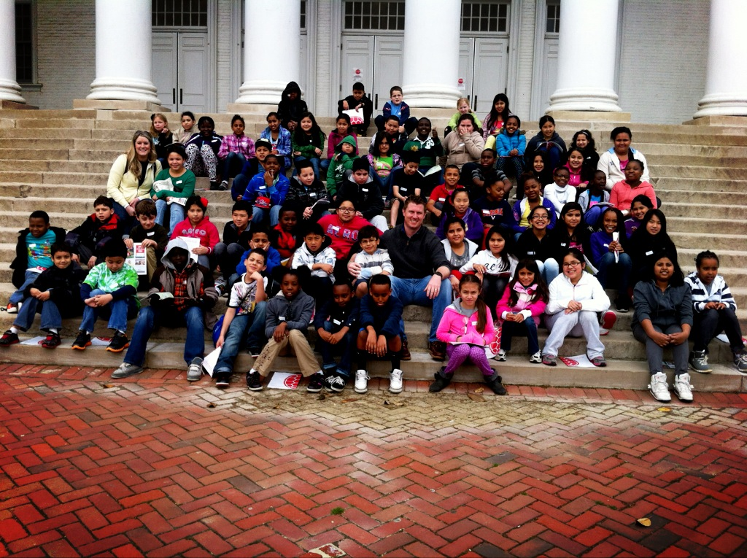

**Message from the Grade 3 Team -***Ms. Davies, Ms. Gottshall, Ms. Edhegard, and Ms. Langrock* 

**Zoo Field Trip**: Our students have been researching topics to develop opinions for writing. We have discussed the pros and cons of animals living in zoos. As a culmination of their opinion writing and research, the third grade will be traveling to The National Zoo on Wednesday, May 22nd, 2013.

**Multiplication Facts**: As you know, the goal is for 3rd graders to know all products, from memory, of 2 one-digit numbers. Please continue to practice these facts, daily, with your child.

**Telling Time:** Please practice having your child to tell time on an analog (non-digital) clock to the nearest minute. Also, create real life elapsed time problems for your child to solve. For example: You woke up at 7:30 this morning and left your house for school at 8:50. How much time has passed?

**Donations Needed:** Your children have been hard at work at school! As a result, we are in need of additional paper towels, tissues, pencils, post-it notes, and erasers. We truly appreciate any items that you might be able to contribute. Thank you in advance!!

**A Few More Weeks:** As school is drawing to a close, we need to remind students that they need to continue to focus and put forth their best efforts to be the best student they can be.

As always, please let us know if you have any questions or concerns!



**News from Fourth Grade-** *Mrs. Mayer, Ms. DeFrehn, and Mrs. Hubbard*

The fourth graders worked so hard on their wax museum speeches and the presentations at Kennedy High School were a great success!  Thank you for all your support parents! We have an educational field trip to the Smith Center planned for May 13th.  The students will learn about the human impact on the Chesapeake Bay watershed.  Remember to bring your permission slips and money as soon as possible.  Our students continue to work hard in math and embrace the new Curriculum 2.0 Transitional Fraction Unit.   Students are engaged in deeper math conversations and making solid connections to the real world.  We just finished taking MAP-M and were very impressed with the continued progress of our 4th graders!  Gooooo 4th Grade Gators!





**News from the Media Center** – *Mrs. Bean and Mrs. Marley-Emory*

April was Poetry Month and several of our grade levels were reading and writing their own poetry. Many published and illustrated their work using the computer programs, *Pixie* or *Word*. Below is just one example of their poetry. This was written by Lucas, second grade.

Things To Do If You Are A Brain

Hold secrets, plan plans,  
day dream about owning bands.  
Erase everything once a week,  
fill in every single leak.  
Think of Friday afternoons,  
to take a raft over the moon.



***One School, One Community, One Goal……….The Success of Every Glenallan Gator***

### Glenallan Elementary School

**“*Where Gators Go Above and Beyond”***

|  |  |
| --- | --- |
|  |  |
|  |  |
|  |  |
|  |  |
|  |  |
|  |  |
|  |  |
|  |  |
|  |  |
|  |  |
|  |  |

### Glenallan Elementary School

**“*Where Gators Go Above and Beyond”***





Important Dates for June 2013



May 22 3rd Grade Field Trip to Zoo

May 23 Career Day at Glenallan

May 24 Kindergarten Family Activity 9:45 a.m.

May 27 No School – Memorial Day

May 28 Field Day Kindergarten – Grade 2

May 29 End Of Year Concert @ Kennedy HS 7:00 p.m.

May 31 Pancakes with the Principals: Patience

June 3 Field Day Third – Fifth Grade

June 6 2nd Annual Glenallan Talent Show

Kennedy High School 6:30 p.m.

June 10 5th Grade Promotion Rehearsal @Kennedy

June 10 4th Grade Family Picnic 1:15 – 3:15

June 11 End of Year Awards Ceremony

K – 2 9:45 3 – 5 10:55

June 11 Grade 2 Family Picnic 11:15 – 1:00

June 12 5th Grade Promotion @Kennedy HS 10:00 a.m.

June 13 Early Dissmissal 1:15

Last day of school for students



**Character Counts:**

The character trait for the month of May is Patience**.** Staff will be looking for students demonstrating respect at school, in the community, and focusing on it through instruction.

[](http://www.google.com/url?sa=i&rct=j&q=Gators&source=images&cd=&cad=rja&docid=OV_55onkedAxjM&tbnid=2XhqYaQa87TltM:&ved=0CAUQjRw&url=http://www.geibelcatholic.org/athletics/Pages/default.aspx&ei=ehIZUdHHLdCM0QG89YHgCw&bvm=bv.42080656,d.dmQ&psig=AFQjCNG81OHwyi3H4l7P9214i94DWg2AmA&ust=1360683980748525)

Thursday, June 6

2nd Annual Glenallan Talent Show

Kennedy High School 6:30 p.m

C:\Users\moranpet\AppData\Local\Microsoft\Windows\Temporary Internet Files\Content.IE5\VQVKYFHF\MC900089784[1].wmf



**Mcpssuper**

The latest edition of Mcpssuper showcases the work being done to measure student and staff engagement in MCPS. In the fall, thousands of students and staff took surveys created by Gallup, and the results are providing insight into employee and student engagement as well as student well-being—information that has a direct impact on student achievement. During the show, Dr. Starr and his guests discuss the survey results and how this information can be used in the school improvement process. The show will be broadcast regularly on MCPS TV and can be viewed online at [www.montgomeryschoolsmd.org/departments/superintendent/mcpssuper/current/](http://www.montgomeryschoolsmd.org/departments/superintendent/mcpssuper/current/). A blurb is provided below.



**New Lineup of Parent Academy Workshops**

Don’t miss the spring session of the MCPS Parent Academy, which offers helpful tips and resources to parents on a broad array of topics. Sessions this spring will cover issues such as cyber safety and social media, effective parenting skills, and preparing for postsecondary education. Visit [www.montgomeryschoolsmd.org/departments/parentacademy/](http://www.montgomeryschoolsmd.org/departments/parentacademy/) to download the workshop schedule and registration information.



.