Cafeteria 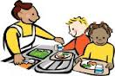
Are you a PALS student?
- Use indoor voices
- Get permission to leave your seat

- Keep your hands to yourself 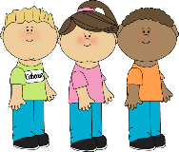

- No sharing food 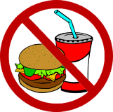
- Throw away, recycle all your trash

