Name: _______________________________________
1st Grade Summer
Reading and Writing GAME BOARD
Directions: Over the summer, complete the reading/writing activities.
Read in your pajamas | Write about your favorite part from a book | Read a book with a flashlight | Read a book about animals | Read twice in one day
Write about your favorite animal | Listen to a book | Write about something you did this summer | Read a non-fiction book and share 2 facts you learned | Read a book to a family member
Have an adult read a book to you | Write and draw about the story elements of a book | Read a funny book | Make up a story and write about it | Write a letter to a friend or family member
Read your favorite book | Read a book outside on a sunny day | Write about your favorite movie | Write about something funny that happened | Read a fiction book and tell an adult about the main characters
Read a book to your friend | Read for 20 minutes | Write about something you accomplished | Eat a snack while you read | Write about your family

Name: _______________________________________
1st Grade Summer
Math and Wellness GAME BOARD
Directions: Over the summer, complete the math/wellness activities.
Stomp as you are counting to 120 | Practice a yoga pose while counting | Practice math facts (addition) for 10 minutes | Do a workout that increases your heart rate | Eat a yummy fruit!
Practice 1 more and 1 less | Clean your room | Dance and count to 120 | Skip count by 2’s | Play outside for 20 minutes
Skip count by 10’s | Write numbers 0 to 120 | Share different ways to make 10 with a friend /family | Practice math facts (subtraction) for 10 minutes | Play a math game on the computer
Go for a nature walk with your family or a friend | Look for shapes in nature or in the sky | Skip count by 5’s | Make your bed after you wake up | Describe a healthy plate for lunch
Go to the swimming pool/ beach | Count how many vegetables you eat in one day | Write a story problem and solve it | Count how many steps you can take backwards (with an adult) | Race your friend or a family member
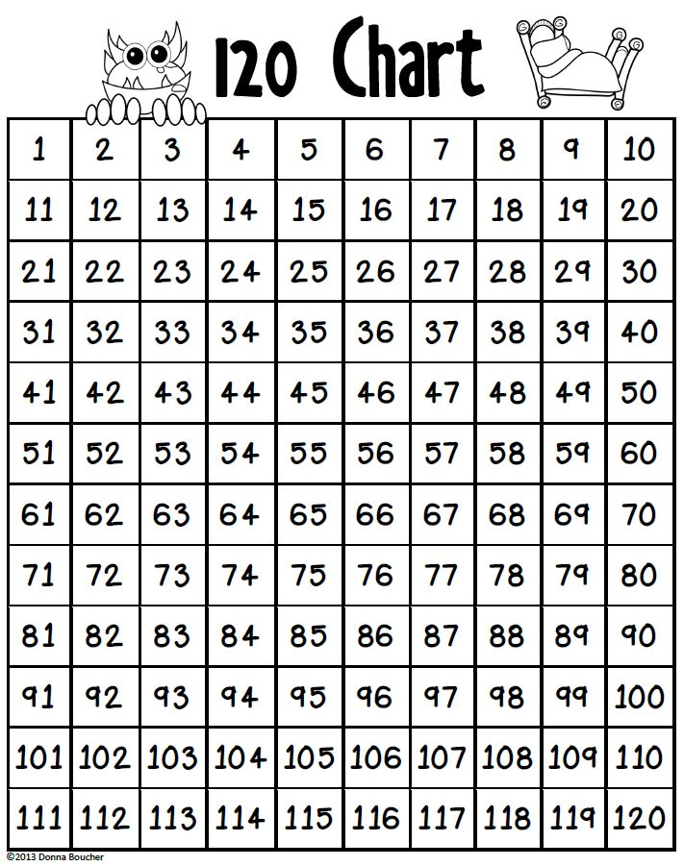
Name: _________________________________________ Date: ______________________
________________________________________________________________________________________________________________________
Name: _________________________________________ Date: ______________________
________________________________________________________________________________________________________________________
Name: _________________________________________ Date: ______________________
________________________________________________________________________________________________________________________
Name: _________________________________________ Date: ______________________
________________________________________________________________________________________________________________________
Name: _________________________________________ Date: ______________________
________________________________________________________________________________________________________________________
Name: _________________________________________ Date: ______________________
________________________________________________________________________________________________________________________
Name: _________________________________________ Date: ______________________
________________________________________________________________________________________________________________________
Name: _________________________________________ Date: ______________________
________________________________________________________________________________________________________________________
Name: _________________________________________ Date: ______________________
________________________________________________________________________________________________________________________

