“You’ve Got a Friend in Me”
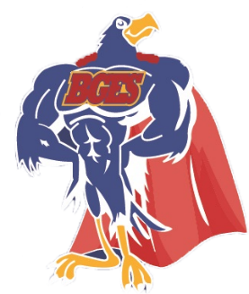
What is your friendly super power?
September - I am Me- Kindergarten
October - I am Respectful- Core Team
November - I am Responsible- 2nd Grade
December - I am flexible and collaborative– 1st gr.
January - I am Kind- PBIS Team
February - I am an Upstander- 4th Grade
March- Pennies for Patients Assembly- SGA
April- I am Mindful – 3rd Grade
May- I am Creative- 5th Grade
June - I am Resilient – Specialists

