Elmo Document Camera Quick Tips

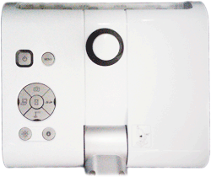
How to Use the Elmo (document camera)
- Turn on Elmo – The power switch is located on the left rear side of the base.
Power Button
Elmo Icon
Brightness Controls
- Turn on Projector or Promethean.
- Put something on the Elmo stage.
- Press the button marked with a Elmo icon located on the front of the Elmo base under Input.
- If there is still no image being projected, see troubleshooting tips below.

Zoom knob
Auto Focus Button
Camera Head
Light Switch
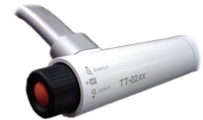
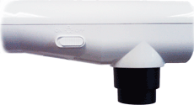
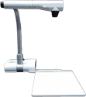

Using Books, Notes, or 3-D Objects with Elmo
- Place item on Elmo stage.
- Turn on the lamp – On the camera head, slide the lamp switch left, to the “On” position.
- Adjust Zoom – Zoom in or out using the black zoom knob on the left of the camera head.
- Adjust Focus – Press the orange button labeled “AF” (auto focus) located in the center of the zoom knob.

Making annotations with the ELMO
Make sure Elmo is on and that PC is chosen on the ELMO.
When you are in ActivStudio, click on the "Annotate Over Windows" Icon from you toolbar
From the School Menu, navigate to "5. Windows Accessories" and double click on the "Image Mate for Presentation - ELMO" shortcut to launch the ELMO software (it looks like a P)
When the software launches click on the Play button to view what is on the ELMO, and hit the Full Screen button and the Promethean tool bar over the image.

Additional Resources

- Elmo TT-02s Feature Overview
http://www.youtube.com/watch?v=r6L6ELQIw3Y
Key points in the video:
  - Pivot Points @ 1 minute 20 seconds
  - Zoom/Auto Focus Functions @ 1 minute 40 seconds
  - How to use the Menu @ 2 minutes 7 seconds
  - Using the ImageMate Sofware @ 3 minutes 25 seconds

- Connecting and Elmo to a Projector
http://www.youtube.com/watch?v=hnR91s6Q3X0
This video uses a previous version of the Elmo. There are a few aesthetic differences, but the cable connects in the same place, and the same general principles apply.
Key points in the video:
  - Elmo range of motion @ 20 seconds
  - Connecting to a projector @ 40 seconds
- Using and Elmo with a Microscope
http://www.youtube.com/watch?v=4XFOvpffygA&feature=PlayList&p=A863BE250625F099&index=0&playnext=1

Troubleshooting
For the issues described below, please follow the suggestions in order. If you are unable to correct your issue, or you have an issue that is not listed below, please contact your ITSS.

Problem | Suggestions
No Power | Make sure unit is plugged into cart and/or wall outlet.  If plugged into a cart, verify the extension cord is plugged into a wall outlet.  You may have a defective Elmo. Contact your ITSS or the Help Desk.
Unit turned on but nothing is displayed on the projector or Promethean board | Make sure video cable is connected between video out of document camera and video input of the projector or Elmo  Verify the button on the base with the Elmo icon is illuminated.  Check the output selector on the left side of the base. Verify it is switched to toward the picture of an LCD Projector.  You may have a defective Elmo. Contact your ITSS or the Help Desk.
Lights on Elmo aren’t on | Verify the lamp switch on the camera head is switched on.  You may have a defective Elmo. Contact your ITSS or the Help Desk.
Image not in focus | Press the auto focus button.  You may have a defective Elmo. Contact your ITSS or the Help Desk.
Image too dark or too light | Adjust the brightness using the brightness controls on the base of the Elmo.
Power light blinks blue continuously | Blinking 5-7 times after power-on is normal; it is focusing.  You may have a defective Elmo. Contact your ITSS or the Help Desk.

