Kidspiration 3.0 User Guide

Kidspiration is a program that enables students to see, organize, and develop their ideas with graphic organizers. This guide will show you how to use Kidspiration.

Main Menu: When you open the program, the main menu will appear.

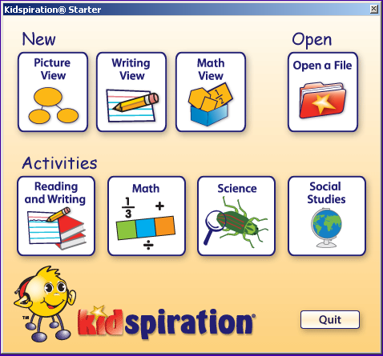

- Picture View: create webs, sorting activities, and other visuals.
- Writing View: create lists and outlines.
- Math View : create math activities with pattern blocks, base ten blocks, etc.
- Open a File: open a previously saved Kidspiration document.
- Selecting a subject under Activities enables you to choose from a variety of templates.

Picture View 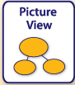
Map, organize, and display ideas visually.

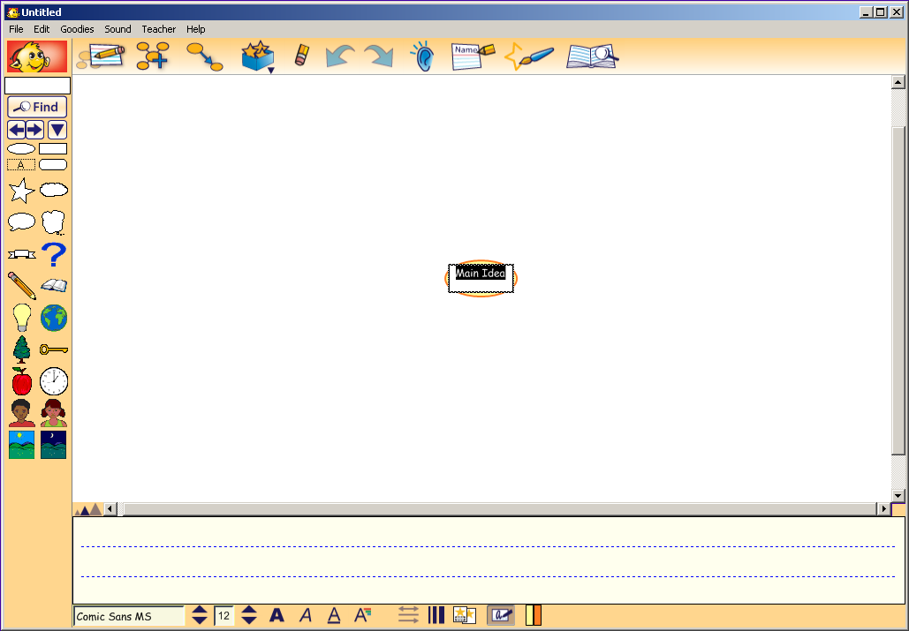
Formatting Toolbar
Picture Toolbar
Symbol Palette

- The Symbol Palette is a menu containing graphics. Click on the left or right arrows to scroll through the menu or click on the down arrow to see a categorized list.
- The Formatting Toolbar enables you to change the look of the text, symbols, and links on your web. Formatting Toolbar buttons:

 | 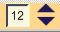
Font | Resize Text | Style | Text Color
Arrow/Line Width | Hide/Show Captions | Hide/Show Handwriting Area | Color

- Point to a button on the Picture Toolbar to see and hear a description of its purpose. Click on a button to select it. Picture Toolbar buttons:

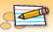
Go to Writing View | Add a Symbol | Link Symbols | Super Grouper
 |  |  | 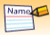
Erase Selected Object  Symbol Maker | Undo/Redo  Word Guide | Listen | Add Your Name

Creating a Web in Picture View
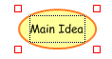
1. Click inside the circle that says “Main Idea”
to type the main idea for your web.

2. To associate a picture with the main idea, click on a picture in the Symbol Palette.
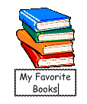
4. The main idea will now look like this

5. To add new ideas off the main idea, click on the Add a Symbol button on the toolbar.

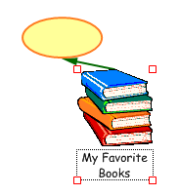
6. A new oval will appear to fill in with a new idea. The new oval extends from
the main idea of the web.

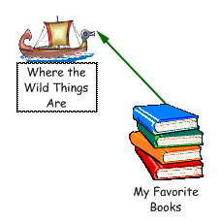
7. To change the oval into a picture, click on the oval so the red handlebars
appear.

8. Then click on the picture to add it.

9. Each time you want to add something new to the web, click on the main idea first, and then on the Add a Symbol button.

Writing View 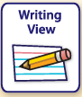
Organize and expand ideas when writing.

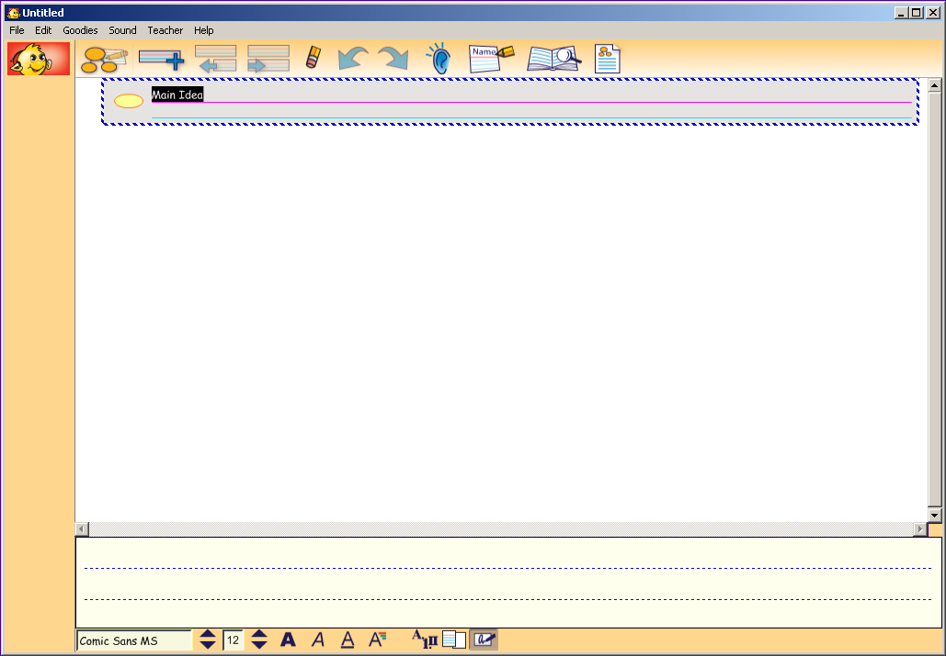
Writing Toolbar
Formatting Toolbar

- The Formatting Toolbar enables you to change the look of the text, symbols, and links on your web. The formatting options are the same as the ones in Picture View.

- Point to a button on the Writing Toolbar to see and hear a description of its purpose. Click on a button to select it. Writing Toolbar buttons include:

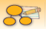 |  | 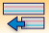 | 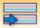
Go to Picture View | Add an Idea | Move Idea Up a Level | Move Idea Down a Level | Publish(to Word)
Creating a List in Writing View

- Click inside the rectangle that says Main Idea to type a starting point for your writing.

- Add additional ideas by clicking on the Add Idea button.

Each time the button is clicked, an idea will be added.

3. Click inside the rectangle to add text. To indent any of the ideas, click on the rectangle you want to indent so the outline is a dashed blue and white line. Then click the Move Right button.

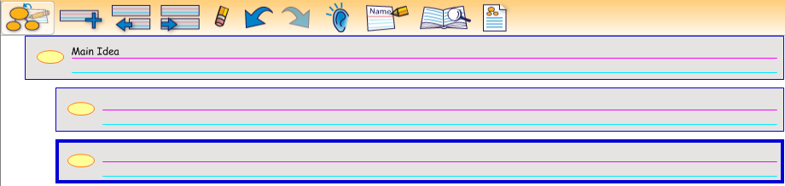

- To transform the list into a web, click on the Go to Picture View button.

5. The web will look like this:
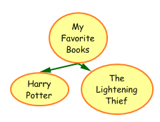

6. To go back to the list, click on the Go to Writing View button.

Math View 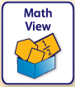
Create math activities with color tiles, pattern blocks, base ten blocks, fraction tiles, or fraction boxes.

- From the Kidspiration Starter Menu, choose Math View. The following menu will appear:

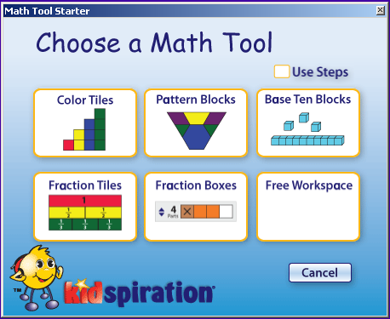

- Depending on the Math Tool chosen, the interface will look different. The following symbols are common to all tools:

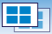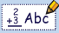
Change Math Tool Go to Page Go to Previous/Next Page Add Math Text
Line

Options specific to certain Math Tools:
- Color Tiles
  - Math SuperGroupers: For sorting color tiles
  - On Formatting Toolbar (click on tile/line to select)
    - Resize Manipulatives: Small, medium, large
    - Colors
    - Cross Out: Puts an X through the color tile
    - Show/Hide Background Grid
- Pattern Blocks
  - Math SuperGroupers: For sorting pattern blocks
  - On Formatting Toolbar (click on block/line to select)
    - Resize Manipulatives: Small, medium, large
    - Colors
    - Cross Out: Puts an X through the color tile
    - Rotate Block Clockvise/Counter-clockwise
- Base Ten
  - Math SuperGroupers: For sorting base ten blocks
  - On Formatting Toolbar (click on block/line to select)
    - Resize Manipulatives: Small, medium, large
    - Colors
    - Cross Out: Puts an X through the color tile
    - Group: Groups broken apart blocks into larger blocks
    - Break Apart: Separates rods, flats, and blocks into smaller units
    - Place Value Mat: Puts a column chart on the workspace (ones, tens, hundreds)
    - Flip Rod: Flips the rod from horizontal to vertical or vice versa
- Fraction Tiles
  - On Formatting Toolbar (click on tile/line to select)
    - Resize Manipulatives: Small, medium, large
    - Colors
    - Cross Out: Puts an X through the color tile
    - Patterns
    - Hide/Show Fraction Labels
- Fraction Boxes
  - On Formatting Toolbar (click on tile/line to select)
    - Resize Manipulatives: Small, medium, large
    - Colors
    - Cross Out: Puts an X through the color tile
    - Patterns

Recording Sound

- Click your mouse inside of the symbol or on the place on the workspace you would like the speaker symbol to appear.

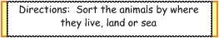

- Under the Sound menu, select Record. A dialogue box will appear.

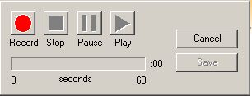

- Click on the Record button to start the recording and the Stop button when done. To hear a playback of the recording, click the Play button. Rerecord if necessary. Click Save when done with the recording.

- A speaker icon indicates that a sound recording is available on the Kidspiration workspace.

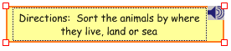

Teacher Menu

The Teacher Menu has additional features that only a teacher would need when preparing a Kidspiration activity. To make the menu available, go to Teacher> Enable Teacher Menu. Some of the features available include:

- Activity Wizard: Save an activity for students as a template
- Locked Item:
- To lock certain items so student won’t accidentally move them, highlight the item/items. (to select multiple items, hold down the Shift key and select items.)
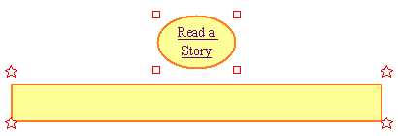
- In the Menu bar, click Teacher and select Lock Items.
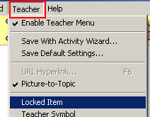
- URL Hyperlink
- Open a website and highlight the address. Then, in the menu bar, click Edit and select Copy.
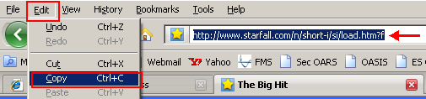
- Type text that you want to link to a website and highlight the text.

- In the Menu bar, click Teacher and select URL Hyperlink…

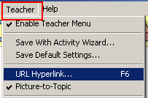

- Place mouse cursor in the Hyperlink Address box and press Ctrl+V to paste.

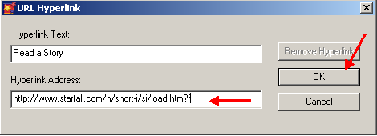

- The text you highlighted will have a blue line underlined.
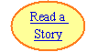

- Install User Symbol: Save a teacher created symbol in the Symbol Library
- New Symbol Library: Create a new category in the Symbol Library
- Edit Symbol Library: Make changes to the default Symbol Library

