Montgomery County Public Schools
Post-Observation Conference Report

Report - Formal Observation #1

Administrator: Date: Time:

School:
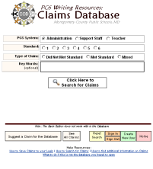
Observer: Post-Obs. Conference Date:

Context Paragraph:

CEIJ Paragraphs:

Post Conference Paragraphs:

Summary:

Observer’s Signature ______________________________ Date __________
Administrator’s Signature* __________________________Date ___________

* The administrator’s signature indicates that the administrator has read and reviewed the Post-Observation Report, not necessarily that the administrator concurs with the contents. The administrator may attach his/her comments.

