Name: ________________________________________________________________________________________________________________________________________________________

Tech Tips for UDL Planning: Build Multimedia-Rich Lessons that Promote Student Choice

Resource | Description | Notes/Applications
Zoom.it  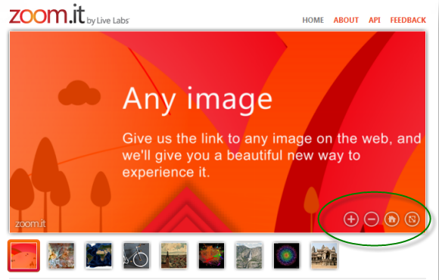  www.zoom.it | Create zoomable versions of online images
Big Huge Labs  www.bighugelabs.com | Use templates to turn images into creative products
Jigsaw Planet  www.jigsawplanet.com | Turn images into online jigsaw puzzles
Bounce  www.bounceapp.com | Annotate online screen captures and images
Thinglink  www.thinglink.com | Tag images with multimedia content
Blendspace  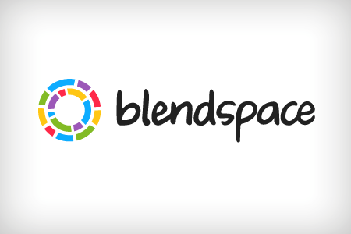  www.blendspace.com | Curate multimedia content for students
Screencasting  www.screencast-o-matic.com  (Feature also available on ActiveInspire software) | Record a screencast
Animoto  www.animoto.com | Create short video stories
WeVideo  www.wevideo.com | Create video projects
Zaption  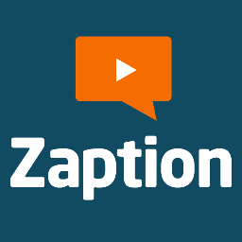  www.zaption.com | Add multimedia content and quiz questions to Youtube videos
Other Notes:

Link to Presentation (Case Sensitive):

http://goo.gl/5KeOyw

