- Where do I go to get my statement?
- Click on the Statements tab.

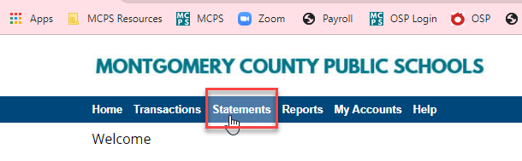
- Click on View Statement (PDF)
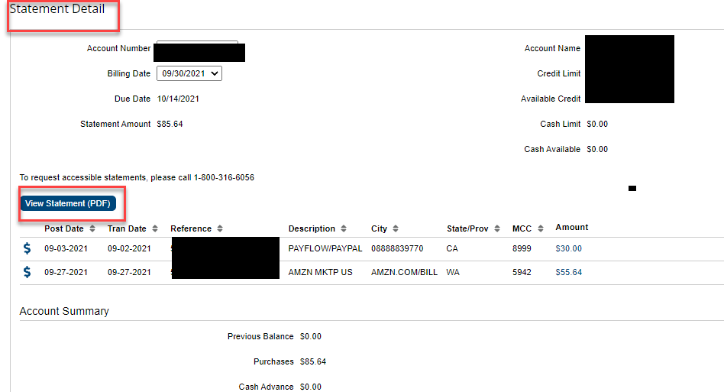

- Print out your statement and attach it along with the receipts in the Employee Expense Module in the Hub.

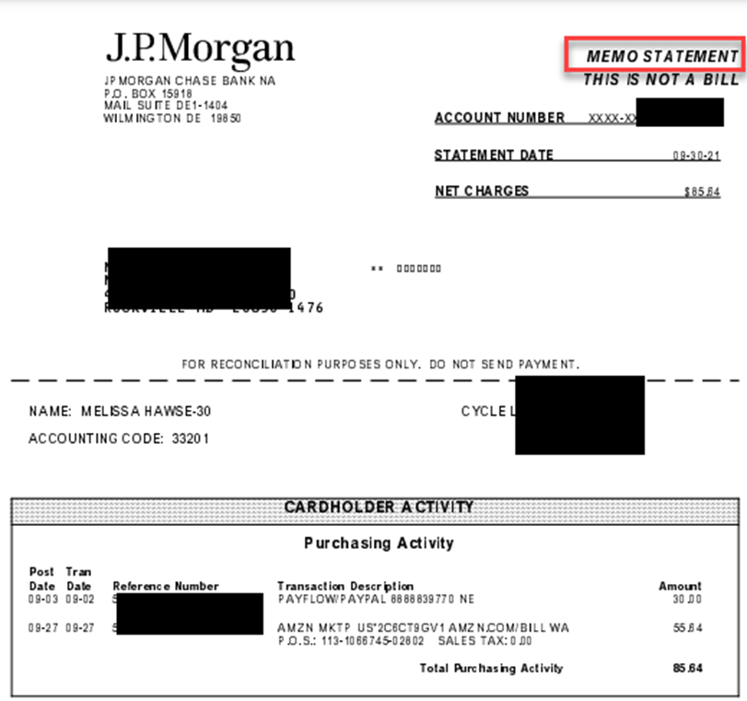

- Please don’t forget to review your transactions before you leave the Pcard homepage.
- You are requested to file the return trip expense report no later than 10 days after the trip.

